**INSTRUCTIONS FOR PROCESSING**

**POOLED POSITIONS & HIRING PROPOSALS**

**Purpose**: The following instructions address “pooled positions.” These procedures are specific to non-benefitted positions (hourly, temporary, part time professional, or adjunct. The procedures contain two parts, *Cloning the Position* and *Executing the Hiring Proposal*(s).

**Definition:** “Pooled positions” entail multiple incumbents occupying the same position description and the same position number, with the same supervisor.

**Warning:** If you intend to hire multiple people into a pooled position around the same time, **you must clone the position before starting the first hiring proposal**.

**Cloning the Position**

1. Log in to the Position Management side of PeopleAdmin (orange banner).
2. Follow these steps to clone the existing position; **create one position per hire needed**.
   1. Click Create New Position Description (orange button)
   2. Complete the required fields at the top
   3. Locate the position you want to clone and select the adjacent radial button. You may search for the position by number or peruse the list of positions within your area.
   4. Click “start action”. All information will carry through, except for the position number. When you send the position to Level 1 indicate the original position number in the pop-up box that allows notes. This step will prompt HR to retain the position number.

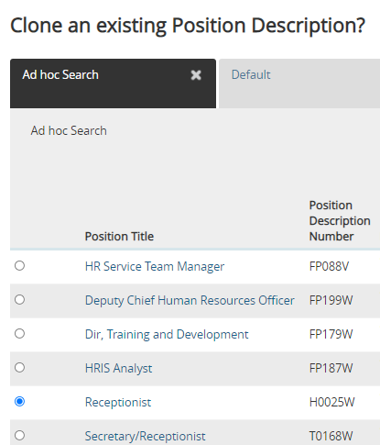

1. Once the cloned positionis fully approved, the newly approved position will have the same position number, but a unique **Position Description ID number**. You will ultimately create a hiring proposal from each Position Description ID number.

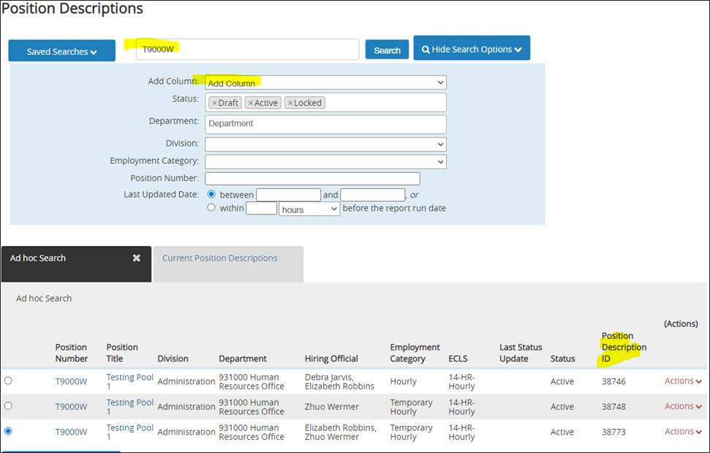

**Execute Hiring Proposal(s)**

1. When ready to make an offer, follow these steps to create a hiring proposal. You will need to create a separate hiring proposal for each pooled hire.
   1. Navigate to the Applicant Tracking side of the system (blue.)
   2. Search for the posting containing an applicant you wish to hire.
   3. If you haven’t already done so, assign a Finalist workflow state to the applicant.
   4. Open the application and click “Start Staff/PPF Hiring Proposal”

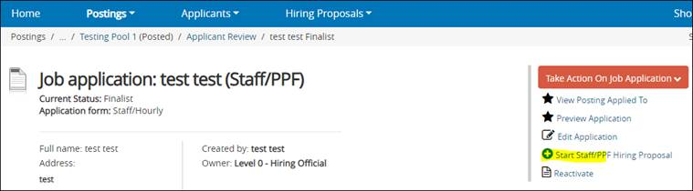

* 1. The page refreshes and prompts you to select a position description. **Scroll down to the Position Descriptions heading and search for the correct position number and position ID.**

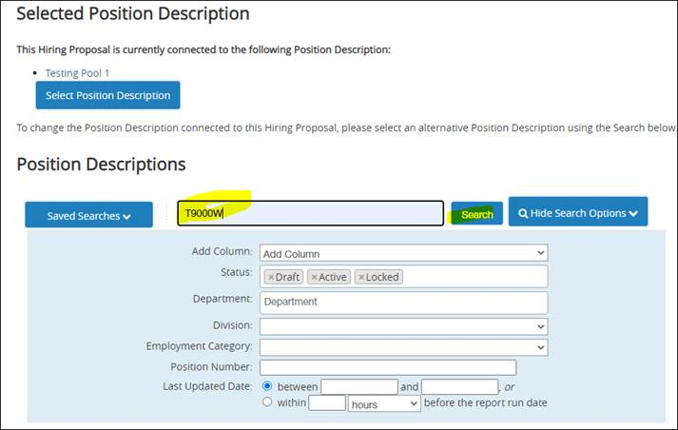

* 1. The screen refreshes and provides ad-hoc results for the pooled PDs. If Position Description ID does not appear, then click on Add Column > Position Description ID.



* 1. Click the button next to the position description with the **position description ID** number you want to fill. If you try to use an already-filled position or an already-in-process hiring proposal you will receive a message:
     1. An error that the job application already has an in-process HP
     2. An error that there's an open action
  2. Prepare the hiring proposal and send to Employment Salary Review.