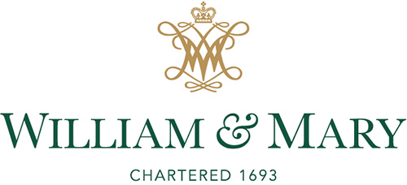

Confidentiality and Ethics Agreement

As a search process participant for the position of ______________________, I understand that the ultimate success of the search and the integrity of the University depend on the search being conducted in an impartial, ethical, and professional manner. I understand that search committee members have obligations of confidentiality both towards the applicants and – consistent with the provisions on privacy in the William & Mary Faculty Handbook – with respect to the deliberative processes of the search itself, in which we are engaged.

Consistent with these understandings, I acknowledge and accept the following:
- I understand that the Search Committee’s charge is to recommend qualified candidates to whomever has the ultimate authority to appoint faculty or staff.
- I understand that non-committee stakeholders may be engaged at the on-campus interview stage, and that the role of those stakeholders is to provide candidate feedback in a standardized format. This feedback may inform selection decisions but does not carry a decision-making “vote.”
- I agree to conduct myself in a professional manner and not to cause disrepute to applicants, my department, Office/School and University.
- I agree to recuse myself in the event of a conflict of interest, or if a reasonable person would be likely to perceive a potential conflict of interest.
- I acknowledge that the only acceptable spokespersons for the search are the Search Committee Chair, their designee, or an appropriate Human Resources professional.
- I acknowledge that all information concerning the candidate pool is confidential and I agree to permanently protect the identity of individuals who have expressed interest in exploring this opportunity, including individual qualifications and merits.
- I will restrict search-related documents and information to designated individuals who are directly involved in the search process, such as the search committee, and to individuals with search oversight, such as University Human Resources.*
- For committee members
- I agree to maintain confidentiality of Committee discussions and deliberations, both during the review process and after its completion. I agree that any breach in confidentiality could damage the reputations and/or livelihoods of the candidates, the Committee and the University. I recognize that such breaches are violations of the codes of conduct outlined in the William & Mary Faculty Handbook.
- I agree to not move any search-related record, report, file, or copy of an official record or report from the place where it is maintained except in the performance of official duties. At the conclusion of the search, I agree to forward any search-related materials in my possession and to abide by separate recordkeeping and destruction policies.
- I understand that I may be excluded from search-related activities if I breach any of these agreements, however the agreement terms shall still apply.
- I have read, understand, and agree to abide by all the terms of this Agreement, as a condition of my participation in the search process.

*When a final interview round requires the participation of individuals outside of the search committee, the Search Chair may share an applicant’s CV/resume with those participants, provided the applicant has pre-approved the document’s circulation and that any personal details or contact information is redacted.

____________________ ____________________ ___________
Printed/Typed name Signature Date

