Disposition of Applicants
The document provides guidance on how to complete the disposition of a single applicant, a group of applicants, and an overview of the workflow states and non-selection reasons. This job aid applies to full-time faculty, adjunct, postdoc and executive applicants.

Single Applicant Disposition
- Log in to PeopleAdmin using https://jobs.wm.edu/hr/ and the SSO (single sign-on) link.
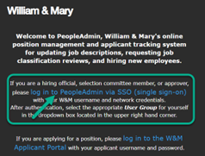
- In the upper right-hand corner, ensure the user group is “Hiring Official.”
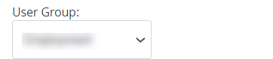
- On the blue ribbon at the top of the screen, click “Postings”, then “Instructional/Executive.”
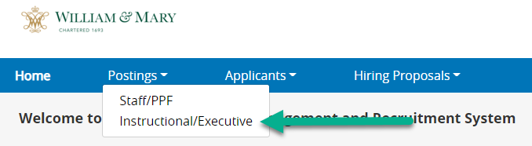
- Locate the posting by typing the position number and “Search,” then click the hyperlink.
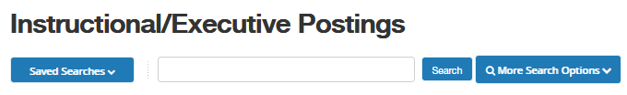
- Click on the Applicants tab, then click on the hyperlinked name of the individual requiring disposition.
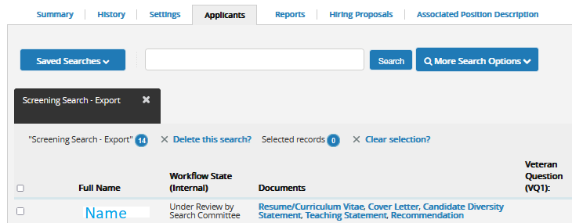
- Click the button “Take Action on Job Application” then select from the drop-down the correct Workflow state. If removing the individual from consideration, click “Not Under Consideration.” The system will then prompt you to enter a non-selection reason. Please utilize existing reasons, wherever applicable.


- Complete disposition throughout the process as soon as a new workflow state is known. It will be necessary to communicate regularly with the committee.

Bulk Applicant Disposition
- From the Applicants tab, check boxes next to applicants with a common disposition status.
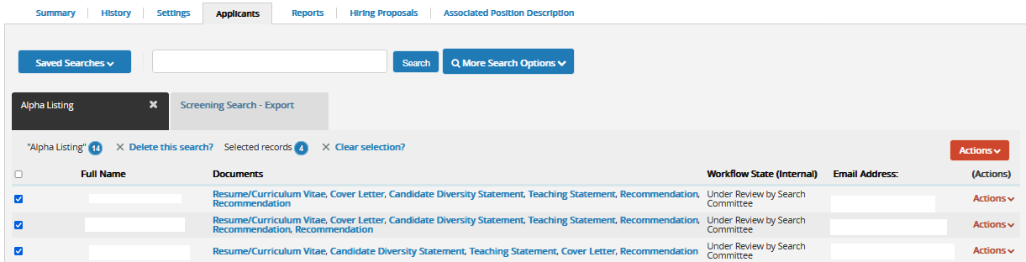

- Hover over the orange “Actions” Button, then click “Move in Workflow.”

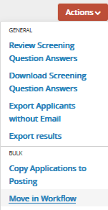

Reasons for Non-Selection - Candidate Disposition

PEOPLE ADMIN Applicant Status *
- Under review by manager
- Short-list
- Interview pending
- Phone Interview
- Interviewed
- Campus Interview
- Finalist
- *Not under consideration
- Offered job - Hired
- Withdrawn
- Interviewed, Not Selected (Send Email)
- Interviewed, Not Selected (Dept to Communicate)
- System Det Does Not Meet Minimum Qualifications
- Interviewed By Phone, Not Under Consideration – Send Email
- Interviewed By Phone, Not Under Consideration – Do Not Send Email
*If this status is chosen, an additional selection is needed from the listing below

Not Under Consideration Reason
- Applicant did not have preferred qualifications
- Applicant withdrew
- Applicant declined offer-Salary
- Applicant declined offer-Other
- Application was incomplete
- Application received after published review date
- Candidate requires a higher salary than authorized
- Did not meet minimum requirements-(provide comment to explain)
- Did not meet preferred qualifications
- Did not return call or show for the interview
- Does not have required license or certificate-(provide comments to explain)
- First Alternate
- Incomplete submission of required forms or documentation
- Less effective interview than applicant hired
- Less relevant education and experience than other applicants
- Less relevant education than other applicants
- Not eligible to apply on internal posting
- Poor oral or written communication skills
- Position cancelled
- Reference or background check unsatisfactory
- Second Alternate
- Unable to accept work condition or schedule
- Unable to contact-(provide comments to explain)
- Interviewed previously for position
- Applicant did not complete application process-(provide comments to explain)
- Position was already filled when application received

