buyW&M Update – Split by Amount on Requisition
buyW&M will now allow for up to 3 splits by amount at the header level of the requisition without failing the validation check.
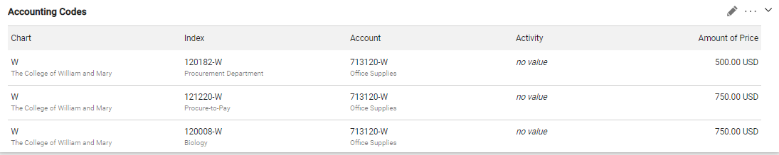
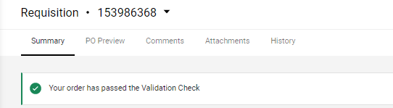
If more than 3 splits are entered at the header, the validation check will fail. Please select the “History” tab to view the error message which reads:
“Only 3 splits are allowed when doing Split by Price. If you need more than 3 splits you will need to convert to Split by Percentage. Optionally, you can create individual line items for each split and put the corresponding Accounting Codes with that line. If doing individual line items then line 1 should not have any Accounting Codes as this will use the information at the header.”
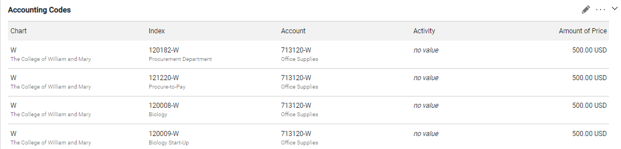

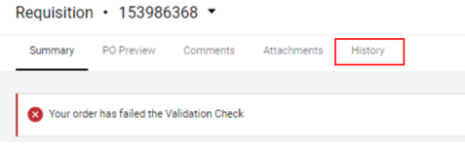
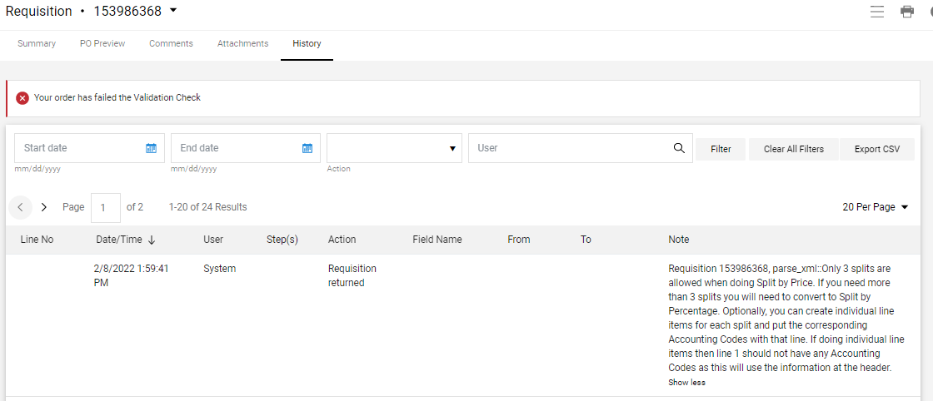
If this error is received and the order cannot be split another way, update your split to be by percentage and the validation check will pass allowing the requisition to be submitted.
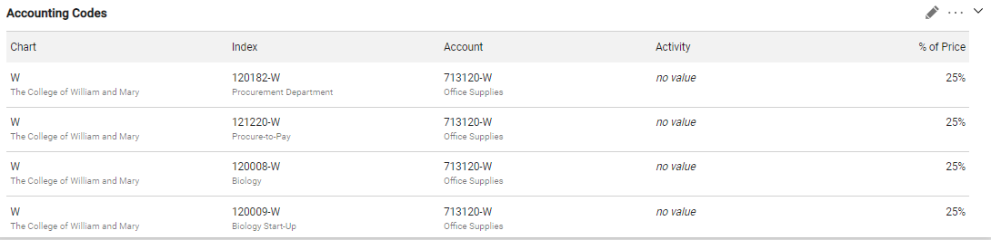
Thank you,

buyW&M Core Team
Questions? Submit a buyW&M help desk ticket

