Invoices – Punchout vs. Non-Punchout Orders
When working with a punchout order, vendors will transmit the invoices through the system – no additional action is needed for the invoice section.
To refresh your memory on whether the order was a punchout order, check the PO, go to line item details and look for the symbol below.
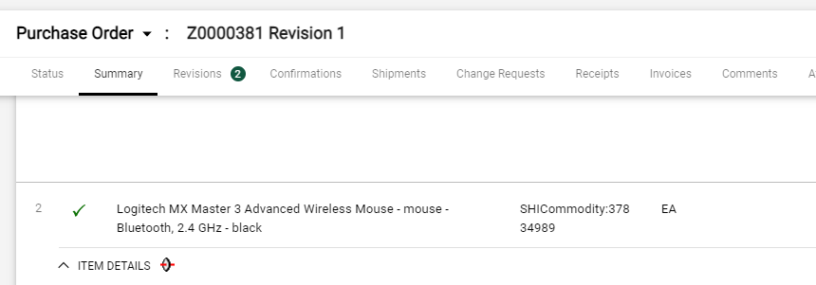
To confirm the invoice has been submitted by the vendor, you will see a number beside the invoice tab to notify you that an invoice has been added from the vendor.
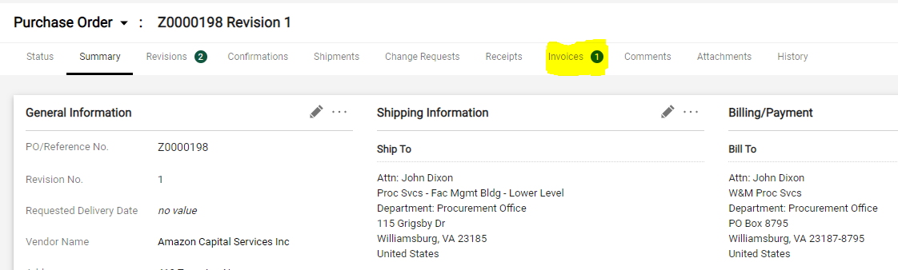
When you click on the Invoices tab you will see the invoice the vendor transmitted (NOT as an attachment) that looks similar to the purchase order, see below.
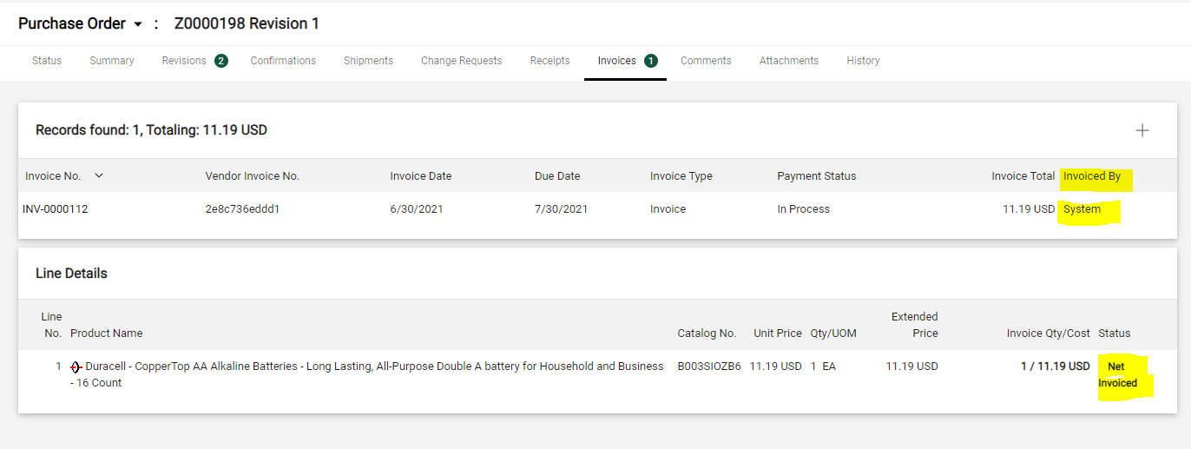
The to get the order queued for payment, you will only need to receive against the order.

