buyW&M Support

Submitting Help Desk Requests
- For internal issues, submitting a buyW&M Help Desk issue is preferable to sending an email to buywm@wm.edu. By using the help desk, tickets are assigned to a core team member more quickly than if it's sent to the same email inbox as vendors use for registration questions. To submit a buyW&M Help Desk issue, please complete this form: https://go.wm.edu/V5GyX2
- If you received a comment from the buyW&M Issue tracking tool and you want to respond back, click on the Go To Comment button, tag the person you want to be notified of your comment by typing "@" and their name. Click on the correct name from the list that displays. Write your comment and click the symbol at the bottom of the Comment box. In this way, the individual will receive an email that there is a comment to review. Otherwise, they have no way of knowing a comment was added.

Office Hours
buyW&M core team members will be hosting weekly buyW&M virtual office hours on Wednesdays from 2:30-4:00 beginning September 8th and running through at least October 27th. Please put these on your calendars and drop in if needed on Wednesday afternoons.
Link to the office hours recurring meeting: https://cwm.zoom.us/j/97304965260?pwd=Q0x3MUIxYitEU3FicWVJNTJoNEFjUT09;

Vendors
Vendor Registration Statuses
Invited – email invitation sent but no action taken; please reach out to the invited contact and encourage action.
In progress – registration has begun but has not been completed; please reach out to the invited contact and encourage them to complete the process.
Profile complete – vendor has completed the registration and it’s in our in internal review process. If information was not completed fully or correctly, the vendor will be contacted; no action needed on your part.
Approved – vendor is ready to use.

Vendor Invitation
If you determine that the invited contact was incorrect, submit a request to invite a new vendor through our buyW&M Help Desk issue log: https://go.wm.edu/V5GyX2

Shopping Updates

New Punchouts
buyW&M Core team is pleased to announce there are two new scientific punchouts available in production, Genesee Scientific and BioRad.
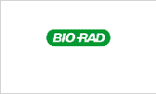

Apple Update
The Apple punchout has been made active! Users can also create non-catalog orders with Apple to include the proposals from IT. We are working with Apple to see if proposals can be created/submitted through the Punchout.

ESI Updates
ESI has agreed to partner with W&M regarding the click for copy charges and will only be issuing invoices quarterly instead of monthly! This will minimize the amount of processing for business administrators for what tends to be low dollar transactions. The new quarterly billing will be from August 1st – October 31st and you can expect those new bills to be sent to you all in early November for processing. Please be sure to create a blanket purchase order for the anticipated amount for this fiscal year to allow you to issue multiple payments/invoices against the PO.

Troubleshooting Chrome Browser Issue
For those buyW&M users that access buyW&M through Google Chrome, it may be best to clear your Cache from time to time and necessary to do so when the page does not load fully.
To do this, click on the 3 dots in the upper right-hand corner of your Chrome browser and select History:

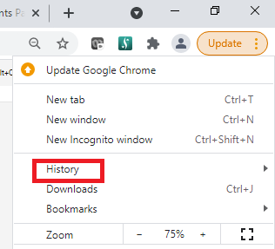
Under History, click on Clear browsing data:

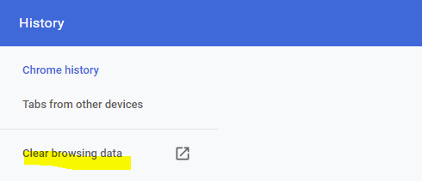
On the next screen, just check the boxes for "Cookies and other site data" and "Cached images and files,"

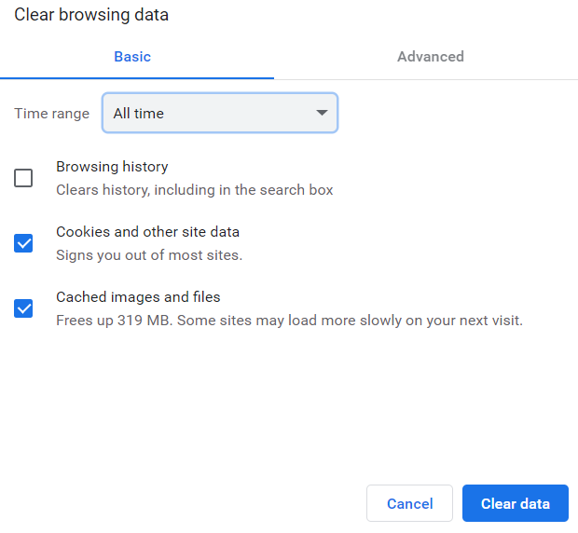
Try logging in and see if buyW&M appears as you would expect.

Assigning Carts
For those of you that are requesters, please remember that you can place the order without having to assign your cart to another person. When you assign a cart to a person, it considers them Prepared by/for and that individual is then eliminated as an eligible Approver. There is no need to assign a cart to someone who is an Index Approver as they will have an opportunity to review the transaction in the requisition workflow.

Checking on Approver Workflows – Who can approve my requisition?
To see who is able to approve pending workflows, reference the right-side section of the screen that says, ‘What’s next for my order?’ By clicking on the specific name of the workflow step, the approver(s) able to approve that workflow step will be listed.
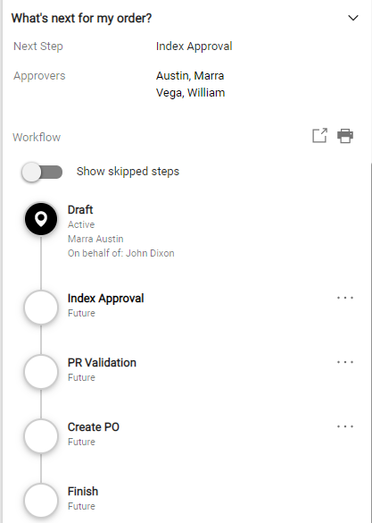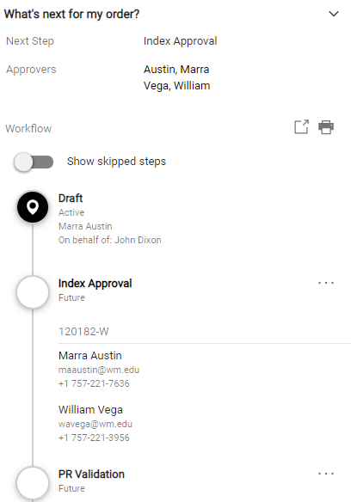

Duplicate Invoice Numbers
Banner will not allow the same invoice number to be paid twice to the same vendor. This includes the same invoice number from previous years. This may cause an invoice to fail in the buyW&M to Banner export for payment. If paying an invoice that might have the same invoice/document number to the same vendor, for example rent or a utility invoice where the account number is used, please add the month/year to each monthly invoice to make the invoice number unique (ex: 123456 09/21). You can also add a -1 (-2, -3, etc.) behind the number (ex: 123456-1). Please keep in mind that Banner will not allow more than 15 characters for the invoice number therefore the invoice number might need to be abbreviated.

Deleting Returned Invoices
If an invoice has been returned and is now listed in your draft invoices, you or AP cannot delete it. If you need to delete the invoice, you will need to resubmit the invoice by completing it and asking the person in the next approval queue to reject the invoice. You can ask the next person in the approval queue to delete the invoice by using the comments tab or by reaching out to them (email, phone or teams might be best in case they fail to look at the comments tab). It might be best to reach out before you resubmit the invoice so they are aware in advance and the invoice does not accidentally get approved.

