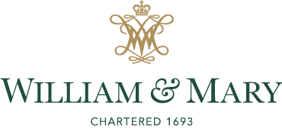
Office of Sponsored Programs

Changes to Uniform Guidance 2CFR200 (Effective October 1, 2024)
Announcement: In response to the implementation of OMB’s October 1, 2024, revision (“2024 Revisions”) to the OMB Guidance for Federal Financial Assistance; Final Rule – Title 2 of the CFR, the Office of Sponsored Programs has compiled a high-level summary of key revisions and their implementation to keep our research community informed and engaged. Please see links provided at the end of our document for additional information.
The Final Rule introduces several revisions, including increases to thresholds for equipment/supplies, modified total direct costs (MTDC), de minimis, fixed amount awards, and single audit threshold. The federal agencies are responsible for implementing the guidance by October 1, 2024. As of November 1, some agencies have not yet announced their implementation plans (see the Status of Agency Implementation Matrix below, which will be updated as new information is received). It remains unclear what the repercussions will be if an agency fails to meet the October 1st deadline.
The analysis and guidance provided are based on our current understanding of OMB’s implementation. However, there is still some uncertainty as to how individual agencies will apply the guidance. As such, these recommendations should be taken with that uncertainty in mind. We are aware of outstanding issues and will continue to review and update this guide, as necessary. If major changes occur, we will promptly inform our research community.
Significant Changes Implemented in the Updated Uniform Guidance:
- Changes in Limits and Thresholds: The updated Uniform Guidance changes the dollar thresholds in several areas. However, keep in mind that no threshold changes will be implemented until after the expiration of William and Mary’s (W&M) current ONR Negotiated Rate Agreement which expires 6/30/2026.
The table below outlines the threshold changes under the new Uniform Guidance.
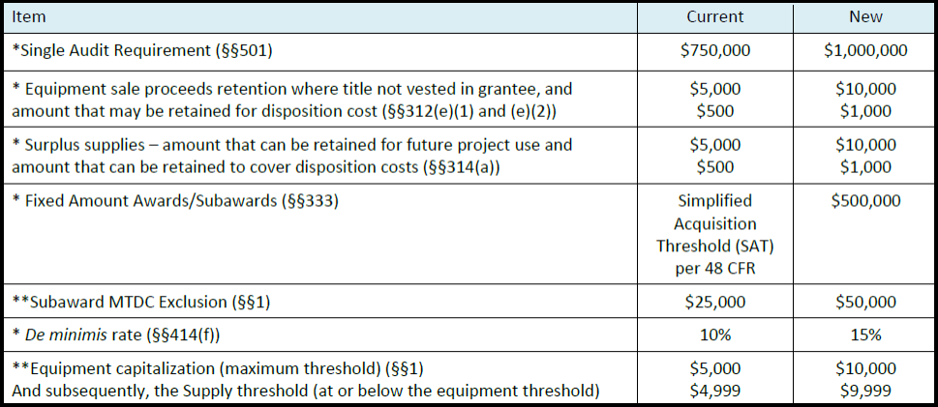
*Implement awards issued or revised on October 1, 2024, and beyond.
**Implement with your negotiated F&A cost rate, rate extension, or rate modification and subsequent receipt of new award or competitive renewal. W&M’s current rate agreement does not expire until 6/30/2026. At this time, please continue to use the Subaward threshold of $25K and the equipment cap of $5K for all budgets. W&M currently has in effect a rate agreement that is valid until the end of FY26 (June 30, 2026), which was negotiated using prior Uniform Guidance.
Note: Equipment Capitalization Threshold – While the limit has increased to $10,000, the decision to change the threshold is under revision. Should W&M decide to adjust our threshold up to the new amount, it will be implemented as part of W&M’s next negotiated agreement, which will take effect in FY27 and later. Should there be a delay in the negotiation of rates by June 30, 2026, further instruction will be provided on how to proceed.
Participant Support Costs: The classification of items as participant support costs must be documented in the recipient's or subrecipient's written policies and procedures and treated consistently across all Federal awards. Recipients must still obtain prior approval to re-budget participant support costs into other categories. Prior approval is no longer needed to include participant support costs in an award budget. A definition of “participant” was added to state “generally means an individual participating in or attending program activities under a Federal award, such as trainings or conferences, but who is not responsible for implementation of the Federal award. Individuals committing effort to the development or delivery of program activities under a Federal award (such as consultants, project personnel, or staff members of a recipient or subrecipient) are not participants. Examples of participants may include community members participating in a community outreach program, members of the public whose perspectives or input are sought as part of a program, students, or conference attendees.”
Changes for Outgoing Subawards:
- SAM Registrations: This clarification specifies that a UEI is required for subrecipients receiving federal assistance awards, but full SAM registration is not necessary to obtain a UEI. However, full registration is required to receive federal contracts. Additionally, significant revisions have been made to the circumstances under which a federal agency may grant an exception to the SAM registration requirements.
- Fixed Price Subawards: Fixed Price Subawards remain restricted without prior written approval from the sponsor. The updated Uniform Guidance reintroduces the requirement that Fixed Price Subawards cannot be used if there is a cost share. Additionally, it now mandates that at the conclusion of the fixed-price award, a certification must be provided in writing, confirming that the project was completed—or the agreed-upon level of effort was expended—as outlined in the Federal Award. If the project was not completed, the uncompleted activities must be identified, along with a confirmation that all incurred expenditures comply with §200.403.
- Higher Risk Subawards: W&M’s risk assessment policy evaluates subrecipient partners and will alert the PI and school about any subawards that are considered high risk. In accordance with the new Uniform Guidance, W&M will coordinate with the sponsor to establish specific terms and conditions to address subrecipient risks and will provide information on the conditions that will be added to manage those risks.
- General Provision: An applicant, recipient, or subrecipient is now required to promptly disclose any "credible evidence" of violations of Federal criminal law related to fraud, conflict of interest, bribery, or gratuity offenses.
- De Minimis Rate: The updated Uniform Guidance has raised the de minimis indirect cost rate to 15% (previously 10%). As a result, pass-through entities can now approve an indirect cost rate of up to 15% for subrecipient organizations without a federally negotiated rate, enabling subrecipients—such as nonprofits and small businesses—to recover a higher portion of their costs.
- Subaward Certifications: The 2024 revision adds that all tiers of subrecipients must now certify the accuracy of their proposals, invoices, and financial reports: “I certify to the best of my knowledge and belief that the information provided herein is true, complete, and accurate. I am aware that the provision of false, fictitious, or fraudulent information, or the omission of any material fact, may subject me to criminal, civil, or administrative consequences including, but not limited to violations of U.S. Code Title 18, Sections 2, 1001, 1343 and Title 31, Sections 3729-3730 and 3801-3812.” W&M has updated our forms to include this statement. If a Letter of Intent is used instead, this statement will need to be included.
- Cybersecurity: The subrecipient must establish, document, and maintain effective internal controls, taking appropriate cybersecurity and other precautions to protect information, including protected personally identifiable information (PII) and other sensitive data. This also applies to information designated as sensitive by the Federal agency or pass-through entity, as well as any information the recipient or subrecipient considers sensitive, in compliance with applicable Federal, State, local, and tribal laws regarding privacy and confidentiality.
How Federal Agencies Are Implementing the Changes:
Currently, we are anticipating agency-specific implementation guidance from several agencies. The National Science Foundation has issued formal guidance on implementing 2 CFR through the Grant General Conditions (GC-1), resulting in the archiving of the Research Terms and Conditions (RTC) and NSF Agency Specific Requirements. Similarly, NASA has released its implementation via a Federal Register Notice and Grant Notice 24-01. The National Endowment for the Humanities issued an update to the guidance on their website (linked below). We will continue to provide updates as we receive guidance from other agencies.
Below is a helpful table laying out what we currently know about different agency implementations:
References:
- Redline Document Showing 2024 Changes (Please Click Here)
- COGR Summary of Guidance changes (Please Click Here)
- Office of Management and Budget Implementation Guidance (Please Click Here)
- COFFA Uniform Guidance (Please Click Here)
- Federal Register Health and Human Services to include NIH (Please Click Here)
- Health and Human Service to include NIH (Please Click Here)
- Questions - Please direct any questions to the OSP Sponsored Programs Administrator assigned to your department. Office of Sponsored Programs | William & Mary

