VPN Access and Two Factor Authentication
What is VPN?
A VPN, or Virtual Private Network, is a technology that creates an encrypted connection from your device into another network. In this case, this encrypted connection is being established between your device and the William & Mary network. By establishing a connection to the William & Mary network, you should be able to access all college resources, including those hosted by Google, that you may not otherwise be able to access. GlobalProtect is the VPN software offered by William & Mary.

What is two factor authentication? Why do I need this?
Authentication is verifying an individual is who they say they are. In most cases, this involves a username and password. Two factor authentication requires not only a password but something else the user would have, in this case, a mobile phone app. The College of William and Mary requires the use of two factor authentication to access the college’s VPN.

Directions for setting up and accessing VPN using two factor authentication
- Download “Duo”, the two factor app, from the Apple or Android store.
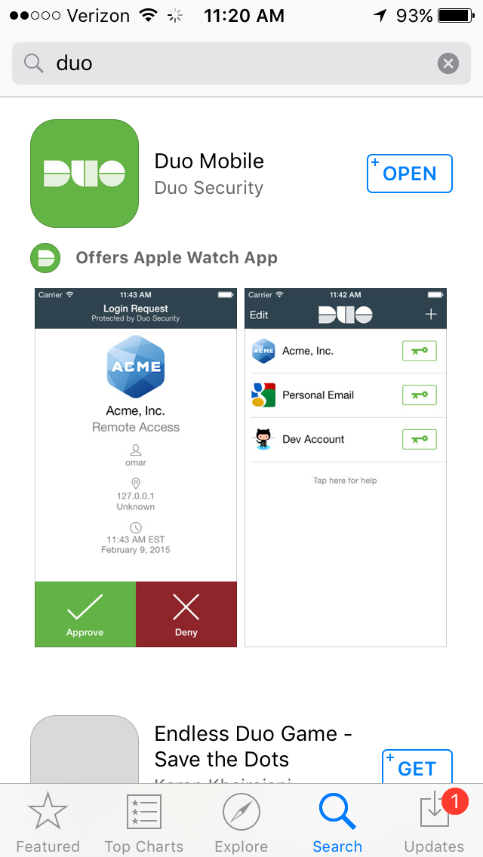

- Sign up for a two factor Duo account on William and Mary’s website https://2f.wm.edu/
Using your campus account, sign up for Duo service as shown below.
- Connect to the website and click Login to W&M
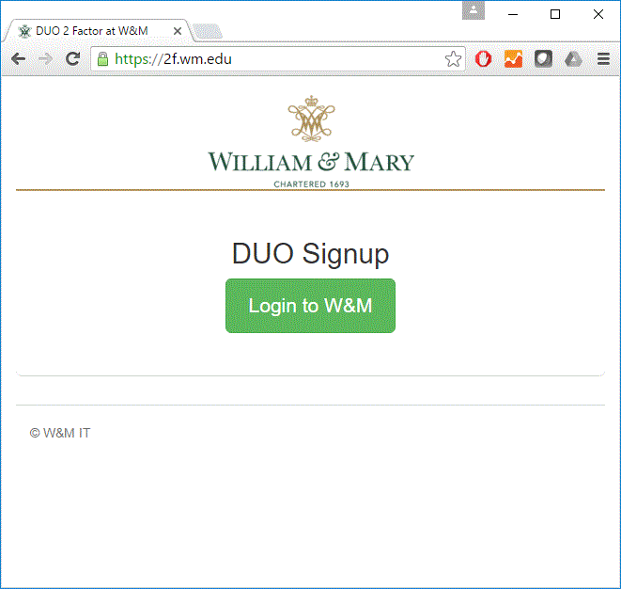
- Click Start Setup
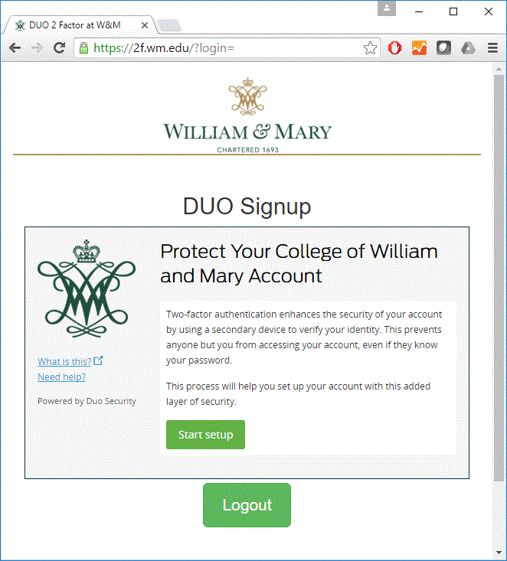

- Identify the device you will use for two-factor authentication and select continue.
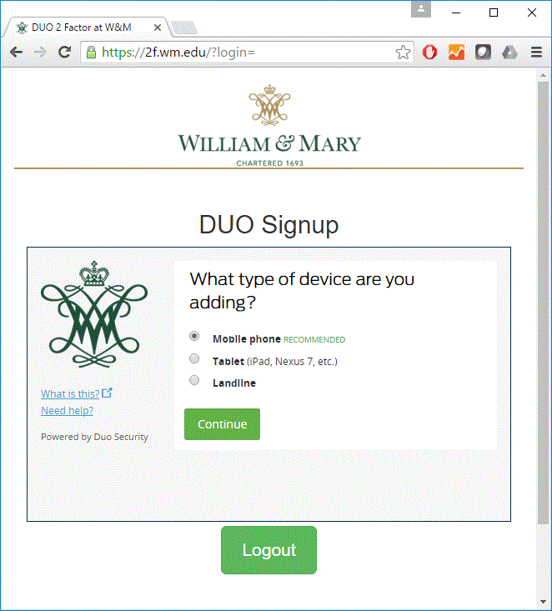
- If you selected “Mobile Phone”, enter your phone number. Follow similar directions for other devices.
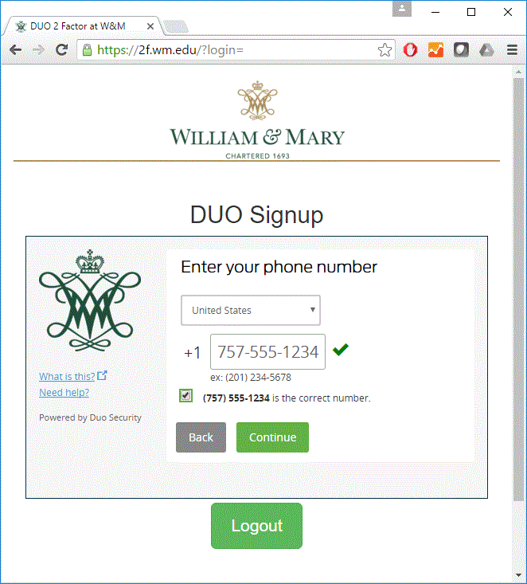
- After entering your phone number, select the type of device and then click Continue.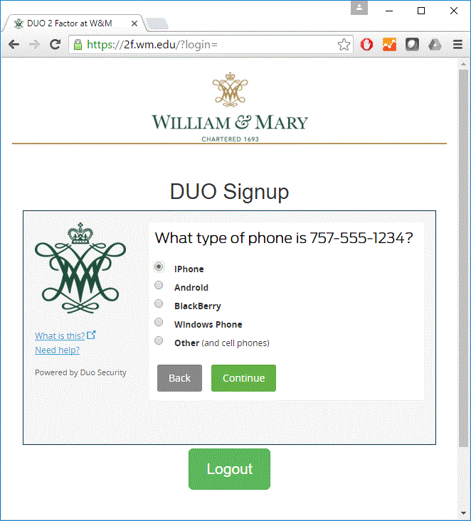
- Once you have installed the Duo Mobile app (completed in step 1), click “I have Duo Mobile installed”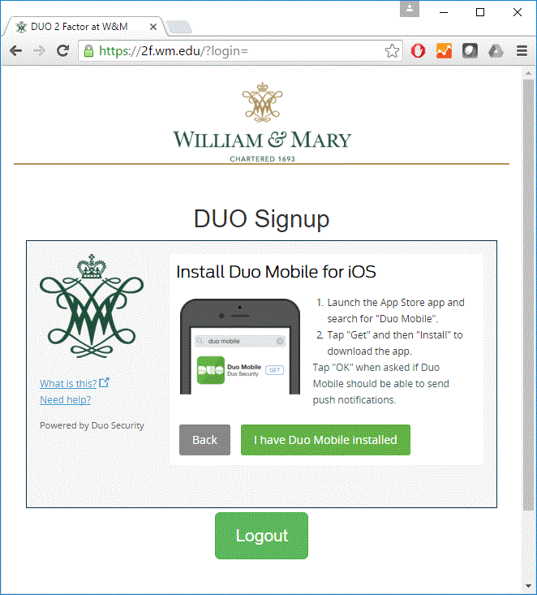
- On your phone or mobile device, open the Duo app and proceed to activate your account by clicking Add Account and then scanning the QR code on the screen. Each code is unique so be sure to only scan your code.
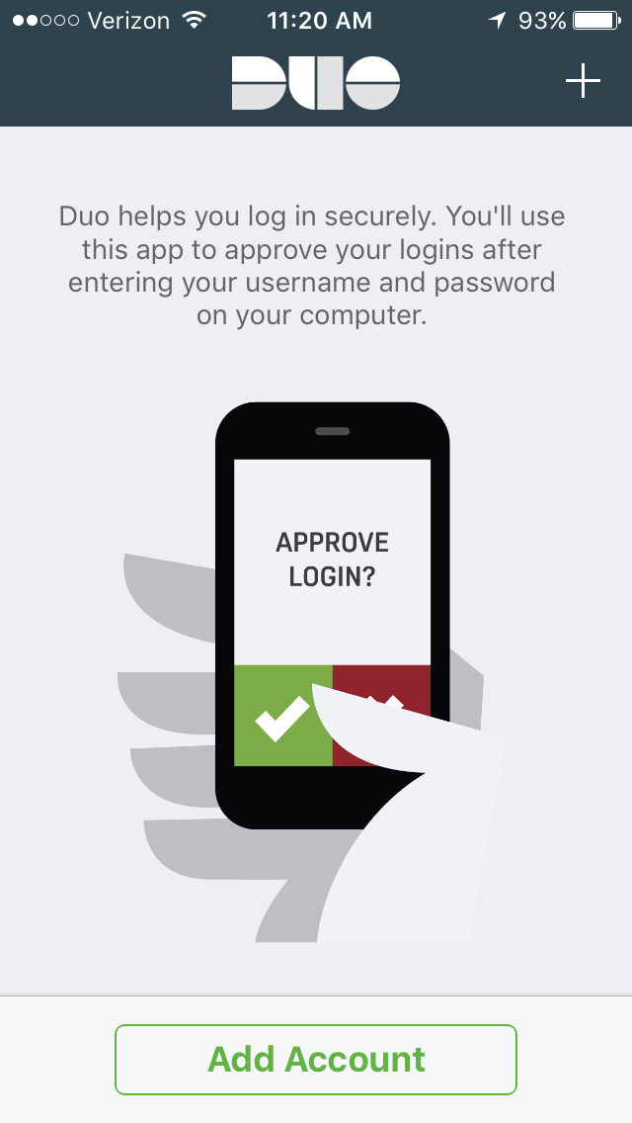 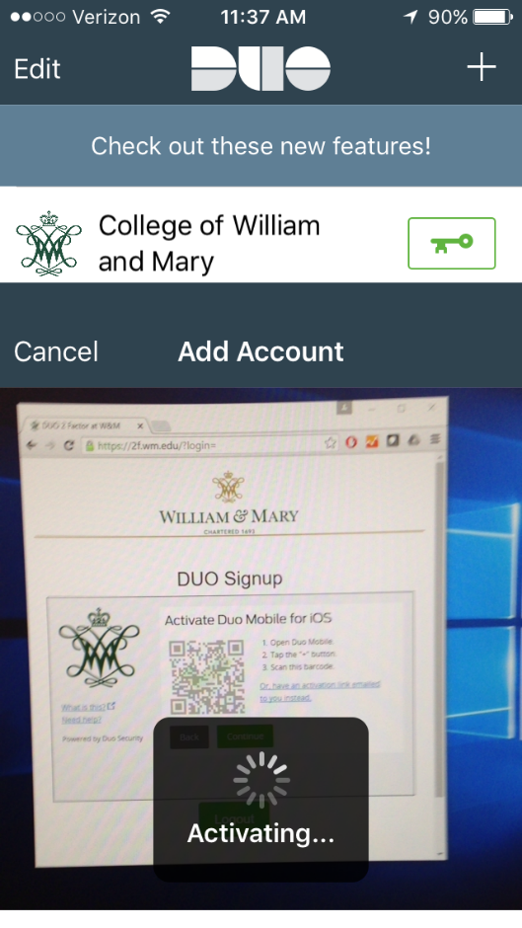
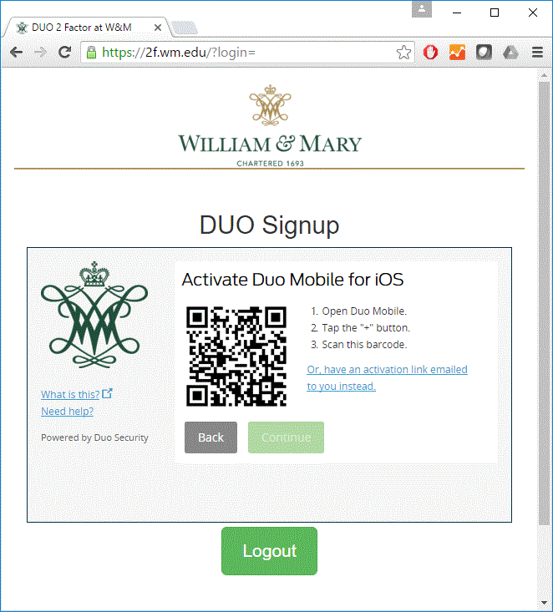
- Congratulations, you have successfully signed up for the Duo mobile service. Check the box to automatically send alerts, select “Duo Push” and then press Save to complete this setup.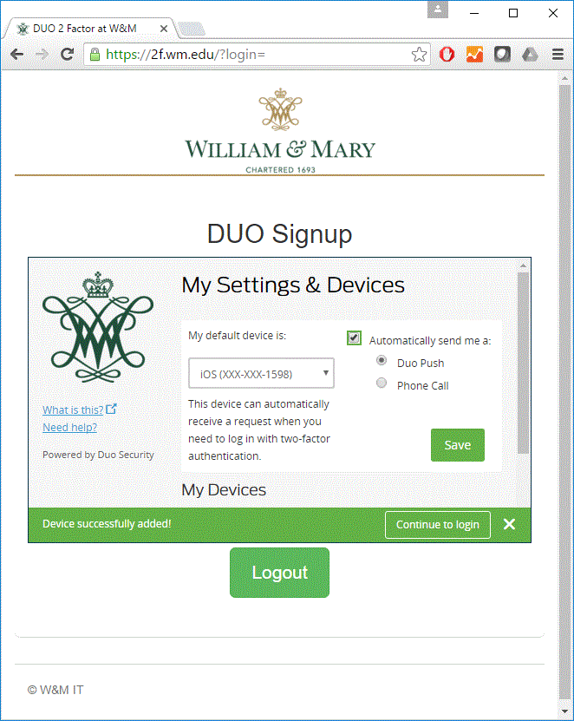

- Download and install the GlobalProtect VPN software from the website https://gp.wm.edu/
- Login with your campus username and password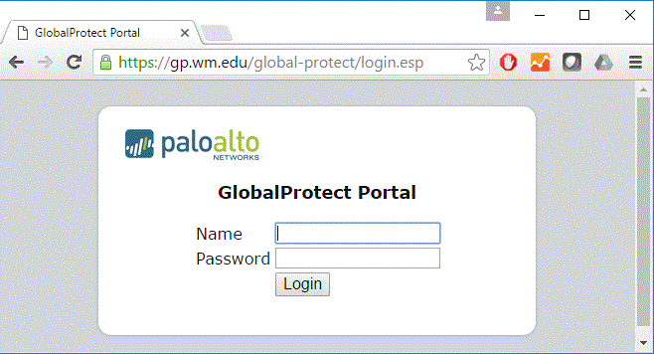
- Based on your operating system (Windows or Mac), download the correct software and run the installer.
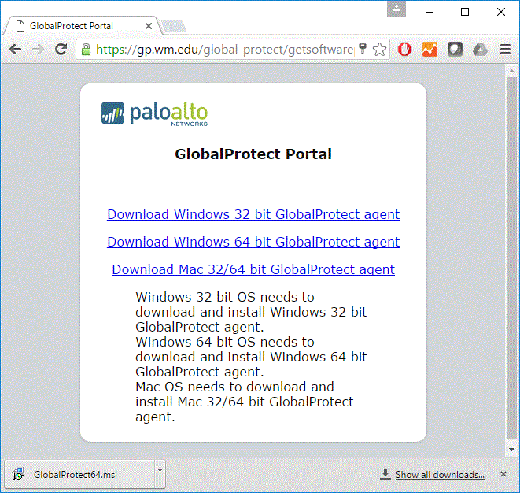
- Follow the install directions of the VPN software by following the wizard as shown below
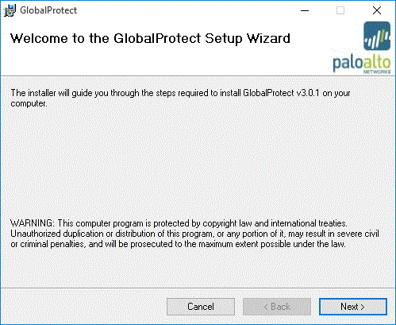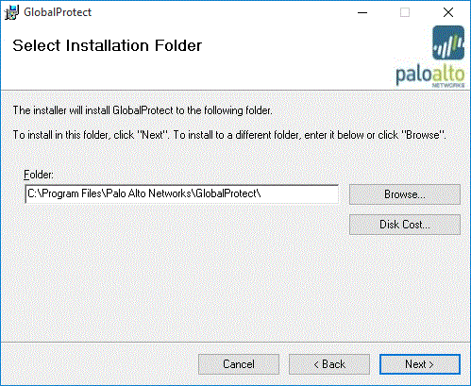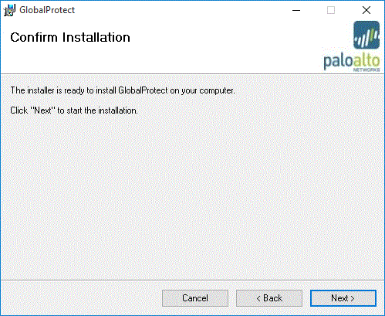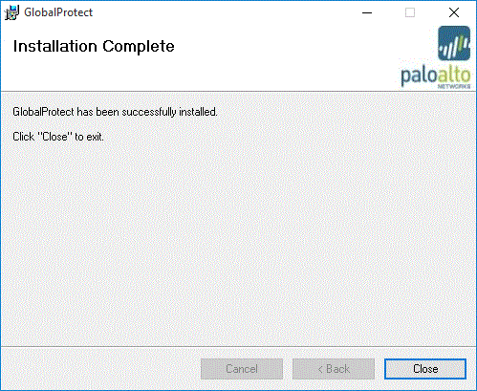

- Connect to the William & Mary VPN using GlobalProtect
- Launch the GlobalProtect software you just installed in the previous step.
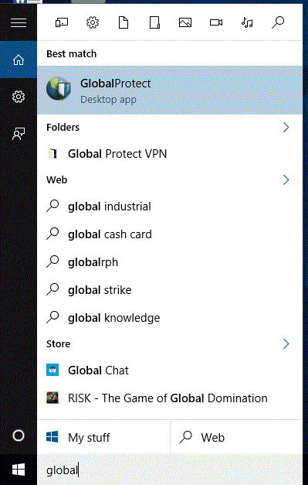

- Enter the following information as shown below and then click Connect:
Portal: gp.wm.edu
username: (your William & Mary campus username)
Password: (your William & Mary campus password)
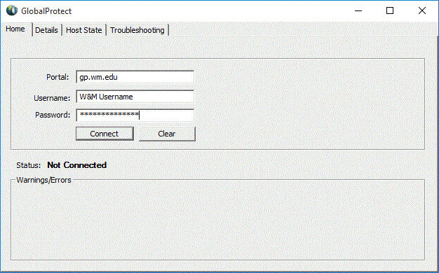
- In this step, you must select a method of sending the second authentication to your phone. The most direct method is to enter 1 in the box and click OK.
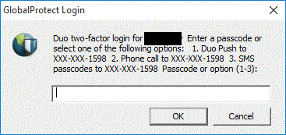
- Upon clicking OK, your phone’s Duo app will be sent a notification, indicating someone with your account is attempting to access William & Mary’s VPN connection. Press Approve to verify you are attempting to connect to the VPN.
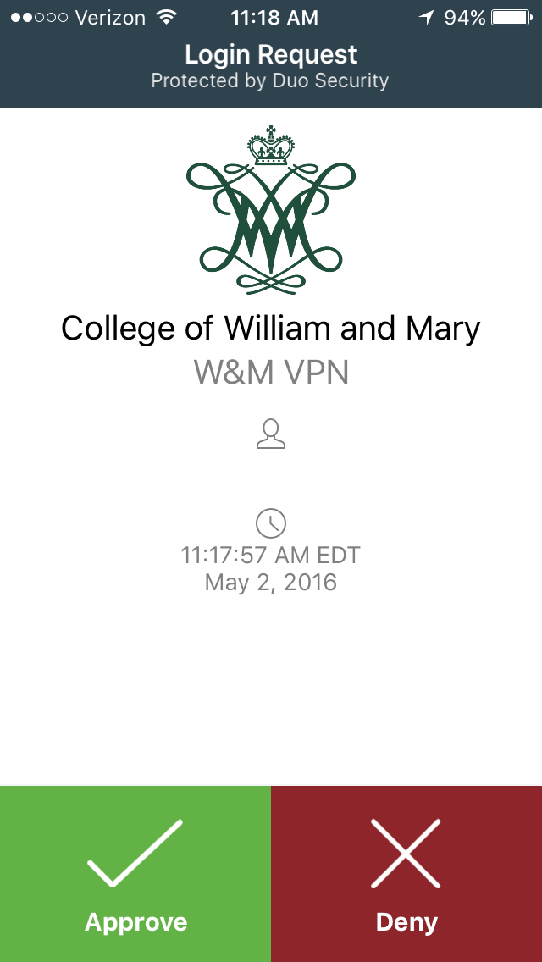

- Once you click Approve, your VPN connection will be established. At this point, you should be able to establish connections to all William & Mary college resources, including those hosted by Google. You are able to confirm your VPN connection by viewing the icon in the taskbar in the lower right corner of your Windows computer.
