Chrome River –Reimbursements for Non-WM Affiliates
Only employees have profiles within Chrome River, for Non-WM Affiliates and students cannot access the system. Therefore, a WM employee will have to process the authorization/reimbursement for the individual.
Only VIMS students will have access to Chrome River, therefore they will be able to process their own reimbursements in the system.
Who is considered a non-employee? Students (WM), student workers, and visiting guests, performers, or speakers.
*Classified, faculty, graduate assistants, and post docs are considered employees.

Step by Step
- Ensure that the Non-WM affiliate is set up in Chrome River for reimbursement.
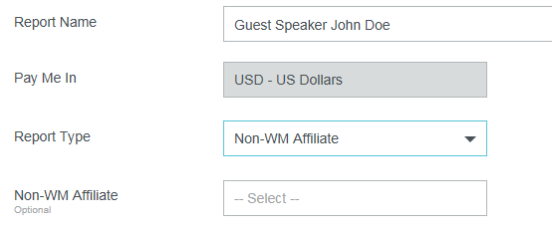
- First, check Chrome River to see if the Non-WM affiliate has already been set up. Go to New Expense Report> Choose Non-WM affiliate under Report Type> Check for the banner ID (930 number) or name of the individual in the drop down box.
- If the individual is not in Chrome River, you will need to submit a request. Obtain a Substitute W-9 and send to apvendors@wm.edu. When requesting a vendor to be
created by AP, you must let AP know the vendor should be entered into Chrome River and verify the address if the individual is existing. AP will contact you when the individual has been created and the Banner Id/Name should populate in Chrome River.

- Complete an Expense Report for the Non-WM Affiliate for approval.
  - Include the traveler’s name in the Report Title. The header MUST include the first and last name, the 93#, and the destination. For example: John Doe 930111111 NewYork, NY.
  - Select the guest from the Non-WM Affiliate dropdown.
  - Process all expense items using the Chrome River expense module.

- Attach Non-WM affiliate’s approval email for expenses.
  - Email the PDF Report of the Expense Report to the Non-WM affiliate for approval.
  - Have the guest “electronically sign” in a reply email. For example: “I hereby certify that all expenses listed here are true and correct to the best of my knowledge and $xxx is the correct amount.” Attach the reply email to the Expense Report, go to Receipts > Upload image.
  - Submit the report.

Covington Travel Pre-approval for Non-WM affiliates
If a Non-WM Affiliate is only requiring airfare from Covington and not seeking additional reimbursements, a paper TA would be feasible to submit to Covington. This will alleviate having to obtain a Substitute W-9 from the guest that are not seeking additional expenses to be reimbursed.

