VA-4 SELF SERVICE DIRECTIONS

- Log in to myWM – Select “Employee” > “Tax Forms”:
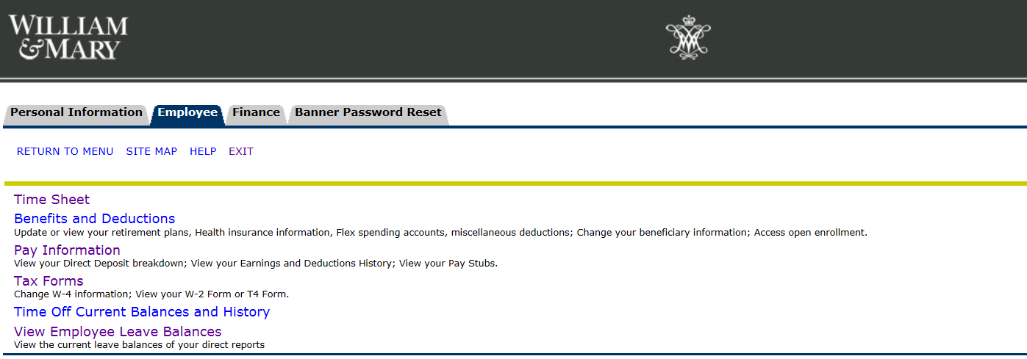

- Select “Electronic VA-4 Submission”
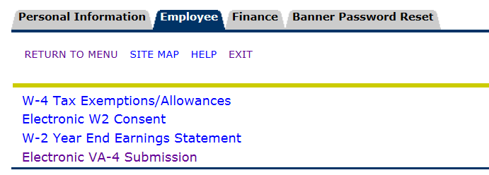

- Read the instructions on the next screen, and if you are ready to continue, select “Form VA-4”
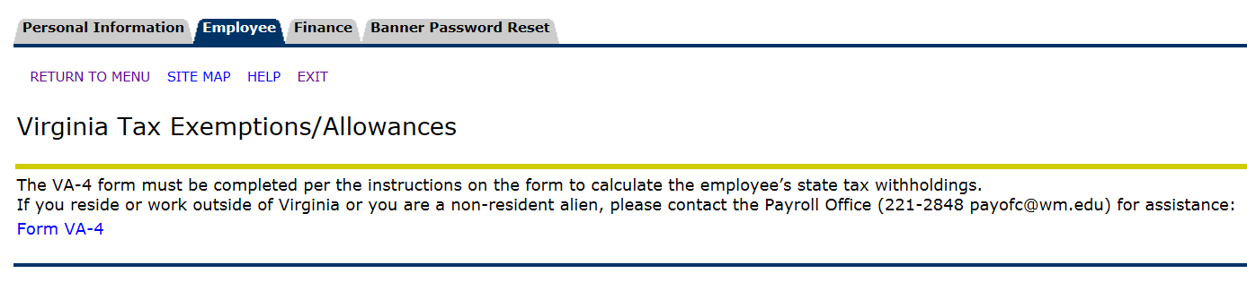

- The DocuSign program will open your Form VA-4. Select “Continue” to access the document for editing.

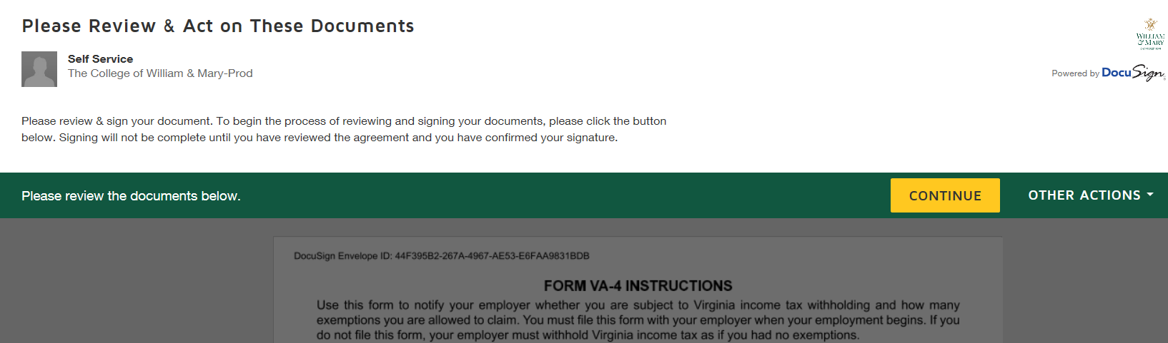

- Review the instructions before completing Form VA-4, paying particular attention to the highlighted fields. Scroll down to the second page to complete the form. All boxes outlined in red must be completed, if the line does not apply to you, enter a zero in the box.

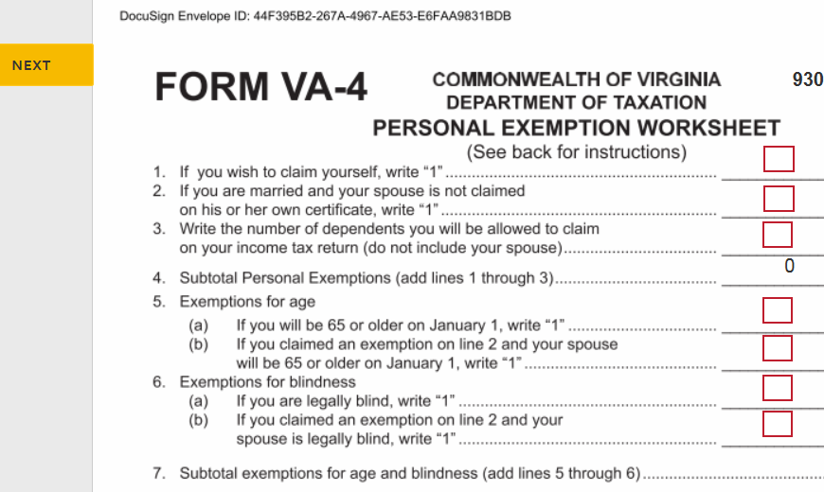

- Your Social Security Number must be entered (with dashes) in the red box at the bottom of the form to confirm your identity. Your Banner ID will appear in the upper right hand corner of the document and your name and address will auto-populate at the bottom.
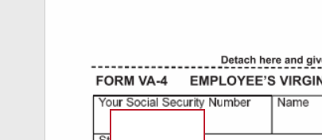

- If you wish to have additional withholding, please enter the dollar amount on line 2 on the lower half of the form and then click on “Sign” to electronically approve the document.

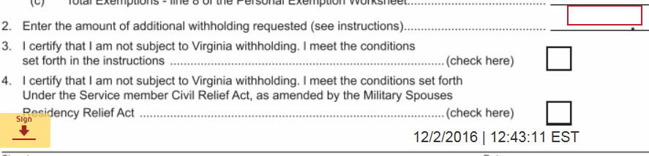

- You will be directed to the certification page, where you must select ONE of the statements to confirm the information submitted.
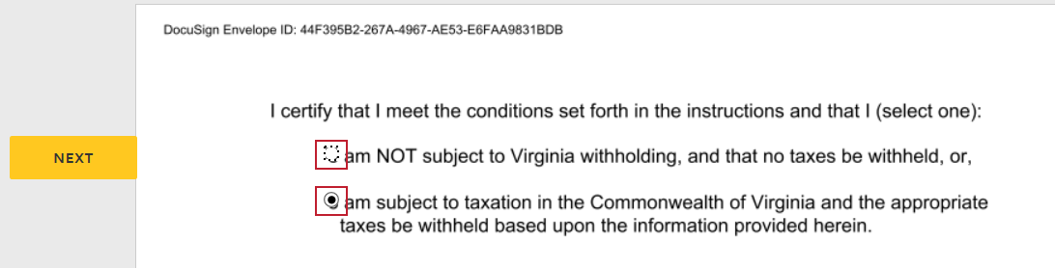

- Once you have confirmed your information, please select “Finish” in the upper right corner of the document.

- You will be directed to the confirmation page, where you may elect to view and print your VA-4 for your records. You may then close out of the program.

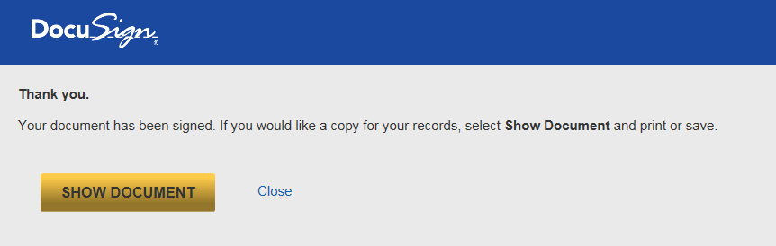

If you have any questions, or require assistance with this form, please contact the Payroll Office at 221-2848.

