Tour the Bill+Payment 7 Homepage
Welcome to your Student Account, where you’ll view, manage, and pay your student bills. Here’s a quick overview of what you can do when you’re here.
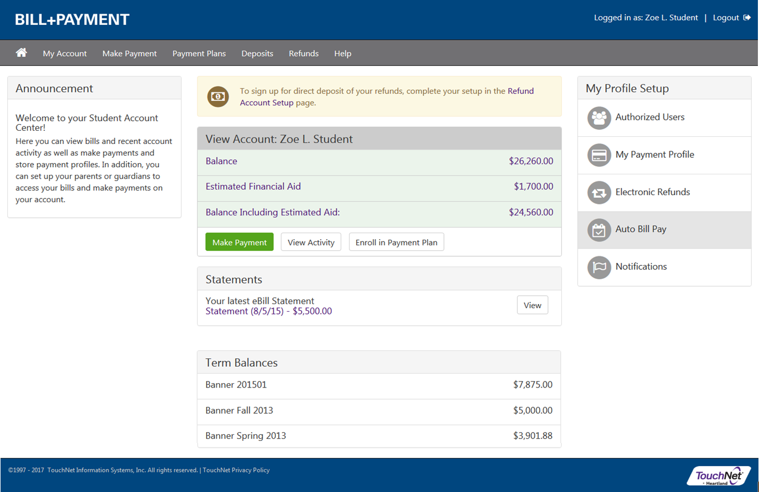
Home page
Your Student Account Home Page is a summary of your Account, where you can:
- Check your account balance (a total of the bills you owe)
- Pay towards your balance
- See important announcements from your school
- View account statements that summarize your bills
- Save payment methods to make future payments easier and faster
- Find links to important profile setup features
- Authorize others to pay bills on your behalf

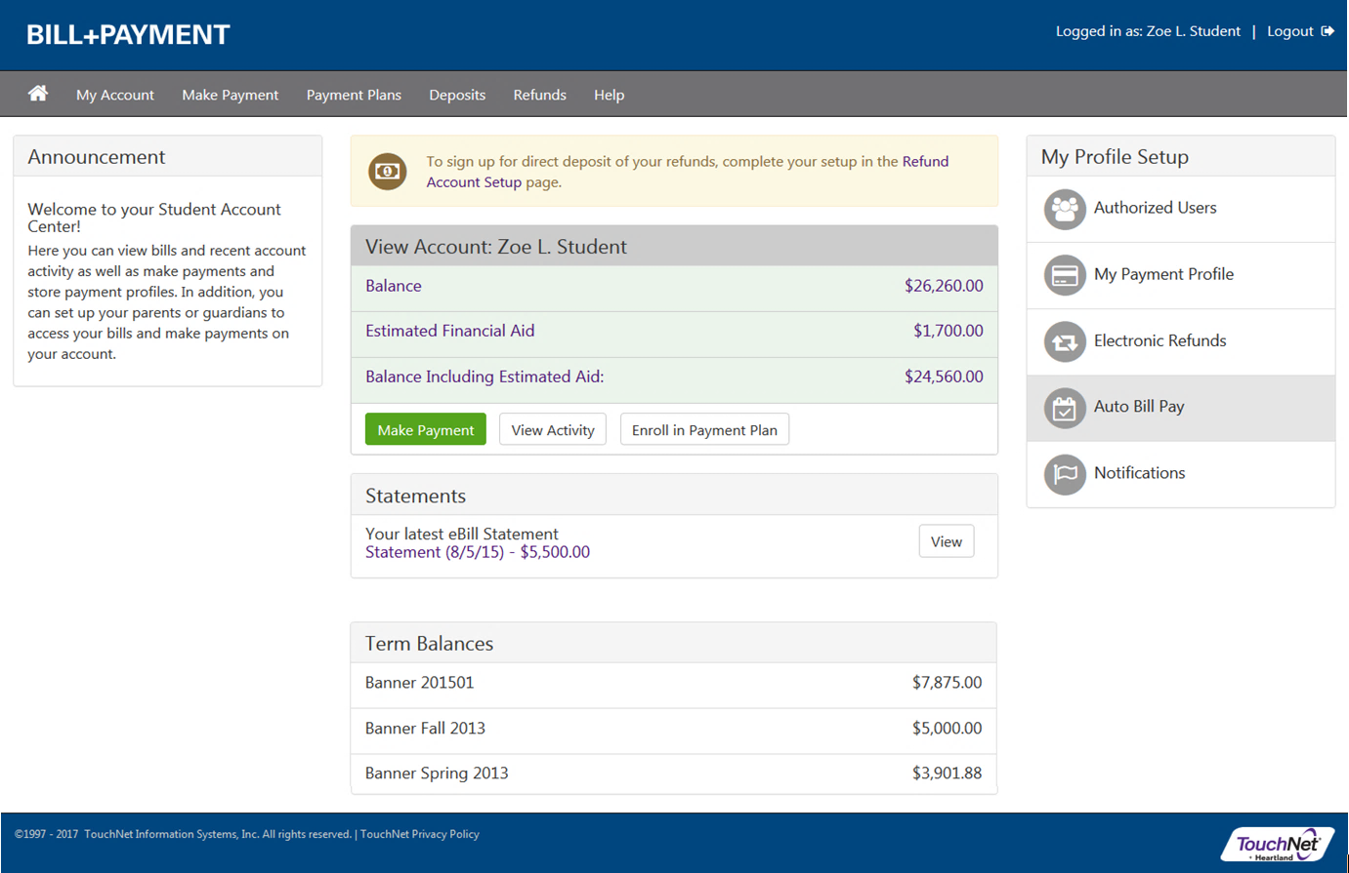
Account Overview
- Announcement – See the Announcement area for information about your campus bills and payments.
- Account Alerts – Watch this space for important messages about your account.
- View Account (Account Balances)
Balance – The total balance you owe, before any Financial Aid is added.
Estimated Financial Aid – Before Financial Aid is officially awarded, you may see your Estimated Financial Aid calculated in this space.
Balance Including Estimated Aid – The total balance you owe, after including Estimated Financial Aid.
Make a Payment – Follow this link to make a payment towards your balance.
View Activity – See all of the bills and payments for your account.
Enroll in a Payment Plan – If your balance is eligible for a payment plan, you may enroll in a plan if one is offered by your school.
- Statements – Your bills and account statements will be listed here. Click a bill description to view the details.
- Term Balances – The balance for each of your terms is listed here. Click the term description for balance details.
Profile Setup
Complete the setup of your Student Account to ensure fast, easy payments and refunds.
- Authorized Users – Give others (like parents) permission to view and pay your bills

- My Payment Profile – Add a payment method to your account to speed your way through future payments

- Electronic Refunds - Add an account for electronic refunds to ensure you get your refunds as quickly as possible

- Auto Bill Pay – Set your account to automatically pay your bill each time a new statement is available

- Notifications – Add a mobile number to your account to get text notifications and updates about your account

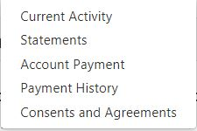
Menu and Navigation
- My Account
Current Activity – All of the charges, payments, and Financial Aid disbursements for your Student Account
Statements – All of your bill statements, along with the amount due and a link to bill details
Account Payment – View of Account Status and Scheduled Payments
Payment History – Any payments that have already been made
Consents and Agreements – Review any online approvals you’ve granted for your Student Account

- Make a Payment – Make a full or partial payment against your account balance

- Payment Plans –View your current payment plan, or enroll in a plan to pay your balance over time

- Deposits – View or pay any required deposits (such as Housing or Enrollment deposits)

- Refunds – Add an account to receive quick refunds, and see a history of your past refunds

- Help – See your options for finding help with questions about your Student Account

