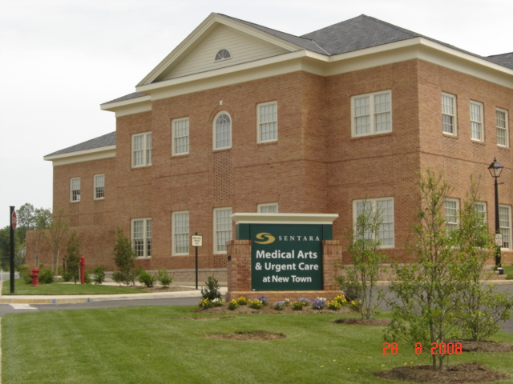

**Newtown Urgent Care**

Newtown Urgent Care

Occupational Health Services

4374 New Town Avenue, Suite 100

Williamsburg, VA 23188

Dr. Levine

Suzanne Wall, Nurse Practitioner

Phone: 757-259-6757

Hours of Operation: 8:30 AM – 5:00 PM

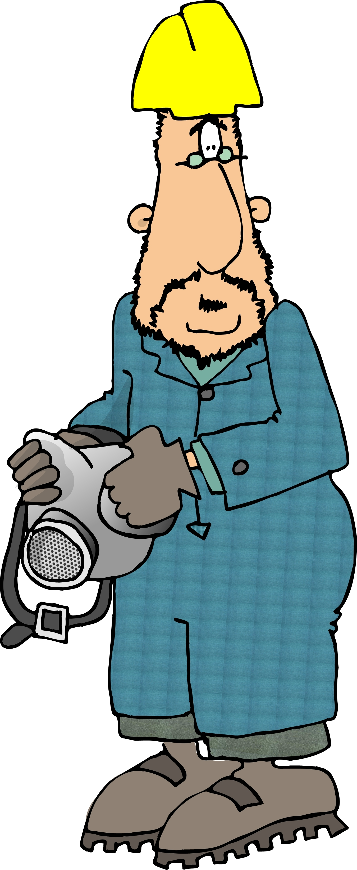



**Respirator Qualification Guidelines**

Note: The Newtown Urgent Care Center is a part of the Sentara Williamsburg Community Hospital (SWCH)

For additional information contact:

Director, EH&S 221-2146

Safety Engineer 221-2288

The Respiratory Protection page can be found at:

<http://www.wm.edu/offices/facilities/services/safety/respiratory/index.php>

For additional information on The College’s Respiratory Protection Program contact:

Sandra Prior, Director EH&S 221-2146

Steve Singleton, RPO 221-2288

The Respiratory Program Plan is available at:

<http://www.wm.edu/facman/documents/Respiratory_Protection_Program.pdf>

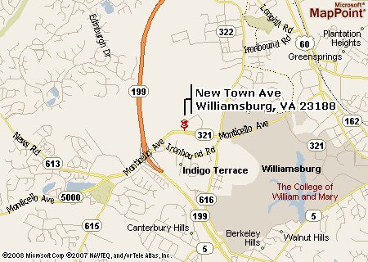

Respirator use at The College of William & Mary can be either *required* by the supervisor or *voluntary* at the employee’s request. In both cases, the decision to wear a respirator is never at the sole discretion of the employee. It is a decision made by the supervisor & EH&S staff only after they have first considered engineering and process alternatives. Once the decision is made, the employee must be *qualified* to wear the respirator before using one on the job. Qualification includes the following:

1. Medical Approval

* Complete the Respirator Medical Questionnaire Form and take it with you to your medical exam. This form is at: <http://www.wm.edu/offices/facilities/services/safety/respiratory/index.php>
* Schedule a medical exam (see back of brochure). The exam includes a review of the questionnaire and breathing test (spirometry). The cost is $50 and is performed by the nurse practitioner. She may also perform an EKG if warranted. The EKG cost is $53.

1. Respirator Fit Testing

* Contact the Respiratory Protection Officer (RPO), Steve Singleton, at 221-2288. The RPO will help you select the correct respirator and perform the fit test. Cost of the respirator and filters will be charged back to your department. There is no charge for the fit test. You may choose to have the fit test done by Urgent Care during your medical exam. The cost is $45.

Note: Medical exam and fit testing costs are paid by the requesting department for both required and voluntary respirator users. Additional/annual exams are not required unless directed by the RPO.

1. Training - provided by the RPO and usually done in conjunction with the fit test.

*Training for voluntary respirator users is an initial requirement only* and consists of providing each user a copy of Appendix D of the OSHA Respiratory Protection Standard. The *training for required respirator users is an annual requirement* and covers:

* the nature and extent of the respiratory hazards to which the employee may be exposed
* an explanation of why engineering controls have not been implemented
* inspection requirements
* proper care, use, storage and maintenance
* selection and fit testing
* limitations of respirators
* recognition of emergencies that would require the use of emergency response respirators
* recognition of emergencies that could arise as the result of wearing a respirator

**Respirator User Responsibilities:**

* use the assigned respirator only for the approved work procedures
* maintain the respirator
* return the respirator when no longer used

**Voluntary Respirator Use:**

At the request of an employee, the supervisor can authorize the voluntary use of respirators when the following conditions have been met:

1. The respirator user must be medically authorized prior to using a voluntary respirator, with one exception. Voluntary respirator

users are not required to be medically approved as long as the voluntary use respirator is used for the sole purpose of escape during an emergency situation.

2. Voluntary use respirators must not be worn in an environment that exceeds any safety guidelines or regulatory requirements.

3. Each respirator user will be provided a copy Appendix D of the OSHA Respiratory Protection Standard.

**Appendix D of the OSHA Respiratory Protection Standard:** (Non-Mandatory) “Information for Employees Using Respirators When Not Required Under the Standard”

Respirators are an effective method of protection against designated hazards when properly selected and worn. Respirator use is encouraged, even when exposures are below the exposure limit, to provide an additional level of comfort and protection for workers. However, if a respirator is used improperly or not kept clean, the respirator itself can become a hazard to the worker. Sometimes, workers may wear respirators to avoid exposures to hazards, even if the amount of hazardous substance does not exceed the limits set by OSHA standards. If your employer provides respirators for your voluntary use, or if you provide your own respirator, you need to take certain precautions to be sure that the respirator itself does not present a hazard. You should do the following:

1. Read and heed all instructions provided by the manufacturer on use, maintenance, cleaning and care, and warnings regarding the respirator’s limitations.

2. Choose respirators certified for use to protect against the contaminant of concern. NIOSH, the National Institute for Occupational Safety and Health of the U.S. Department of Health and Human Services, certifies respirators. A label or statement of certification should appear on the respirator or respirator packaging. It will tell you what the respirator is designed for and how much it will protect you.

3. Do not wear your respirator into atmospheres containing contaminants for which your respirator is not designed to protect against. For example, a respirator designed to filter dust particles will not protect you against gases, vapors, or very small solid particles of fumes or smoke.

4. Keep track of your respirator so that you do not mistakenly use someone else’s respirator.

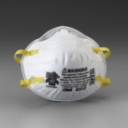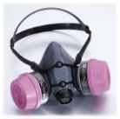**Only NIOSH-approved respirators will be worn at The College of William & Mary.**