The Workstation Ergonomics Self-Assessment is best undertaken by two people e.g. with your supervisor or another employee.
This enables the person to sit at their workstation while a second person observes and assists them achieve the recommended posture.
Item | The Office Chair | Yes | No | N/A | Suggested Actions
1. | Can the height, seat and back of the chair be adjusted to achieve the posture outlined below? |  |  |  | - Obtain a fully adjustable chair
2. | Are your feet fully supported by the floor when you are seated? |  |  |  | - Lower the chair  - Use a footrest
3. | Your knees should be the same height as your hips |  |  |  | - Adjust the chair height  - Use a footrest
4. | Does your chair provide support for your lower back? |  |  |  | - Adjust chair back  - Obtain proper chair  - Obtain lumbar roll
5. | When your back is supported, you are able to sit without feeling pressure from the chair seat on the back of your knees? |  |  |  | - Adjust seat pan  - Add a back support
6. | Do your armrests allow you to get close to your workstation? |  |  |  | - Adjust armrests  - Remove armrests
7. | Hands, wrists and forearms should be straight, in-line and roughly parallel to the floor |  |  |  | - Make needed adjustment to the chair
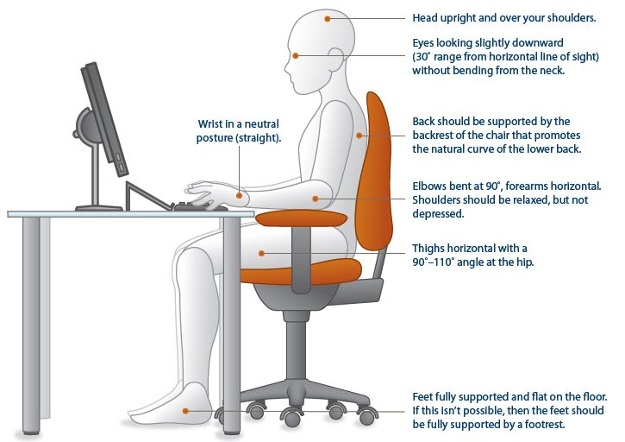

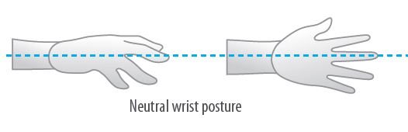

Item | Keyboard and Mouse | Yes | No | N/A | Suggested Actions
8 | Are your keyboard, mouse and work surface at your elbow height? |  |  |  | - Raise / lower workstation  - Raise or lower keyboard  - Raise or lower chair
9 | Are frequently used items within easy reach? (i.e. phone) |  |  |  | - Rearrange workstation
10 | Is the keyboard close to the front edge of the desk allowing space for the wrist to rest on the desk surface? |  |  |  | - Move keyboard to correct position
11 | When using your keyboard and mouse, are your wrists straight and your upper arms relaxed? The keyboard should be flat and not propped up on keyboard legs as an angled keyboard may place the wrist in an awkward posture when keying. |  |  |  | - Re-check chair, raise or lower as needed  - Check posture  - Check keyboard and mouse height
12 | Is your mouse at the same level and as close as possible to your keyboard? |  |  |  | - Move mouse closer to keyboard  - Obtain larger keyboard tray if necessary
13 | Is the mouse comfortable to use? |  |  |  | - Rest your dominant hand by using the mouse with your non-dominant hand for brief periods.

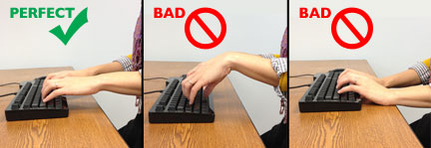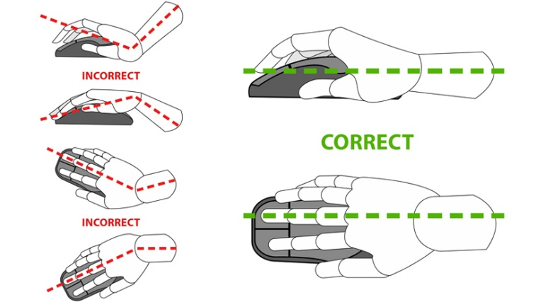

Item | WorkSurface | Yes | No | N/A | Suggested Actions
14 | Is your monitor positioned directly in front of you? |  |  |  | - Reposition monitor
15 | Is your monitor positioned at least an arm’s length away?  Note: the monitor’s location is dependent on the size of the monitor, the font, screen resolution and the individual user e.g. vision/use of bifocal spectacles etc. |  |  |  | - Reposition monitor  - Seek an alternative monitor if necessary e.g. flat screen that uses less space
16 | Is your monitor height slightly below eye level? |  |  |  | - Add or remove monitor stand  - Adjust monitor height
17 | Is your monitor and work surface free from glare? |  |  |  | - Windows at side of monitor  - Adjust overhead lighting  - Cover windows  - Obtain antiglare screen
18 | Do you have appropriate light for reading or writing documents? |  |  |  | - Obtain desk lamp  - Place on left if right-handed – place on right if left handed
19 | Are frequently used items located within the usual work area and items which are only used occasionally in the occasional work area? |  |  |  | - Rearrange worsktation
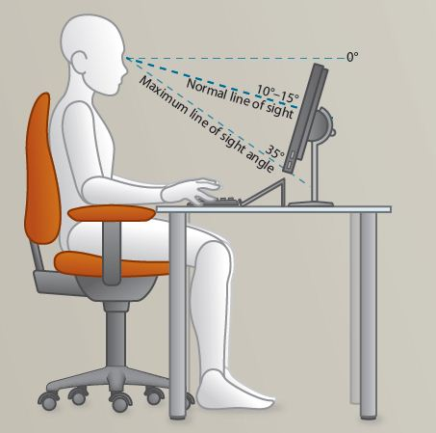

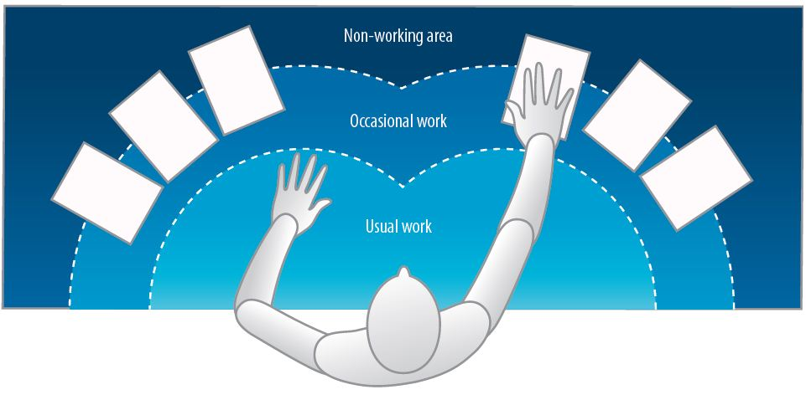

Item | Breaks | Yes | No | N/A | Suggested Actions
20 | Do you take postural breaks every 30 minutes? E.g. standing, walking to printer / fax etc.? |  |  |  | - Set reminders to take breaks
21 | Do you take regular eye breaks from looking at your monitor? |  |  |  | - Refocus on picture on wall every 30 minutes

Item | Accessories | Yes | No | N/A | Suggested Actions
22 | Is there a sloped desk surface or angle board for reading and writing tasks if required? |  |  |  | - Obtain an angle board
23 | Is there a document holder either beside the screen or between the screen and keyboard if required? |  |  |  | - Obtain document holder
24 | Are you using a headset or speakerphone if you are writing or keying while talking on the phone? |  |  |  | - Obtain a headset if using the phone and keyboard
25 | Assess the lighting in the space. If overhead lights are not adequate or turned off is task lighting available? |  |  |  | - Purchase task lamp if necessary
Item | Laptop | Yes | No | N/A | Suggested Actions
26 | In the event of using a laptop computer for prolonged periods of time use of;  - A full sized external keyboard and mouse;  - Docking station with full sized monitor or a laptop stand |  |  |  | - Obtain appropriate laptop accessories

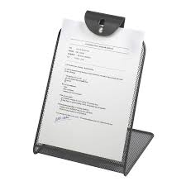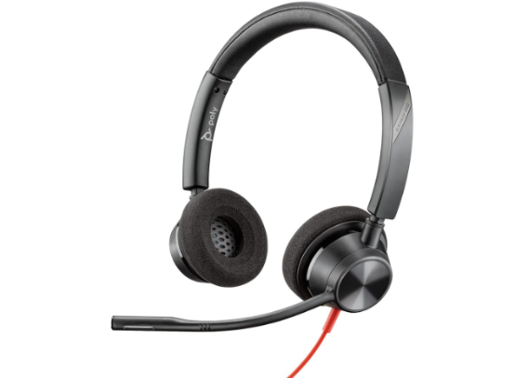

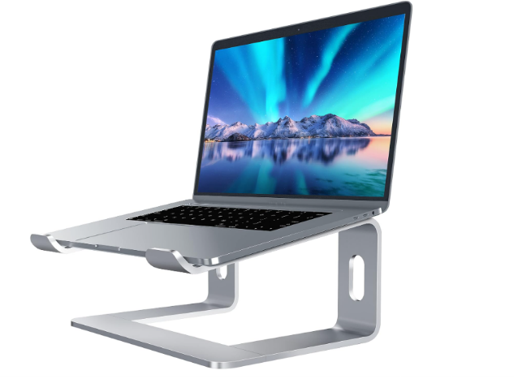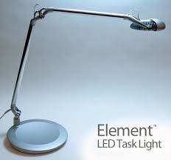

Following completion of this checklist, please discuss any concerns or requirements with your supervisor.

All completed assessments should be submitted to your supervisor.

Changes should be implemented systematically to determine if the change is effective. Allow a trial time of the changes for a minimum of 30 days in order to measure the effectiveness. If after this time period pain or problems continue to persist return this completed form, along with your name and department, to the EH&S office via email to safety@wm.edu

Person Completing Assessment
Name |  | Position
Signature |  | Date

Notes:

