Click the link to schedule meeting with Academic Wellbeing or go to askacademicwellbeing.wm.edu. Upon clicking on the link you will be directed the Central Authentication System. Utilize your William & Mary ID and Password to sign in.
The system may ask if you are a staff or student, please click student.
Once signed in, you will be directed to this screen. To schedule an appointment, click “Request An Appointment” on the top right hand side of the page
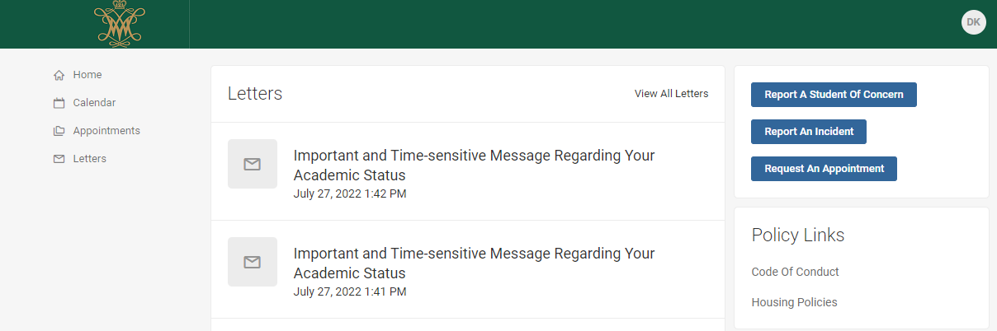
When you click Request an Appointment a list of all topics available for discussion are listed, find the meeting topic that best represents the reason you are meeting and click the box.

The system will then ask how you prefer to meet. For some of our appointments, both options may not be available. If you click “In-Person” it will then bring you to a location page. All in person appointments take place in the Academic Wellbeing Suite in the Sadler Center (Room 181)
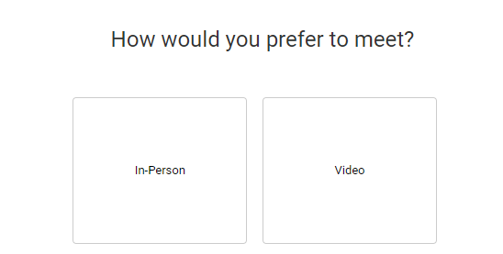

Next, it will ask if there is a particular staff member you would like to meet with. You are able to schedule with particular staff members if you have worked with someone in the past. If this is your first meeting, we encourage you to select No Preference as it will show the most availability of appointments
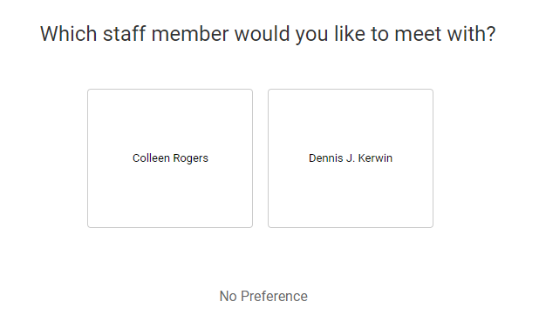

You will then be brought to a calendar of availability. Unavailable dates are greyed out in the calendar and are unavailable to select. Days with availability appear with black text and are able to be selected. If you selected a particular staff member, only their availability will appear. Select the date, and then time you would like your appointment to begin and press Next in the bottom right corner.
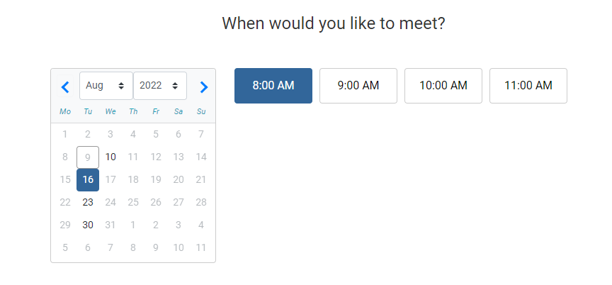
Next will bring you to the confirmation screen for your request. There is a box for you to type in to explain what in particular you are looking for in this appointment. Please be as detailed and specific as you can so our staff is best prepared. Once completed, hit submit in the bottom right corner.

Once you click submit, a requested appointment summary will appear. Shortly after, you will also receive an email to your WM Outlook Email Address that your appointment request has been received. Please note that these are tutoring requests. Once the staff member has reviewed your request they will then either confirm or deny the appointment.
Common reasons for denial:
- You requested less than 48 hours in advance.
- An emergency has risen and the staff member is not available during that time.
Once confirmed, you will receive a confirmation email. It is only once you have received that confirmation that your appointment is confirmed and set for the time you requested. Please read the entire confirmation email as it will confirm location, as well as any notes the staff member may have of you.
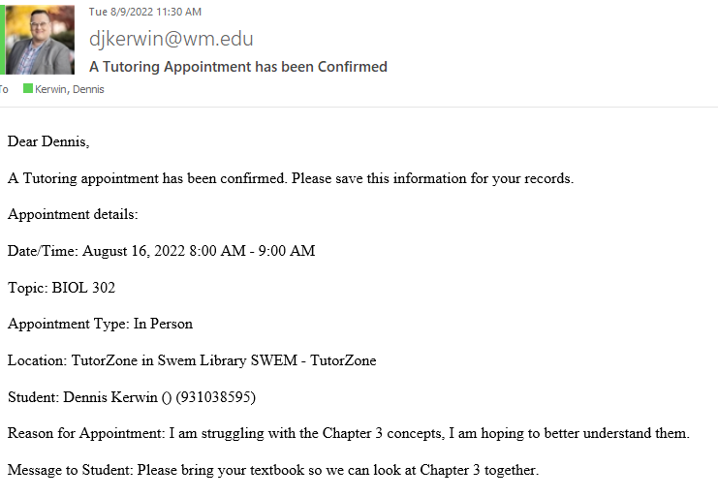

Please be sure to be on time for your appointment. All tutoring sessions are one hour in length, if you need more time, please request a second appointment.

