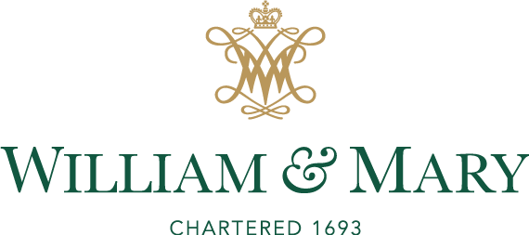
Financing Study Away Programs & Financial Aid Information
The Financial Aid Office wants your experience to be memorable and trusts that you will follow all steps necessary to ensure a smooth process.

Undergraduate students planning to study abroad must first be registered with the Global Education Office Graduate students interested in study abroad should contact their respective schools.
If you are planning to study abroad, meet with your financial aid counselor in the Office of Student Financial Aid to be sure that you understand how financial aid works with Study Abroad. It takes time to work out the details, so meet early in the semester before your study begins! The Free Application for Federal Student Aid (FAFSA) should be filed on-line at www.fafsa.ed.gov by April 1 for the upcoming school year. An academic year begins with the fall semester and ends with summer session.

Financial Aid will advise you of your financing options for your program of study. The Financial Aid Office does not meet payment deadlines set by the host or sponsoring institution. If the program starts around the same date as the College’s semester, your funds will be disbursed on the same schedule for students remaining at W&M.

If using a 529 or Prepaid College savings Plan, make sure of the fund eligibility by checking with your Plan Provider. You do not want to end up abroad without resources to pay for the program.

In order to receive aid for your study, you must register with the Global Education Office, and complete and file a Financial Aid Disbursement Form and a Study Abroad Consortium Agreement (see pp. 2 and 6 for details).

All students studying abroad, even if they are participating in a W&M faculty-led program, need the Consortium Agreement completed. If you submit your form to an external institution or agency, have them fax the Consortium Agreement containing program start dates, cost, and required signature, to the Global Education Office (757-221-3594). You are encouraged to call the Financial Aid Office to confirm that your Consortium Agreement has arrived two weeks after you submit it to host institution. Remember that you need to be enrolled full-time to receive your financial aid! If you fail to maintain full-time status, your aid may be lost.

Your counselor will determine the amount of aid you are eligible for during the semester you are abroad. Grant eligibility may decrease if total cost of attendance is less than the standard William & Mary cost of attendance.

Your financial aid award may be adjusted based on the budget collected from the visiting school/program. Funds are not released until verification of registration is received and budgets are adjusted. A consortium agreement is required for all programs of study. Financial aid is available for programs approved by the appropriate department. The amount of grant will not exceed what would have been received for attending the semester or year at William and Mary.

Plan ahead to meet all applicable deadlines to ensure prompt disbursement of financial aid. The Financial Aid Office is available to answer and clarify your financial aid questions and concerns. Feel free to schedule an appointment to discuss these concerns. Late registration with the appropriate offices will affect the timeliness of aid being processed.

You must adhere to all payment deadlines set by the visiting institution. The College will not release a refund to a 3rd party institution or program. In most cases, programs accept confirmation of aid awarded in place of actual payment. However, the programs are not obligated to do so. Therefore, you should consider all financial obligations prior to making a commitment to study away. To avoid further delay, be sure the Student Accounts Office has on file a forwarding address for all refunded aid to be used for your program of study. Study abroad is a lifetime opportunity that the College supports.

Note: Similar procedures apply to undergraduate students studying in off-campus domestic programs. In most cases, the approving office will be the University Registrar’s Office.

Office of Student Financial Aid
124 Blow Memorial Hall

Financial Aid and WMDC

- Paying for William and Mary DC programs:

WM DC | Grants  FAFSA required | Loans  FAFSA required | TPP  Tuition Payment Plan | *Pre-paid plans | DC TAG
W&M Semester  Programs | Yes | Yes | Yes | Yes | Yes
W&M Fall  Seminars incl winter | No | Yes | No | No | No
W&M Spring  Seminars | No | Yes | Yes | Yes | Yes
W&M Summer  Sessions 1,2 | Pending on the availability of funds | Yes | No | No | No
W&M Summer  Institutes | Pending on the availability of funds | Yes | No | Not  Advised | No

- WMDC provides information on the tuition, fees and anticipated expenses, including airfare to Financial Aid. Once students complete WMDC document identifying the program they wish to attend, an initial list sent to W&M Financial Aid.

Upon registering for the above 1-credit course, a $250 course fee appears on the student’s account.

3, Disbursement Process

For W&M DC summer and semester programs: financial aid is disbursed and transferred to WMDC program accounts by the Bursars’ Office.

For all other WMDC programs, students may receive a refund and pay WM DC directly.

PLEASE NOTE: Disbursements are made no earlier than the start of classes for the regular WM semester calendar. For programs beginning after that date, disbursements will occur on the first day of the study abroad program. Students should be prepared to pay fees, airfare, etc. before receiving their financial aid disbursements.

- Scholarships for WMDC programs

- The Charles Center offers some grants for students who do research projects abroad.
These are need-based scholarships, which rarely cover the entire cost of the program.
- WMDC provides some need based scholarships.

