DATE | TIME | EVENT | LOCATION | DESCRIPTION
9/5/2026 | 11am – 2pm | Introductory ride to New Town | Depart from Sadler Terrace | Ride with us to Sweet Frog in New Town!  6-8 mile round trip
9/19/2026 | 9am – 1pm | Family Weekend Ride | Depart from Sadler Terrace | Bring your family and join us as we ride to Spoke N Art Café!  13–15mile round trip
10/24/2026 | 9am – 1pm | Homecoming Group Ride | Depart from Sadler Terrace | Waller Mill Park Loop  10 mile ride
11/7/2026 | 9am – 1pm | Chickahominy River front Park Ride | Transportation to the park will depart from Sadler Terrace | Chickahominy River front park ride to Cul’s Courthouse Grill and back to the park  30 Mile ride
8/31/2026  9/14/2026  10/19/2026  11/2/2026  11/16/2026 | 3 PM – 5 PM |   Mechanical Mondays | Fix-it Station near Integrated Wellness Center & Sadler Terrace  (The Daily Grind) | Does your bike need some fixing? Let us take a look at it! Co-sponsored by the Williamsburg Co-op
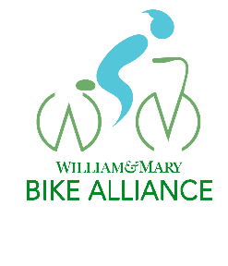
W&M Bike Alliance Fall 2026 Schedule

Contact info – Matthew Nelson menelson01@wm.edu (757)-221-5659


