

Department of Religious Studies

**NEWSLETTER**

2017-18/FALL 2017/Volume 18

In recent years, the Department has welcomed three new Assistant Professors and two new Lecturers in Religious Studies. As 2017 draws to a close, we celebrate the careers of two long-time and beloved members, Julie Galambush and Tammy Cooper, who are now retiring.

Julie Galambush joined the Department in 1993 after four years at St. Olaf College, becoming William and Mary’s first woman professor of Religious Studies. Prof. Galambush established herself as a leading authority on the Hebrew Bible, particularly the books of Genesis, Ecclesiastes, and Ezekial. The latter served as the focus of her first book and several research articles. Her farthest-reaching work is her 2005 opus, *The Reluctant Parting: How the New Testament’s Jewish Authors Created a Christian Book.* With this engagingly written and eruditely researched book, she achieved both scholarly and popular success. Prof. Galambush will be acutely missed in her role as teacher and mentor to generations of William & Mary students. Her Israelite History and Religion and upper-level courses on the Hebrew Bible challenged countless students to examine the literary nature of religious traditions. Her keen interest in student learning and in students’ lives built relationships that span decades. Prof. Galambush’s colleagues will remember her for her dedication to faculty governance—she served for years on a myriad of important Department and Arts & Sciences committees—and, perhaps more importantly, as a trusted and dear friend.

Tammy Cooper has been at the heart of Religious Studies for nearly thirty years; at her retirement this month, she is our longest serving member. Tammy has supported decades of students as they passed through the Wren with her clear advice and compassion. We faculty find it hard to imagine how the Department will function without her. With her vast knowledge of every nook of the College, she has guided each of us through every imaginable obstacle. A sign in her office reads, “Google must be a woman because it knows everything”; we consult Tammy more than Google and owe her our lasting gratitude. Those of us who have chaired Religious Studies have had the daily benefit of Tammy handling most every administrative task, always a step ahead of any problem. While we have borne the title of Department head, Tammy has made Religious Studies run. We will miss her deeply and wish her the best on her well-deserved retirement.

Kevin Vose

Chair, Religious Studies Department

Kevin Vose

Chair, Religious Studies Department

Kevin Vose

Religious Studies Department Chair

# Greetings from the Chair

**Contents:**

**• Page 2:** Faculty Changes

**• Pages 2-4:** Faculty News

**• Page 4:** Spotlight on New Faculty

**• Page 5:** Alumni News

**• Page 5:** New Initiatives

**• Page 6:** Lectures

**• Page 6:** Donor Opportunities

**• Page 6:** Religious Humor

**• Page 7:** Fall 2016 Courses

**• Page 7:** Spring 2017 Courses

## Faculty Changes

Faculty

Publications

On Leave Academic Year 2017-2018

**Annie Blazer**

On Leave Spring 2018

**Faraz Sheikh**

**Patton Burchett**

Visiting Faculty, 2017-2018

**Robin McCall:** PhD, Princeton Theological Seminary; teaching History and Religion of Ancient Israel (F’17, S’18), Fr Sem: Sympathy for the Devil (F’17), Elementary Biblical Hebrew (F’17, S’18),

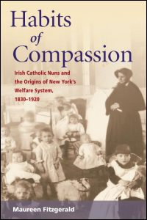

## Faculty News

**Alexander Angelov:**

**Annie Blazer:** Professor Blazer was one of five recipients of the Alumni Fellowship Award for excellence in teaching in 2017. She continues to be involved in educational initiatives at the College by developing courses for the COLL curriculum, teaching online, and developing a team-taught course as a W. Taylor Reveley, III Interdisciplinary Faculty Fellow. Over the past year, Prof. Blazer shared her research from her 2015 book, *Playing for God: Evangelical Women and the Unintended Consequences of Sports Ministry*, in multiple venues including a campus lecture at University of Tennessee-Knoxville, a keynote address for the Christian Society for Kinesiology and Leisure Studies, and a paper presentation at the annual meeting of the International Society for the Sociology of Religion. During her 2017-2018 research leave, she has started a new research project investigating the effects of rapid gentrification on religious communities using the neighborhood of Church Hill in Richmond, VA as a case study.

**Patton Burchett:** This past year, his second at William & Mary, Patton Burchett taught “Introduction to Hinduism” and “Yoga and Tantra” in the fall and was on Family Leave in the Spring, taking care of his (then six-month-old) daughter Cate. The manuscript for his first book, tentatively titled *A Genealogy of Devotion: Bhakti, Tantra, Yoga, and Sufism in North India*, is currently under review with Columbia University Press; Patton is optimistic that it may be published there by Fall 2018.

Patton has taken the lead in the department’s Programming Committee (on which, see “Spotlight on Faculty – Student Research” below). In this capacity, he has planned a variety of events including campus-wide lectures by invited scholars and “brown bag lunch” presentations by our own faculty, faculty in other William and Mary departments who work on religion, and by our own student majors.

**Julie Galambush:**

**Maggie Fraser Kirsh:**

**Mark McLaughlin:**

**Marc Lee Raphael:** Marc Lee Raphael continued his pattern of teaching one new course every semester, and in the spring the students read Talmud and in the fall they learned about the history of God. Between the two courses, he led a Study Tour (also COLL 300) of the Third Reich, National Socialism and the Jews to five cities in Germany and the Czech Republic. He will repeat the Study Tour in the summer of 2018 while preparing to teach his final new course, Introduction to Jewish Mysticism.

**Faraz Sheikh:**

**Kevin Vose:** After chairing the department for a second year, Kevin Vose spent a month of the summer in Vienna as a Visiting Fellow at the Austrian Academy of Sciences’ Institute for the Cultural and Intellectual History of Asia. While there, he worked with Academy member Pascale Hugon on editing and translating a twelfth-century Tibetan philosophical manuscript and gave two research presentations; he also became acquainted with many excellent ways to eat a pig. He wrapped up the summer with a trip to Toronto for the International Association of Buddhist Studies’ triennial conference, where he presented research from his book-in-progress on Indian and Tibetan Buddhist traditions of rational inquiry.

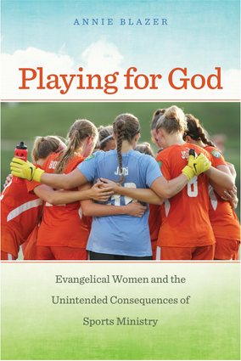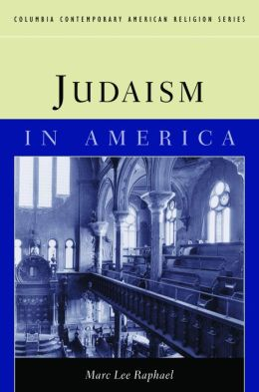

Faculty

Publications

## Faculty News Continued

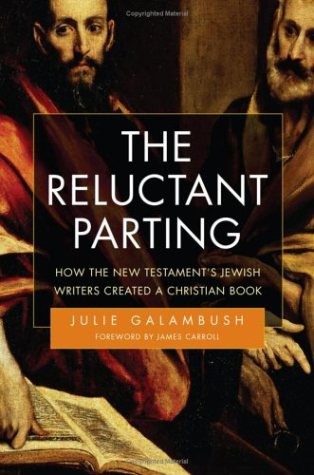

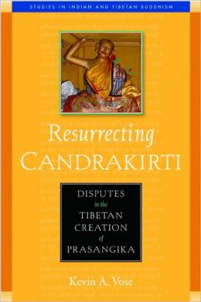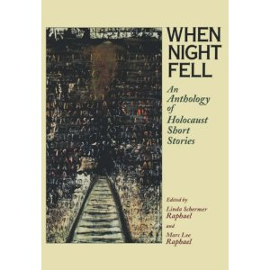

## Faculty News Continued

Faculty

Publications

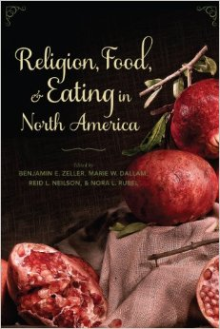

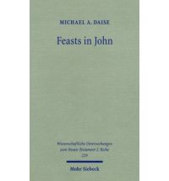

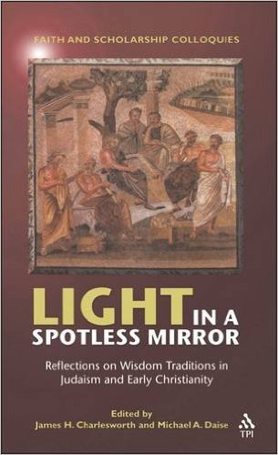

Thomas Smith (’93): Following a 20 year career in executive arts administration, and the founding of a property redevelopment company in 2013, he has recently been appointed Major Gift Officer for the Drake University Law School.

Rachel Hamberger (’03): Rachel finished up her coursework for a PhD in Special Education and she will be working on her dissertation. Rachel is the Preschool Supervisor for Falls Church City Public Schools.

Derek Turrietta (’89): In October 2015, he was awarded a Masters of Theology from Saint Leo University. Additionally, Derek was also ordained a Roman Catholic deacon by Bishop DiLorenzo of the Catholic Diocese of Richmond in October 2015 and he’s currently assigned to Blessed Sacrament Catholic Church in Norfolk, VA.

Religious Studies last year began a forum to showcase current research in the broad field. Patton Burchett has taken the lead in forming the department’s Programming Committee, on which Alex Angleov, Oludamini Ogunnaike, and Faraz Sheikh have served. The committee aims to promote conversation about department members’ research and that of William & Mary faculty in other departments who work on religion and to create an intellectual space outside of the classroom for our majors and minors to interact with us and to develop their own self-confidence as young scholars.

The committee has also begun planning a multi-year annual speaker series tentatively entitled "Religion and Public Life" which will focus on religion and contemporary politics (particularly in America, but also globally); diversity in religious communities; and public discourses on religion and science. Given the current social and political climate, with Islamophobia, anti-Semitism, and (more generally) fear, hostility, and misunderstanding toward ethnic and religious "others" all too prevalent, the time is ripe for a speaker series of this sort. This series will bring in speakers from outside William & Mary and will dovetail with our faculty and student presentations. These events will foreground on campus the importance of reasoned inquiry and clear expression concerning religion and promote respectful conversation. We envision that the series will have a meaningful impact on students and the larger campus and Williamsburg communities. We hope to support this annual series by raising a fund that will be dedicated to its continuity in perpetuity.

In keeping with our vision for the format, we held four events in 2017. In March, three senior majors presented their research from their senior thesis projects. Meghan Downey utilized ethnographic research conducted among her peers to study the effectiveness of W&M’s orientation programs on promoting appreciation of religious, gender, and sexual diversity. Abigail MacMillan examined projects in Saudi Arabia and Morocco to promote and export competing visions of Islam, investigating how Morocco’s imam training program presents itself as the champion of a “moderate Islam” in response to Saudi Arabia’s more conservative version, in an attempt to gain the support of western governments. Finally, Paul Stein presented his investigation of the “Q-hypothesis” for understanding the Synoptic Gospels.

In the fall, Julie Galambush (in her final semester of teaching) reflected on what her decades of research on Ancient Israel and now Mesopotamia have taught her about the role of religious texts in forming communities’ notions of political rule. Our annual keynote speaker came in October: Kerry San Chirico from Villanova University spoke on “Khrist Bhaktas,” devotees of Christ in the Hindu heartland of India whom the region’s Catholic Church does not recognize for the “Hindu” form of their worship and are held in suspicion by Hindus for the object of their devotion. Finally, Jonathon Glasser from William and Mary’s Anthropology Department capped off the year with the talk, “What Music Can Teach Us About the Muslim-Jewish Interface in North Africa.” Prof. Glasser drew on his fieldwork and archival research on poets, singers, and musicians in Algeria to show how these artists draw on common musical and poetic resources that speak more to their unity than their respective differences—offering a very different picture of the lived experiences of Jews and Muslims than can be gained from political and economic evidence.

All told, the project’s second year was a terrific success. Please let us know if you’d like to participate in any way.

## Alumni News

## Spotlight on Forum for Faculty – Student Research

Keep up with Religious Studies news all year long! Like us on Facebook to see faculty and student accomplishments, departmental events and more!

## New Initiatives ?????

Fall 2016 Courses

Thanks to the generous donations from our friends and alumni*, the department is able to sponsor lecture series and host events for our concentrators. Here are highlights from our 2016/17 schedule:

**10/4-6/16: Alan T. Levenson**

Professor, Univ of Oklahoma. **“Mendelssohn: Medieval or Modern?”;** **“The Return of Rachel in the Bible”; “Joseph: Sage or Despot?”; “Misdirections: Hannah in the Bible and Talmud”; “Samson Raphael Hirsch and the Invention of Modern Orthodoxy”**

**10/13/16: Brantley W. Gasaway**  Professor, Bucknell Univ., PA. **“Beyond Belief? The End of White Christian America”**

**11/03/16: Fred Reiner**

Rabbi Emeritus, Temple Sinai, Washing DC. **“Samson and Delilah – A Fresh Look”**

**11/10/16: Benjamin Gordon**

Professor, Univ of Pittsburgh, PA. **“Ritualized War and Israelite Mythmaking in Joshua 6-7”**

**11/10/16: Richard Miller**

Professor, Univ of Chicago, IL. **“Religion, Medicine, and the (Perilous) Care of Children”**

**11/10/16: Matthew Klein**

Cantor, Congregation Beth El, Bethesda, MD. **“Conservative Judaism”**

**11/17/16: Farideh Goldin**

Assist. Professor, Old Dominion Univ., VA. **“Growing Up in Iran as a Jew”**

**11/22/16: Daniel Zemel**

Rabbi, Temple Micah, DC. **“Reform Judaic Thought Today”**

**2/14/17: Maggie Kirsh**

PhD, Univ. of Wisconsin, **“Young Jewish Voices from Interwar Poland”**

**2/17/17: Martha Nussbaum**

Ernst Freund Distinguished Service Professor of Law and Ethics, Univ. of Chicago, IL. **“Anger and Forgiveness: Resentment, Generosity, Justice”**

**2/28/17: Waitman Beorn**

PhD, Lecturer, University of VA, **“Documenting Crime and Drawing Pain: Reevaluating Art as Holocaust Testimony”**

**3/14/17: Daniel Zemel**

Rabbi. Temple Micah, DC. **“Reform Judaic Thought Today”**

**3/24/17: Daniel Schwartz**

Assoc. Professor, George Washington Univ., DC. **“What makes a Sacred Place Sacred?”**

**3/28-29/17: Alan Avery-Peck** Professor, College of the Holy Cross, MA. **“Talmudic Conceptions of God and God’s Relationship to History”; “The Rabbis, the Mishnah, and the Foundations of Judaism”**

**3/28/17: Majorie Woollacott** Professor, Univ. of Oregon. **“Near Death Experiences: Windows into the Nature and Origin of Consciousness”**

**4/6/17: Patricia Heberer-Rice** Historian, US Holocaust Memorial Museum, DC. **“German Physicians and Nazi Crimes”**

**4/18/17: Bennett F. Miller**

Rabbi, Anshe Emeth Memorial Temple, NJ, **“Constructing a Theology after the Holocaust”**

**4/20/17: John E. Kelsay**

Professor, Florida State University. **“Is ISIS Islamic? The Debate over the Islamic State Group”**

**\*July 2016-June 2017 Donors:**  S. Allibhai-Mawani; M. Allison; A. Anderson; G. Barr; K. Bowerman; P. Brockwell, Jr; K. Corn; C. Darnell; R. Davis; A. Dean; H. Dickinson; S. Dorton; M/M Dost; A. Eichel; M/M Erdahl; M/M Estes; A. Fisher; A. Gardner; C. Heaney; M/M Jordan; D. Lewis; M/M Martin; A. McCulla; R. Miller; J. Morgan; A. Morrow; K. Nelson; N. Nir; K. Pantazes; A. Peyton; M. Poteet; M/M Rector; R. Rochte; L. Schray; M/M Semmens; M. Sims; S. Smith; M. Stachel; M/M Turrietta; R. Tuttle; K. Wiseman;

## Lectures

##### Donor Opportunities

If you wish to support the Department of Religious Studies by contributing on-line to our operating funds, you can do so by visiting our website: <http://www.wm.edu/as/religiousstudies/> and clicking on “Support Religious Studies.”  To contribute by mail, please make your check payable to Gift Accounting, The College of William and Mary, P.O. Box 1693, Williamsburg, VA  23187-1693 and write “For the Department of Religious Studies” in the memo area of your check.  Your gift will enhance the kind of student-faculty engagement that makes Religious Studies a special place for our students.

## Religious Humor

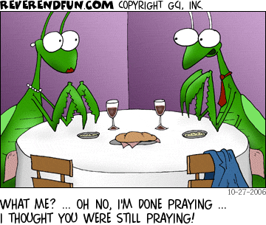

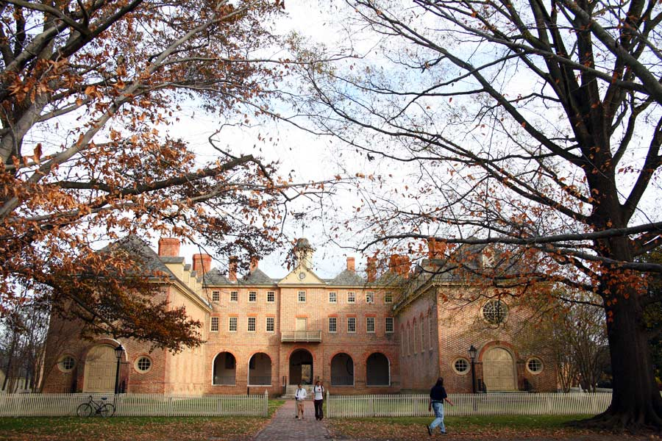

Fall 2017 Courses

R.S. 100: Topic: Meditation and the Mind M. McLaughlin

R.S. 100: Topic: Meditation and the Mind M. McLaughlin

R.S. 150: Topic: Writing the Self M. Kirsh

R.S. 150: Topic: Sympathy for the Devil R. McCall

R.S. 203: History & Religion of Ancient R. McCall

Israel

R.S. 203: History & Religion of Ancient J. Galambush

Israel

R.S. 204: Christian Origins M. Daise

R.S. 205: Reading the Bible in Hebrew 1 A. Tobolowsky

R.S. 210: Intro to History of Christianity A. Angelov

R.S. 211: Intro to History of Jewish Thought M. Kirsh

R.S. 212: Intro to Islam O. Ogunnaike

R.S. 213: Intro to Hinduism P. Burchett

R.S. 214: Intro to Buddhism K. Vose

R.S. 221: Religion and Ethics F. Sheikh

R.S. 308: Topic: Magic, Science & Religion P. Burchett

R.S. 308: Topic: Elementary Biblical Hebrew R. McCall

R.S. 308: Topic:The History of God M. Raphael

R.S. 308: Topic: American Religious M. Fitzgerald

Nationalism

R.S. 308: Topic: Yoruba Religions O. Ogunnaike

R.S. 308: Topic: Religious Liberty in the US M. Fitzgerald

R.S. 308: Topic: All I Wanna Do Is Be Free T. Harris

R.S. 309: The Holocaust M. Raphael

R.S. 310: German Crit Thought: 1670-1830 R. Leventhal

R.S. 315: Judaism in Greco-Rmn World M. Daise

R.S. 319: Mesopotamian Religion J. Galambush

R.S. 337: African Rit & Rel Practice B. Weiss

R.S. 334: Protestant & Catholic Reform A. Angelov

R.S. 361: Modern Hinduism M. McLaughlin

R.S. 481: Independent Study A. Blazer

R.S. 495: Honors A. Angelov

R.S. 150: Topic: Temples, Tombs & M. McLaughlin

Topography

R.S. 150: Topic: Voice from the Holocaust M. Kirsh

R.S. 150: Topic: Sex & God in America M. Fitzgerald

R.S. 203: History & Religion of Ancient R. McCall Israel

R.S. 204: Christian Origins M. Daise

R.S. 210: Intro to History of Christianity A. Angelov

R.S. 213: Intro to Hinduism M. McLaughlin

R.S. 301: Reading Biblical Hebrew II A. Tobolowsky

R.S. 304: The Prophetic Books M. Raphael

R.S. 308: Topic: Buddhism and Science K. Vose

R.S. 308: Topic: Into to Islam in Africa O. Ogunnaike

R.S. 308: Topic: Elementary Biblical Hebrew R. McCall

R.S. 308: Topic: What is Love? O. Ogunnaike

R.S. 308: Topic: Rabbis and Fathers M. Daise

R.S. 309: The Holocaust M. Raphael

R.S. 310: Modern Eur Jewish History M. Kirsh

R.S. 348: African American Religions M. Fitzgerald

R.S. 391: Theory of Religion A. Angelov

Spring 2018 Courses