Grant Management for William & Mary Fiscal Administrators

Bliley, Rebecca

Contents
Terms 2
Sample NIH Award Notification 3
Sample Award Notification 5
Using Banner Administrative Prod to Retrieve Grant Inception to Date 6
Using Banner Prod to Retrieve Grant Information 10
Using Banner Prod to look up Remaining Grant and IDC Balances 12
Using Banner Prod to Grant Transaction Detail 14
Grants with Parent and Child Indexes 17
Qlik Reports for Grants 19
Sample Expense Tracking Spreadsheet 25
Sample Subaward 26
Sample Effort Certification 27

Terms
- Effort Certification
Quarterly reports that the P.I. must approve that track payroll for all individuals working on a sponsored project- time and effort.
- Indirect Costs
The university currently has an indirect cost of 50.7% through 6/30/24 charged to grant activities. The exceptions are for equipment over $5,000, tuition payments, and subawards only incur IDC charges for the first $25,000.
Annually the IDC monies are returned to support university research programs in the following disbursements:
15% - Deans
40 % - Departments
40% - Office of the Vice Provost for Research
5 % Individual Principal Investigators
- NIH- National Institute of Health
https://grants.nih.gov/policy/nihgps/index.htm
- NSF- National Science Foundation
https://www.nsf.gov/pubs/policydocs/pappg22_1/nsf22_1.pdf
- Office of Sponsored Programs
Responsible for:
Pre-Award Post-Award
Proposal Review Invoicing/Draw-downs
Proposal Submission Allowable Costs
Award Conditions Negotiation Financial Reports
Award Administration Closeout
Award Modifications Audits
- Principal Investigator
Responsible for developing the finding funding, writing the proposal, preparing the budget and justifications, approving subaward invoices, certifying effort and expenditure certification reports, generating progress reports, requesting amendments/modifications/extensions to the grant, and publishing findings.
- Subawards
Per 2 CFR 200.92, "Subaward means an award provided by a pass-through entity to a subrecipient for the subrecipient to carry out part of a Federal award received by the pass-through entity. It does not include payments to a contractor or payments to an individual that is a beneficiary of a Federal program Research conducted by another entity." Invoices should be generated monthly by the other institution and are sent to the Office of Sponsored Programs for the Principal Investigator to approve, and the fiscal Administrator will submit the payment.

Sample NIH Award Notification
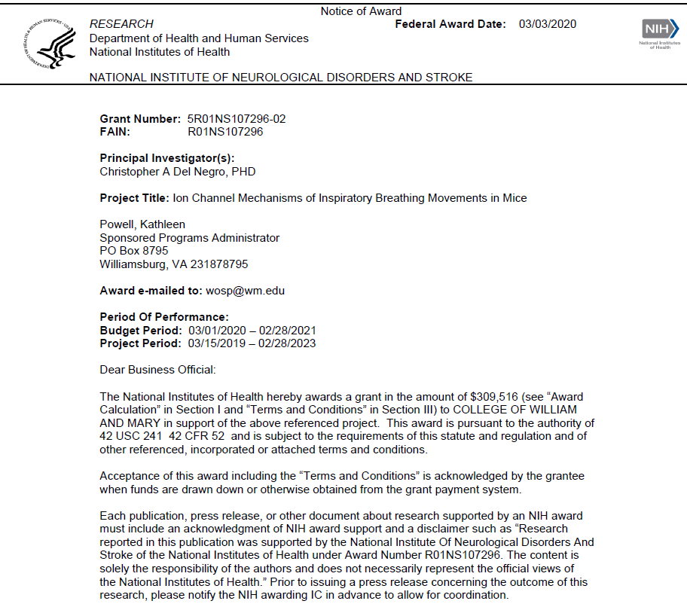
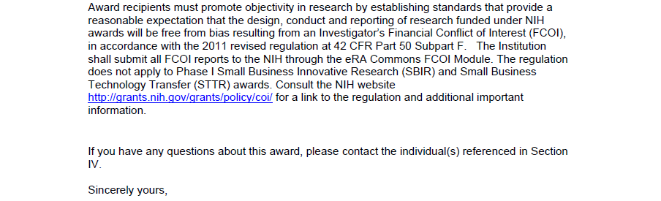
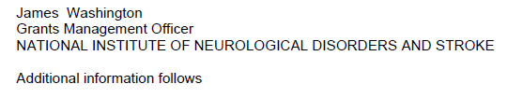

Sample Award Notification
The Office of Sponsored Programs generates these after receiving a grant award.
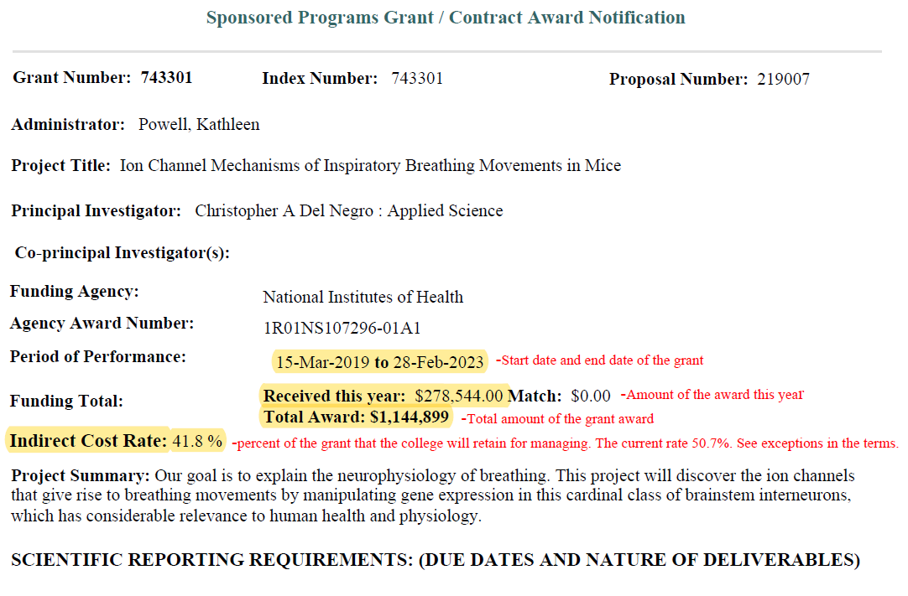
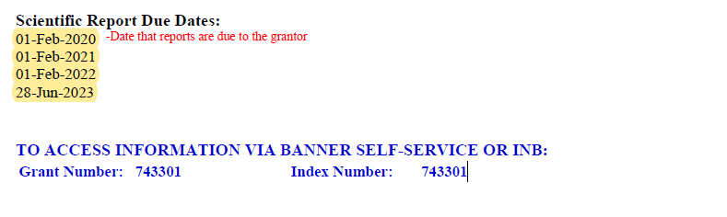

Using Banner Administrative Prod to Retrieve Grant Inception to Date
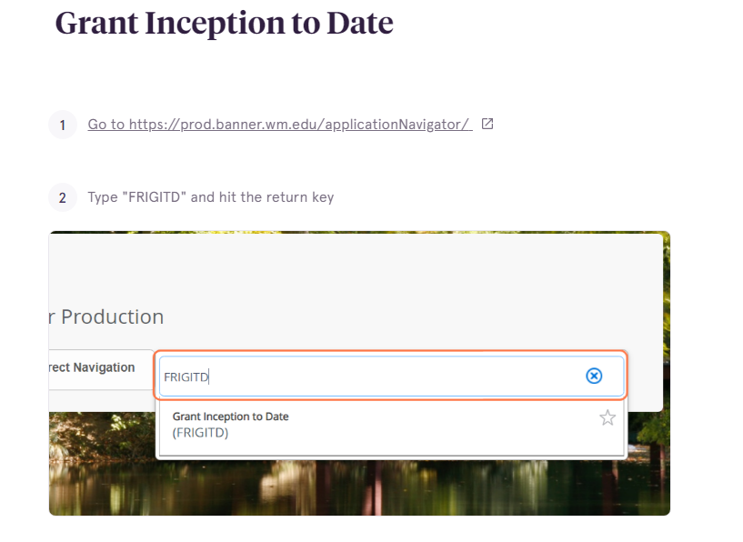
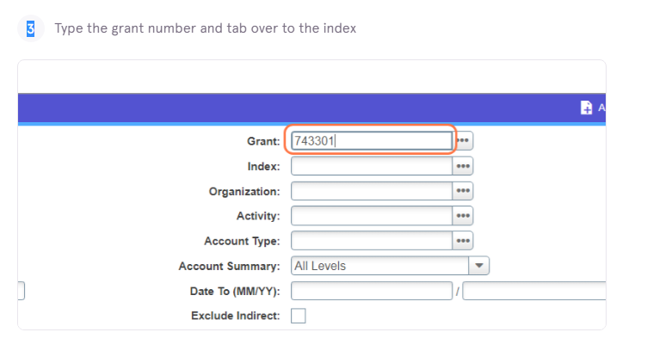

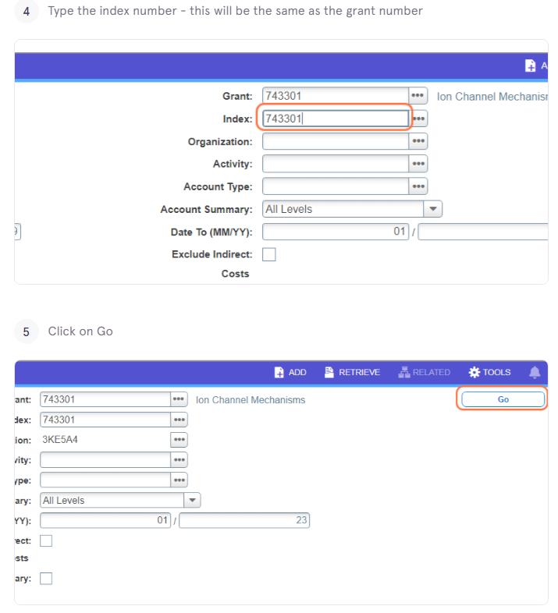

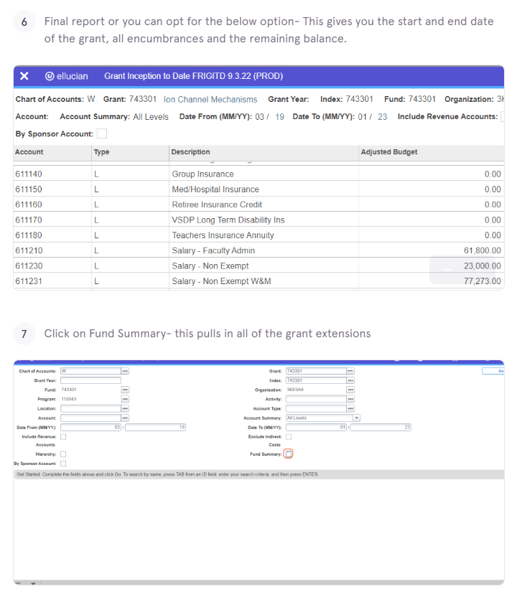

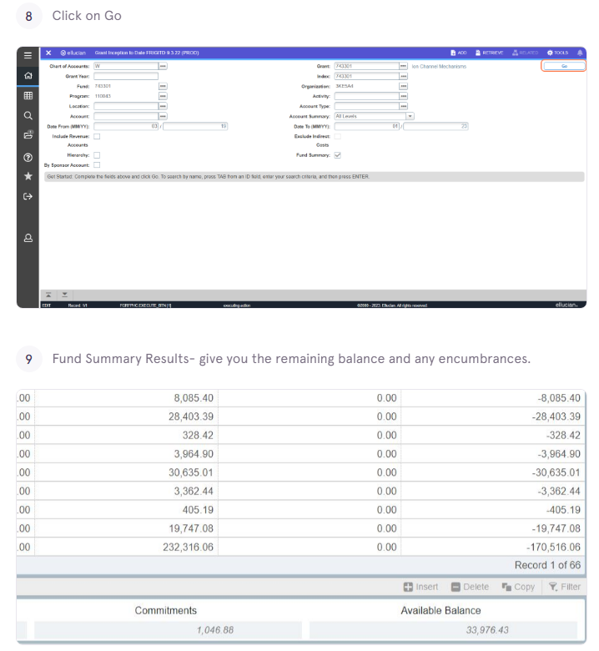

Using Banner Prod to Retrieve Grant Information
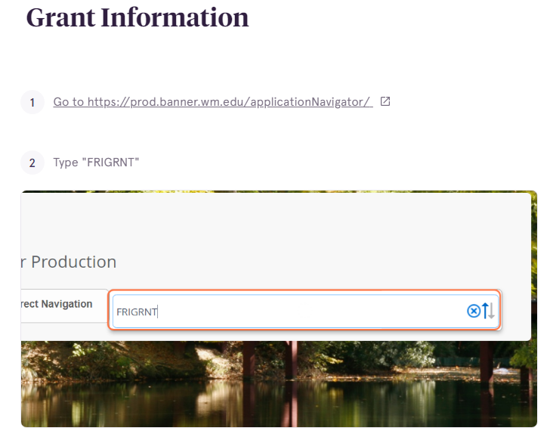
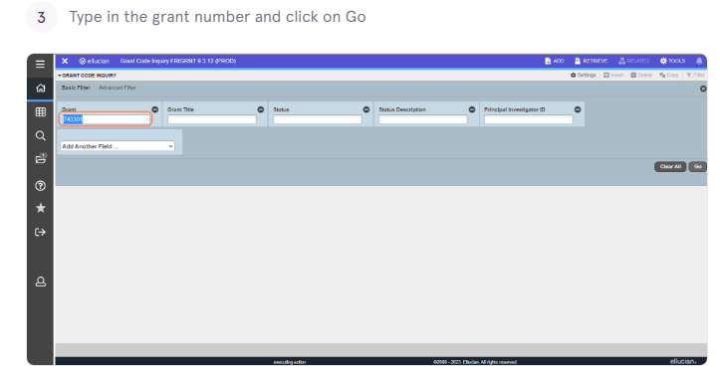

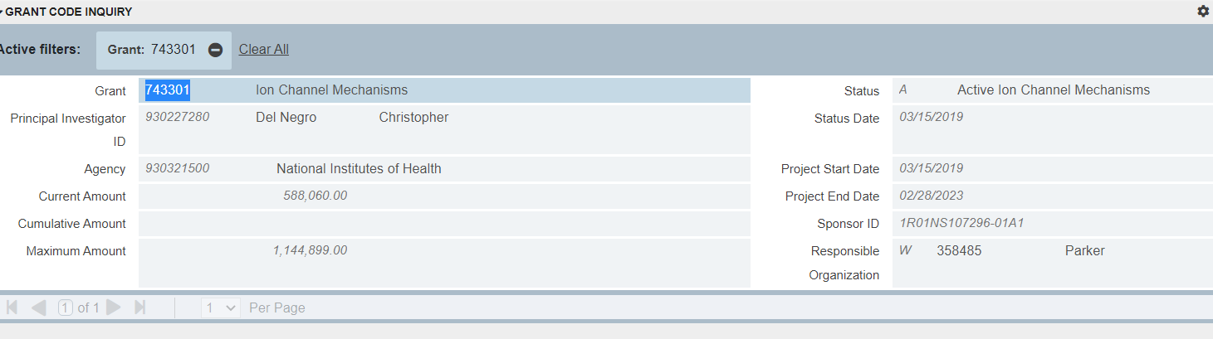

Using Banner Prod to look up Remaining Grant and IDC Balances
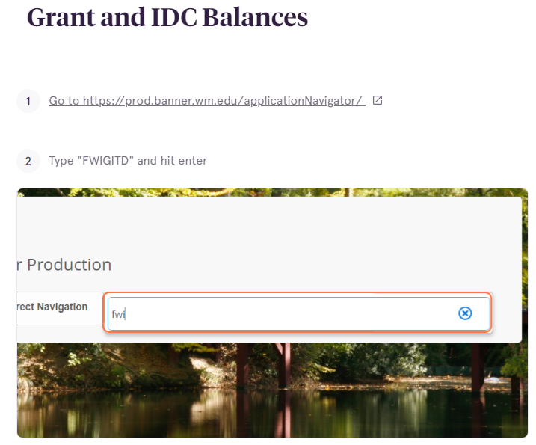
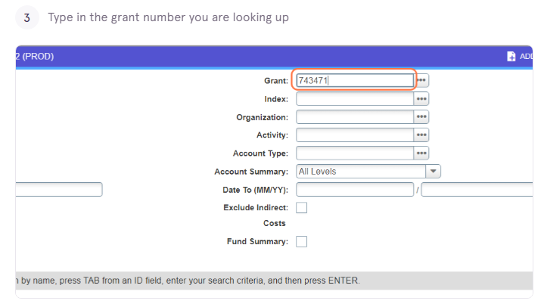
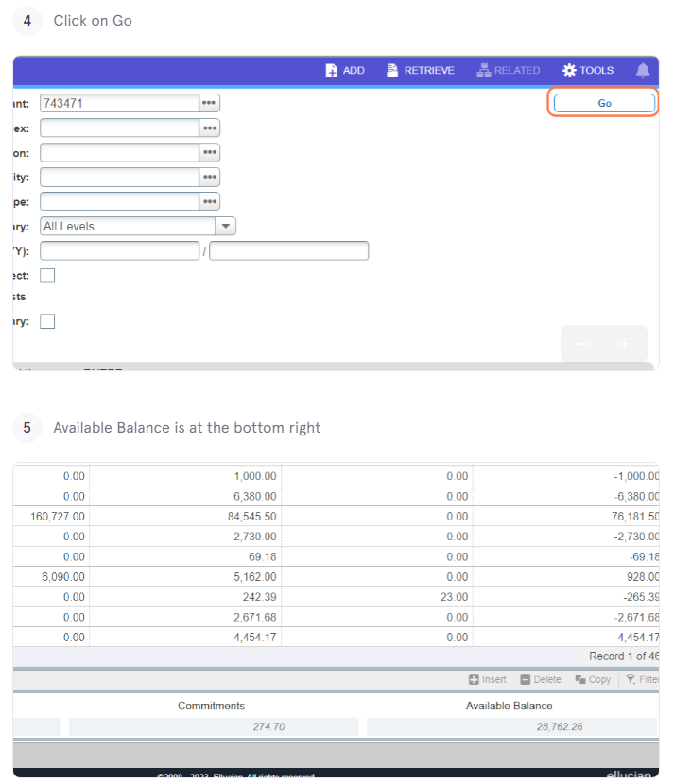

Using Banner Prod to Grant Transaction Detail
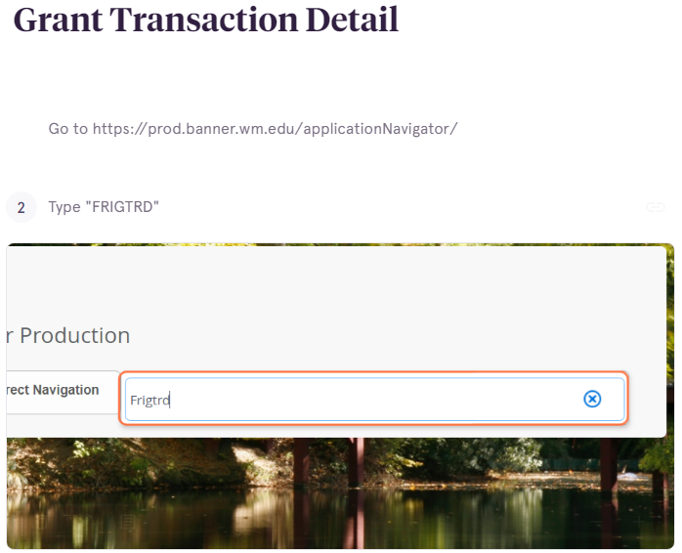
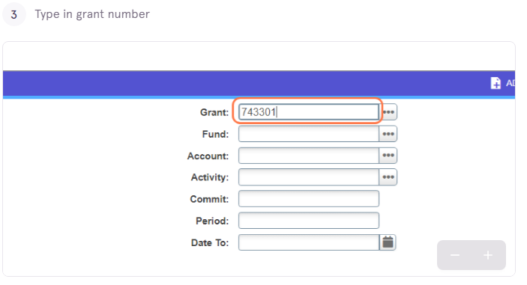
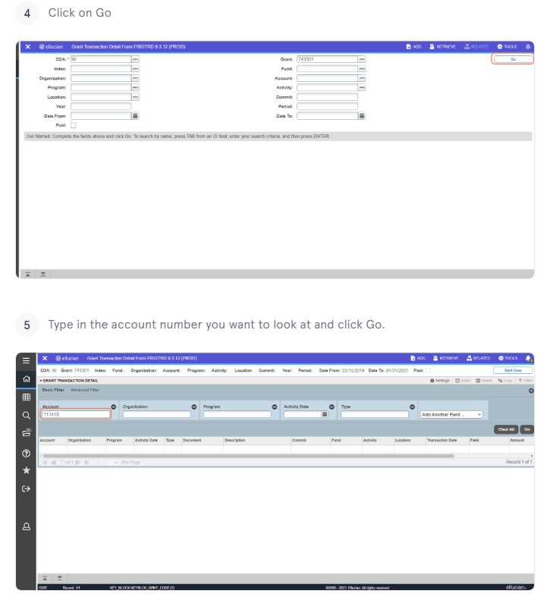

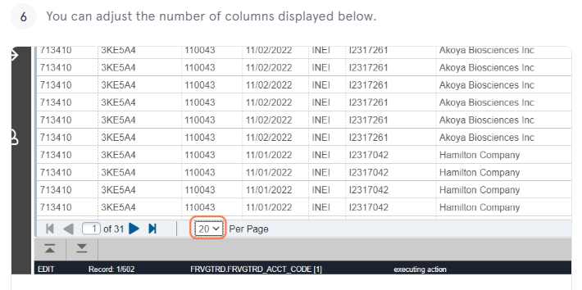

Grants with Parent and Child Indexes
The grant number is the parent the index and fund are the children.
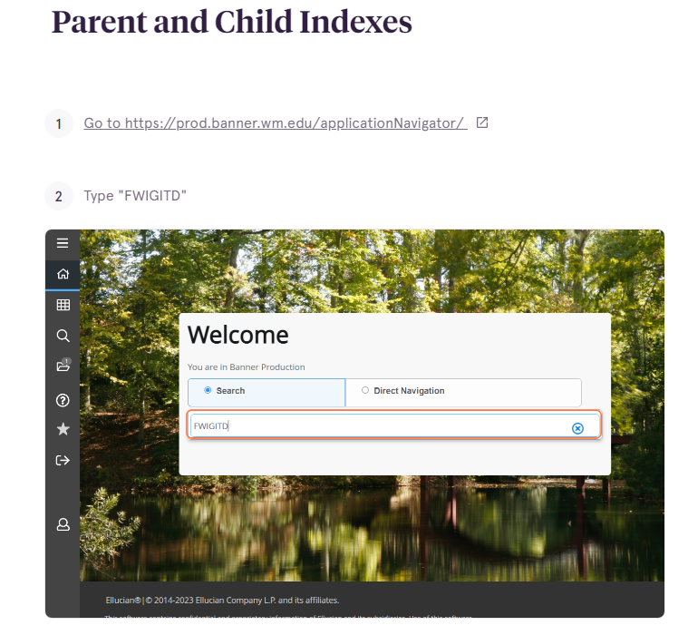
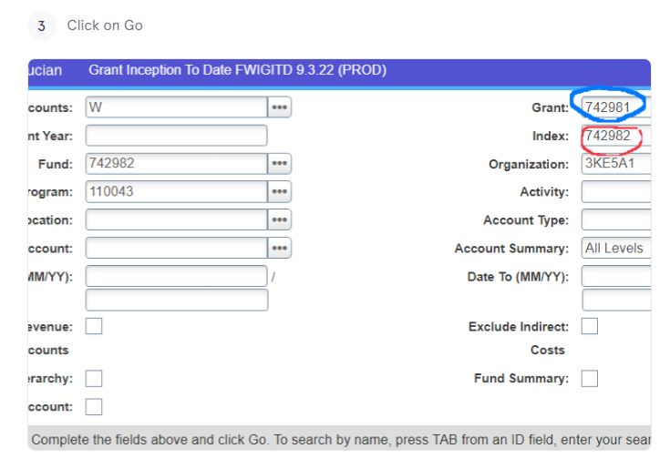
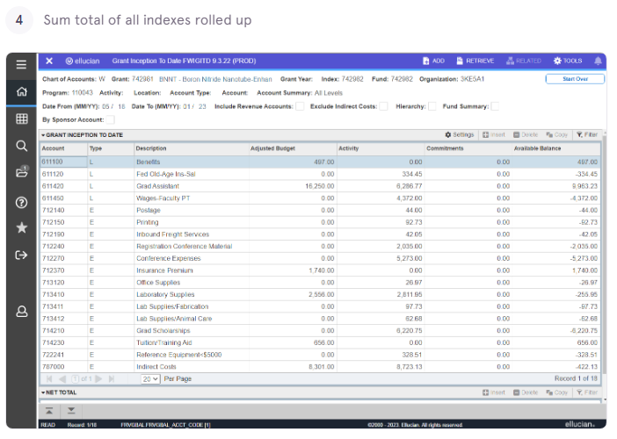

Qlik Reports for Grants
There are many types of reporting options on Qlik for grant management.
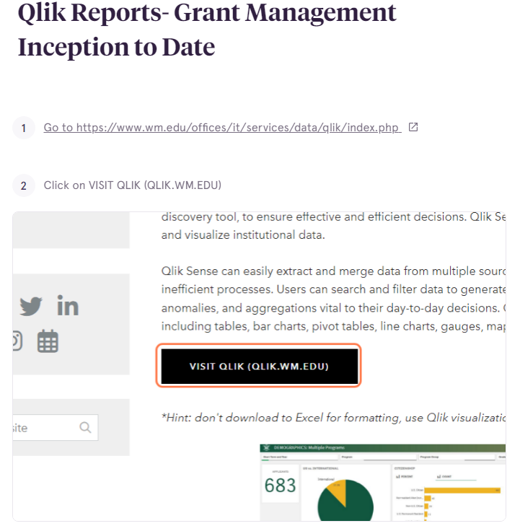

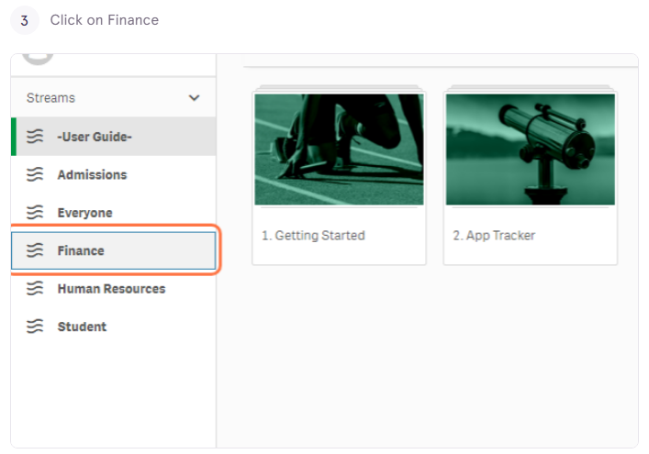
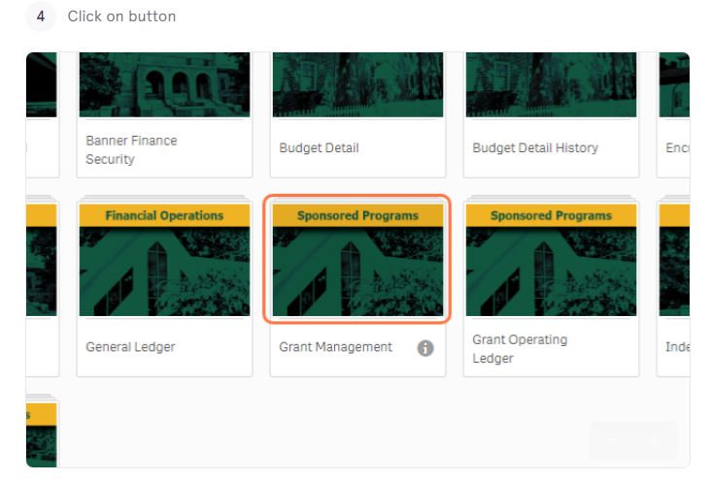
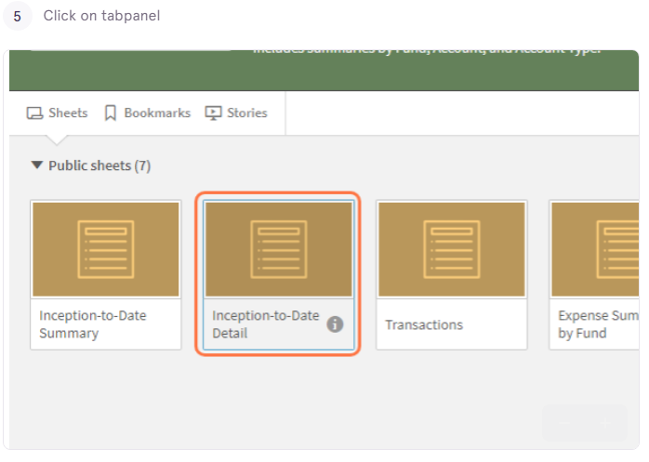
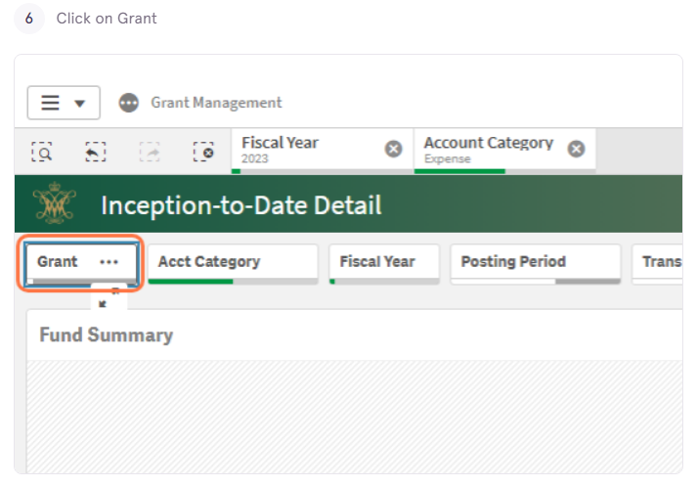
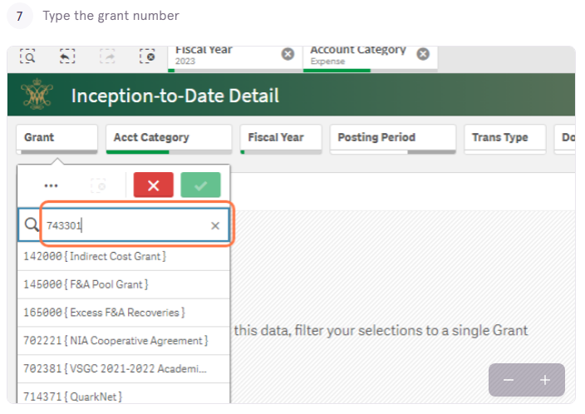
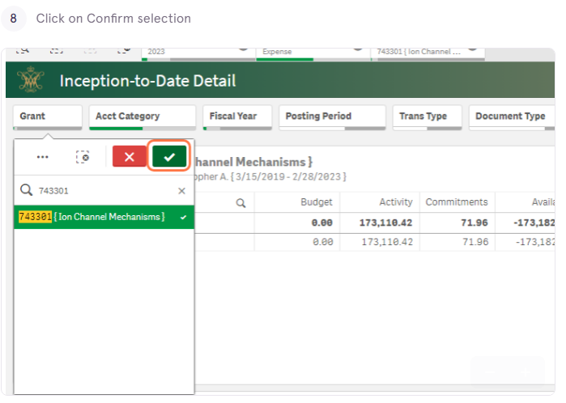
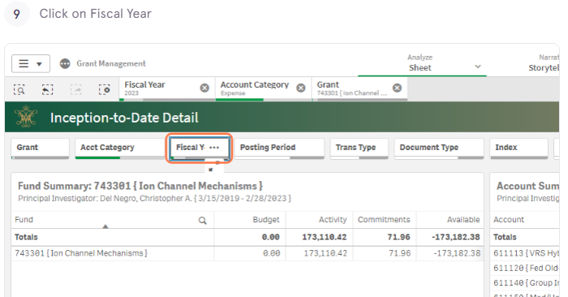

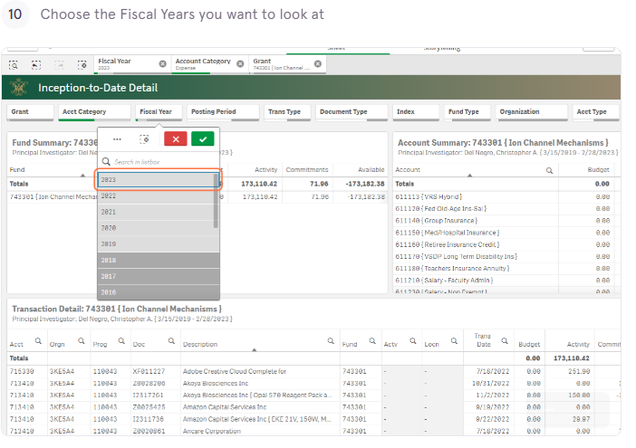
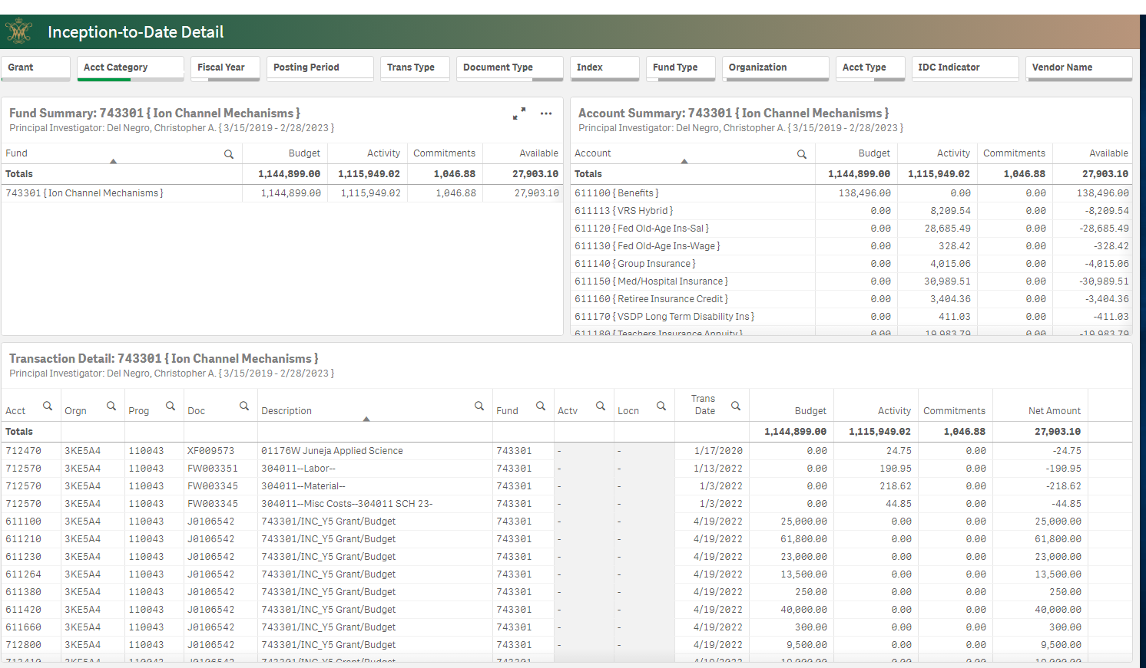

Sample Expense Tracking Spreadsheet

Track all past and pending expenses on an excel spreadsheet.

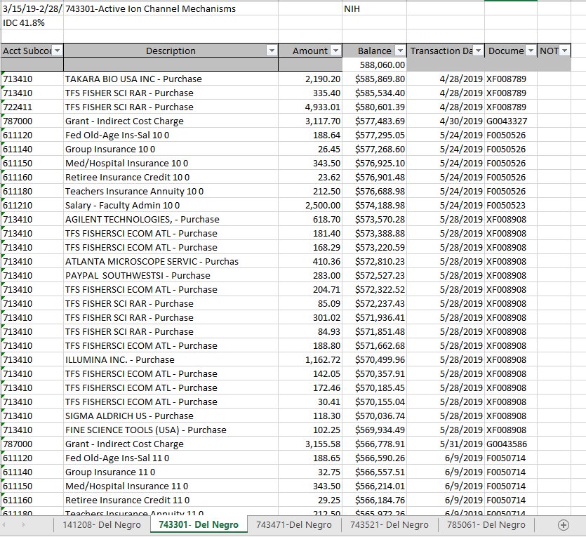

Sample Subaward

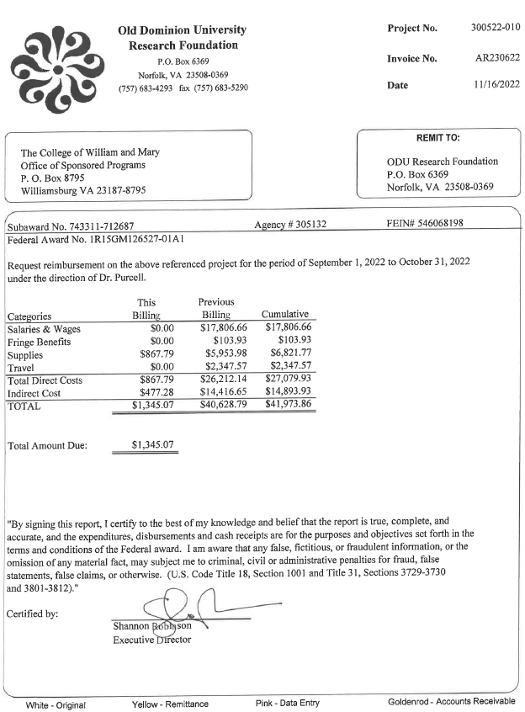

Sample Effort Certification

Effort Certifications are uploaded to a box folder by OSP, and you will have to print them, have the primary investigator sign them, and upload it back to the box folder in the signed folder. These are done in each semester's spring, summer, and fall.

