Jesse Smyth and Kendall King
EcoAmbassador Program
7 December 2016
Mapping the Banks of the Crim Dell Pond
Introduction
Invasive species are those that expand into an area that they did not previously occupy; whether or not it is native to the location is irrelevant. A non-native species is one that is outside of its native distributional range. When discussing plants such as bamboo or wisteria, the most accurate phrase is non-native invasive species. Factors that allow a species to invade a particular area include a broad ecological tolerance and large native range, a life-history strategy that allows for rapid reproduction, expansion, and competition, a lack of natural enemies, and high resistance and resilience to change. Additionally, a location is likely to be invaded if it has low resistance and resilience, low species richness and diversity, and abundant resources. Finally, the biggest predictor of biological invasion is the impact of people - without human interference (such as habitat destruction, introduction of new species, and more), the likelihood of a species becoming established in a new location is extremely low (Restoration Ecology, 2016). Non-native invasive species are harmful to ecosystems because they choke out native plants and reduce the biological diversity of an area, fundamentally changing how the ecosystem functions (Zavaleta et. al., 2001). Invasive species (including both plants and animals) cost the United States around $120 billion annually based on losses and damages combined with the cost of controlling them, and invasive plants are spreading at a rate of 700,000 ha/year, taking over areas previously occupied by diverse native species (Pimentel et. al., 2005).
The Crim Dell is a beautiful, iconic location on our campus, but has been overgrown by non-native invasive plants that were planted there years ago, before their detrimental effects were known. These plants include English ivy, golden bamboo, Chinese wisteria, and Japanese honeysuckle, to name a few, and are the original impetus for the work leading up to this Eco-Ambassador project. Efforts to remove these plants began in 2010, with “No-Ivy Day,” run by the Virginia Master Naturalists’ Kathi Mestayer, and continued with a Make A Difference Day service project in Fall 2014, which focused on removing bamboo on the southernmost slope of the Crim Dell. In Spring of 2014, the project was taken on by a new committee of the Student Environmental Action Coalition, or SEAC, whose goals are to make the Crim Dell ecologically healthier, more aesthetically pleasing, and more accessible for students and visitors to have access to green space on campus. Green space and taking time to be outside is especially important on a college campus with a focus on reducing stress levels among students because, according to Van Den Berg, et. al. (2010), people “with a high amount of green space in a 3-km radius [are] less affected by experiencing a stressful life event than respondents with a low amount of green space in this radius.” SEAC applied for and was awarded a Green Fee Grant that first semester to get started. This proposal totalled $1,285 for tools, gloves, plants, and other necessities for invasive plant removal, which was the first priority for the project. Since then, there have been multiple workdays, resulting in the removal of at least 300 stalks of bamboo, many wheelbarrows full of ivy, wisteria, and other weeds, totalling over 200 student volunteer hours. In Spring 2016, SEAC was granted funds from another Green Fee application. This one was significantly larger, as the project goals expanded into the realms of aesthetics and accessibility. SEAC requested $11,497.36 for informational signs, more plants, trail improvements, a rock garden, and more.
Our Eco-Ambassador project is an expansion of the work that has already been done on the Crim Dell, and is a way to ensure the continuation of the project information after the current leaders graduate. The goals of our project were to map and document dominant woody vegetation, invasive species of interest, sunny and shady slopes; to calculate the percent slopes around the pond; and to create a planting plan using information gathered and research options for planting on steep slopes, ideally using recycled or natural materials. This essay will go through the methods, tools, and information used to come up with suggestions for how to replant the slope. In addition, we have created two maps that will be of great use to determine what areas still need attention in terms of invasive removal, as well as the optimal places to plant. Throughout the semester, we have had to modify our goals, a process we will also detail below.
Methods
Throughout the semester, we investigated available map bases and a variety of tools to help us map various components of interest in the Crim Dell area. Initially, we used a paper map from the Collection of Woody Species and a measuring tape to identify areas of native plants and patches of bamboo (Mathes, 1980). Shortly after trying that, we decided to switch to ESRI ArcMap, a GIS software, and a hand-held GPS unit to plot points and polygons and transfer them onto a computerized base map. After struggling to produce the results we wanted, we looked to using ArcCollector, a phone application that allows you to map areas more accurately and sends the data to an online GIS database. ArcCollector had accuracy issues as well, however, so we also used a map from Tim Russell, Spatial Data Manager for W&M Facilities. Created for facilities by contracted engineering firm Draper Aden Associates, this map documented pertinent woody species, contour lines, and finished and future stormwater control projects conducted on or around the Crim Dell. Combining the ArcCollector and more accurate Draper Aden Associates paper map methods allowed us to produce maps that show current woody species, plants recently planted by the Restoration Committee of the Student Environmental Action Coalition, areas of extended sunlight exposure, and areas that currently contain invasive species. We were able to achieve a simple, accurate map, by digitizing elements from the Draper Aden map that were relevant to our target study. Although originally our goals were to map the entire Crim Dell area, after trying and failing multiple times to find an accurate mapping application, we decided to limit our efforts to the south arm of the Crim Dell near Landrum Hall and McGlothlin-Street Hall.
In addition to actively mapping the area, we both worked in SEAC Restoration to come up with plans for planting, erosion control, and improving aesthetics and accessibility of the area. This semester, SEAC Restoration conducted four workdays. The first two focused on removal of bamboo, wisteria, and English ivy as well as planting plants bought from a local plant nursery. The last two workdays in October and November 2016, in addition to removal of invasives and planting of new plants, we also installed two large erosion control mats. Combined,these mats cover an area of 240 square yards. The mats are held in place with biodegradable stakes on the steeper slopes of the southernmost edge of the Crim Dell. With the help of SEAC Restoration members, we also compiled research on the importance of planting native plants and removing non-native species, as well as the types of plants native to this area of Virginia. In addition, we also conducted further research on plants that we already planted in our area of study, as well as important facts about them such as sunlight preferences, and important ecological uses.
Results
We must examine the original Draper Aden Associates map in order to clearly delineate how we achieved our results. Figure 1 is a detail of the map of the Crim Dell created by Draper Aden Associates for use in ongoing and future stormwater infrastructure improvement projects. This map accurately displays the Crim Dell, large woody species, contour lines, and pathways. 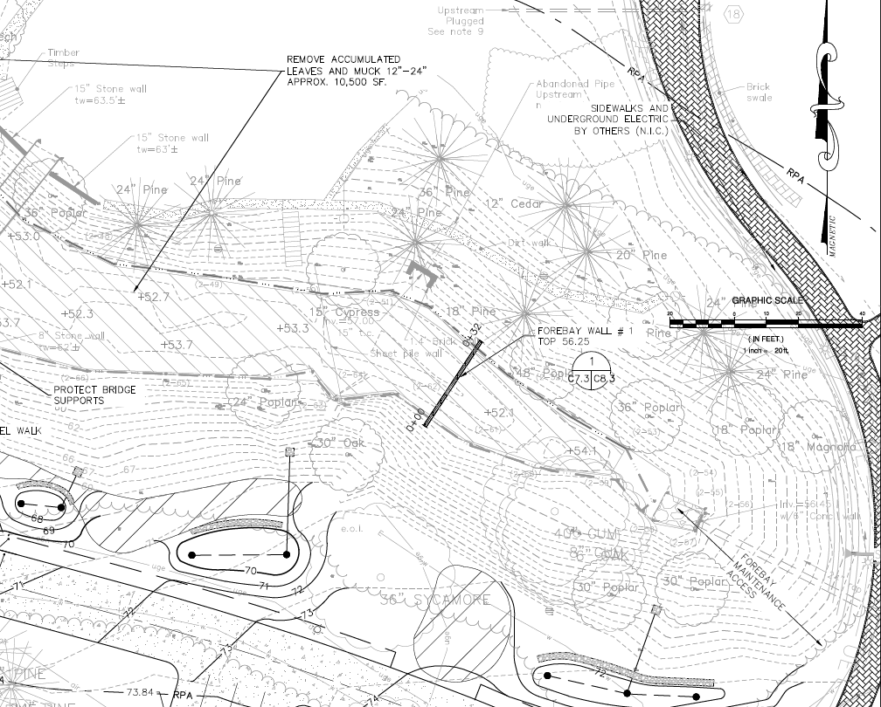
Fg. 1: Detail of Draper Aden Associates map of the southern arm of the Crim Dell.
For our final map, we decided to use this printed copy of the map created by Draper Aden Associates to sketch out the features of the Crim Dell that we focused on. As seen in Figure 2, we used different colors to categorize various factors, such as patches of sunlight, areas where invasive species currently or previously did exist, new plants that have been planted, as well as the erosion mats installed by SEAC Restoration. While the sketches made on the map were very accurate, the inclusion of elements planned for future development, such as some new BMPs, as well as topographic lines on the original map, obscure many of the elements we mapped. After gathering the information and drawing it on the Draper Aden map, we decided to scan and digitize it so that the elements we wanted to focus on were easier to view. 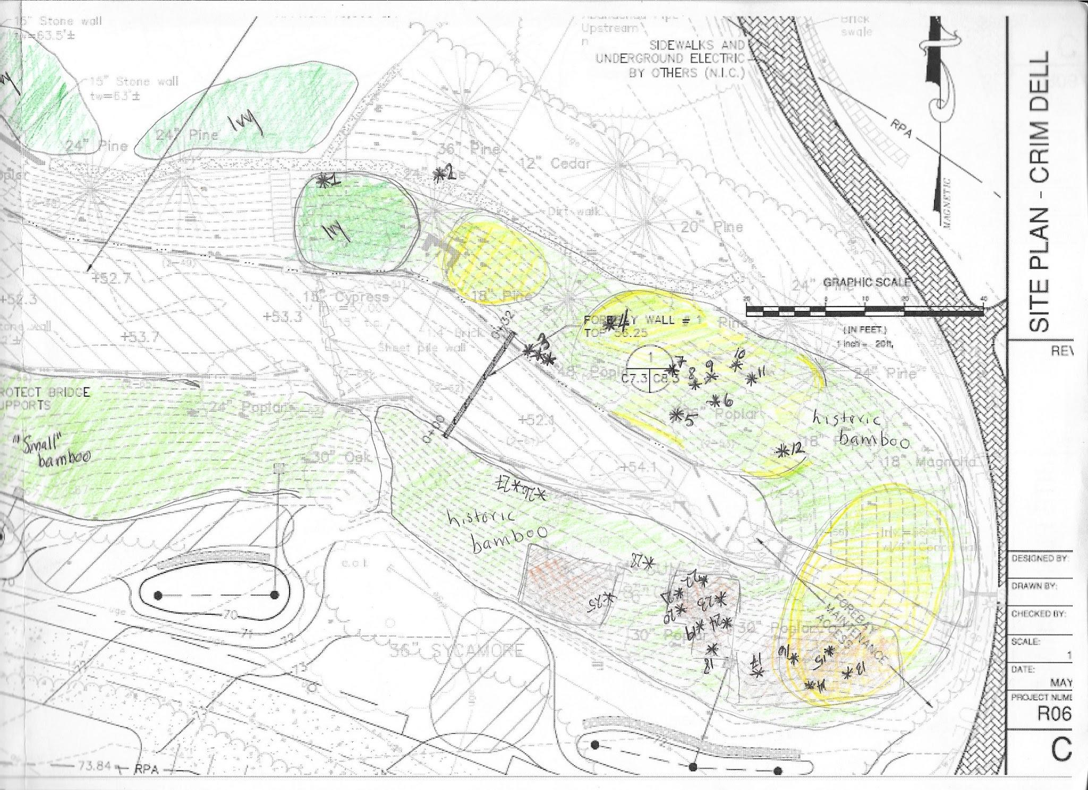Fg. 2: Draper Aden map with sketches of features such as invasive species and newly planted plants.
Figure 3 shows the digitized version of Figure 2 and includes new plants planted, invasive species, patches that receive the most sunlight, and the erosion control mats installed by SEAC Restoration. The numbers correspond to the plant listings, which are documented in Appendix B. This digitized map also includes the treeline in order to show what area around the Crim Dell contains plants and fall under canopy cover.
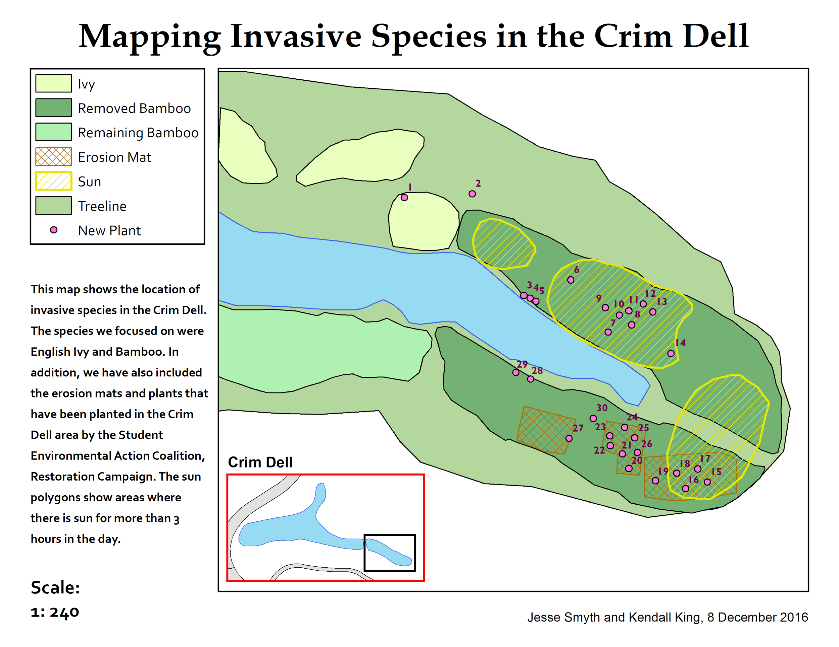
Fg. 3 Shows the digitized version of the preceding map, along with an inset map and legend to improve readability and usefulness of the map.
Based off the Draper Aden Associates map, we were able to also digitize the location of present woody species. In the southern arm of the Crim Dell, there are about two dozen large trees that provide varying levels of shade to the slopes. Figure 4 shows the location of large woody species in relation to areas of invasive species and patches that receive the most sunlight. Appendix C contains information about the trees that correspond to the numbered points on the map. This information includes common name, latin name, diameter, and native/non-native classification.
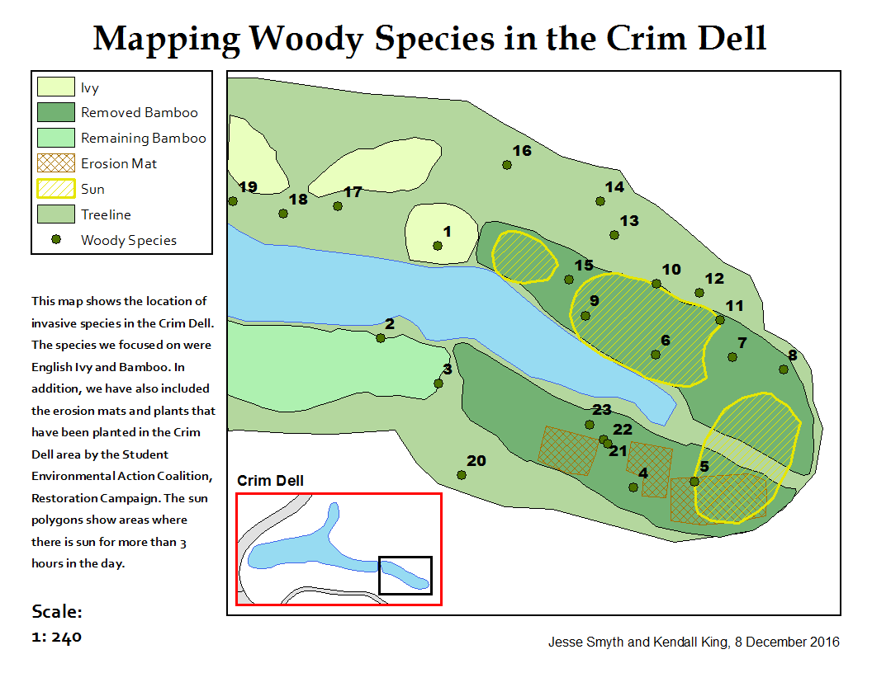
Fg. 4 Shows the digitized version of the preceding map, including the location of large woody species.
Mapping this area of the Crim Dell in such a way allows us to analyze the areas that are suitable for planting, what type of plants can be planted, and the risk of threat by invasive plants. Currently, most new plants that have been planted are surrounded by the rhizomes, or roots, of chopped bamboo stalks. Because of the nature of bamboo growth, removal is very difficult as they “spread via long rhizomes, which help the plant to colonise new areas” (Royal Horticultural Society, 2016). While SEAC Restoration has removed almost all of the bamboo stalks in the Crim Dell Area, the existing rhizomes make planting difficult. Instead of digging out the rhizomes, which would lead to extensive erosion on the slopes in that area, we have decided to leave the stumps and rhizomes there to wither and decay. The erosion mats will control most of the erosion that will occur from this process, and will also provide a stable area where new plants can be planted.
Some native plants that have been planted by the SEAC Restoration Committee so far include spicebush, beautyberry, mountain laurel, turtlehead flowers, azaleas, pawpaws, and more. Encouraging the growth and planting of native species helps the ecological health of native ecosystems as a whole. In Coastal Virginia, there is a myriad of gorgeous, native plants that not only contribute to strengthening ecosystems, but also maintain the Crim Dell as an aesthetically pleasing area that many can enjoy. In addition, there are multiple cost incentives to buying native plants as they “often require less water, fertilizer and pesticide, thus adding fewer chemicals to the landscape and maintaining water quality in nearby rivers and streams” (Virginia Native Plant Society, 2011). Many of the plants listed above will be helpful in the restoration of native plants to the Crim Dell area. In Appendix B, we have attached a table that delineates the plants’ number on the map, name, species, store purchased from, date planted, uses, and sunlight preferences. The majority of the first plantings (Fall 2015) successfully survived the winter to bloom in Spring 2016. Most of the plants have been donated from the Virginia Native Plant Society, transported in pots and planted in the Crim Dell. In June of 2016, some William and Mary students went to a construction site in Hampton, Virginia slated for development and rescued multiple wild, native plants. Since then we have planted quite a few more, some donated and some purchased, and will continue to monitor them to see which survive and which do not. We will be able to use our new map to keep track of the plant locations and check on them each semester.
All of the current plants planted by SEAC Restoration have some sort of value for horticulture, conservation, or wildlife attraction (Appendix B). We plan to continue planting woody species such as dogwoods, redbuds, and native azaleas that are also flowering plants, in order to improve the aesthetics of the area as well as the ecological health. Plants such as flowering dogwood, which bloom beautifully in the spring, also provide food for songbirds, deer, rabbits, squirrels, and skunks (Eastern Trees 219). Turtlehead and Spicebush also attract hummingbirds, butterflies, swallowtails, deer, and opossums, important animals that improve the overall health and diversity of the Crim Dell ecosystem. Tying into the ecological health also includes opportunities for students or community members to engage with the plants in a healthy way. Whether it be enjoying the serenity of the area, or seeking out particular plants for functional purposes, we believe we should keep in mind the multiplicity of activities one can engage in when interacting with nature. The recently planted azaleas will be a magnificent sight to behold when they bloom in spring, enhancing the visual wonder of the area. Pawpaws produce sweet fruits that can be foraged and sold locally, and is an understory species that thrives in moisture-rich soils (Common Forest Trees of Virginia 60). Prioritizing native plants that have an additive value to the Crim Dell will keep the iconic beauty of the area, but improve its overall health and use for plants, humans, and animals.
Further planting in the area should take into consideration the location of invasive species, areas of sunlight, and already existing native plants. The patches of ivy and remaining bamboo shown on Figure 3 should not be considered for areas to plant in until almost all of the invasive plants are removed. Planting too close to large woody species, such as Tulip poplars, that provide extensive shade and have a shallow root system, would be detrimental to the growth of many plants (Common Native Trees of Virginia 75). On the other hand, trees such as redbuds thrive underneath shade and on hillsides, making it a perfect native plant for the areas of the southern arm of the Crim Dell that don’t get a lot of shade (Common Forest Trees of Virginia 67). Most native plants like a balance between sunny and shady, so for most new plants, we should plant them close to the areas that receive the most sunlight, but not directly in those areas. Some species that would thrive in those conditions include azaleas, redbud, turtlehead, pawpaws, and dogwood. Plants such as blueberry bushes prefer more direct sunlight, and so would be great to put inside the areas of prolonged sunlight exposure indicated in Figure 3. While slopes tend to be difficult to plant on, the erosion mats installed in November should help with stability and allow plants to grow and thrive.
Discussion
There were many issues with mapping the area. Initially, Jesse and I attempted to use a paper map from The Collection of Woody Species by Martin Mathis. The map had no scale or legend, and therefore many symbols that we could not identify. In addition, the map was from 1980, so elements on it did not match up with existing features that are there today. For example, the Lodges, which are now in the process of being torn down, are shown as Fraternity houses and McGlothlin-Street Hall does not exist. The benefit of using this paper map would have been that it already had many of the trees and other plants that are in the Crim Dell mapped out for us, so while we decided to use a different basemap, we continued to refer to the maps in the Collection of Woody Species to identify trees in that area. Even for plant identification, however, we could not rely completely on the Collection of Woody Species because only the trees on the perimeter of the tree line were mapped out (see Figure 5).
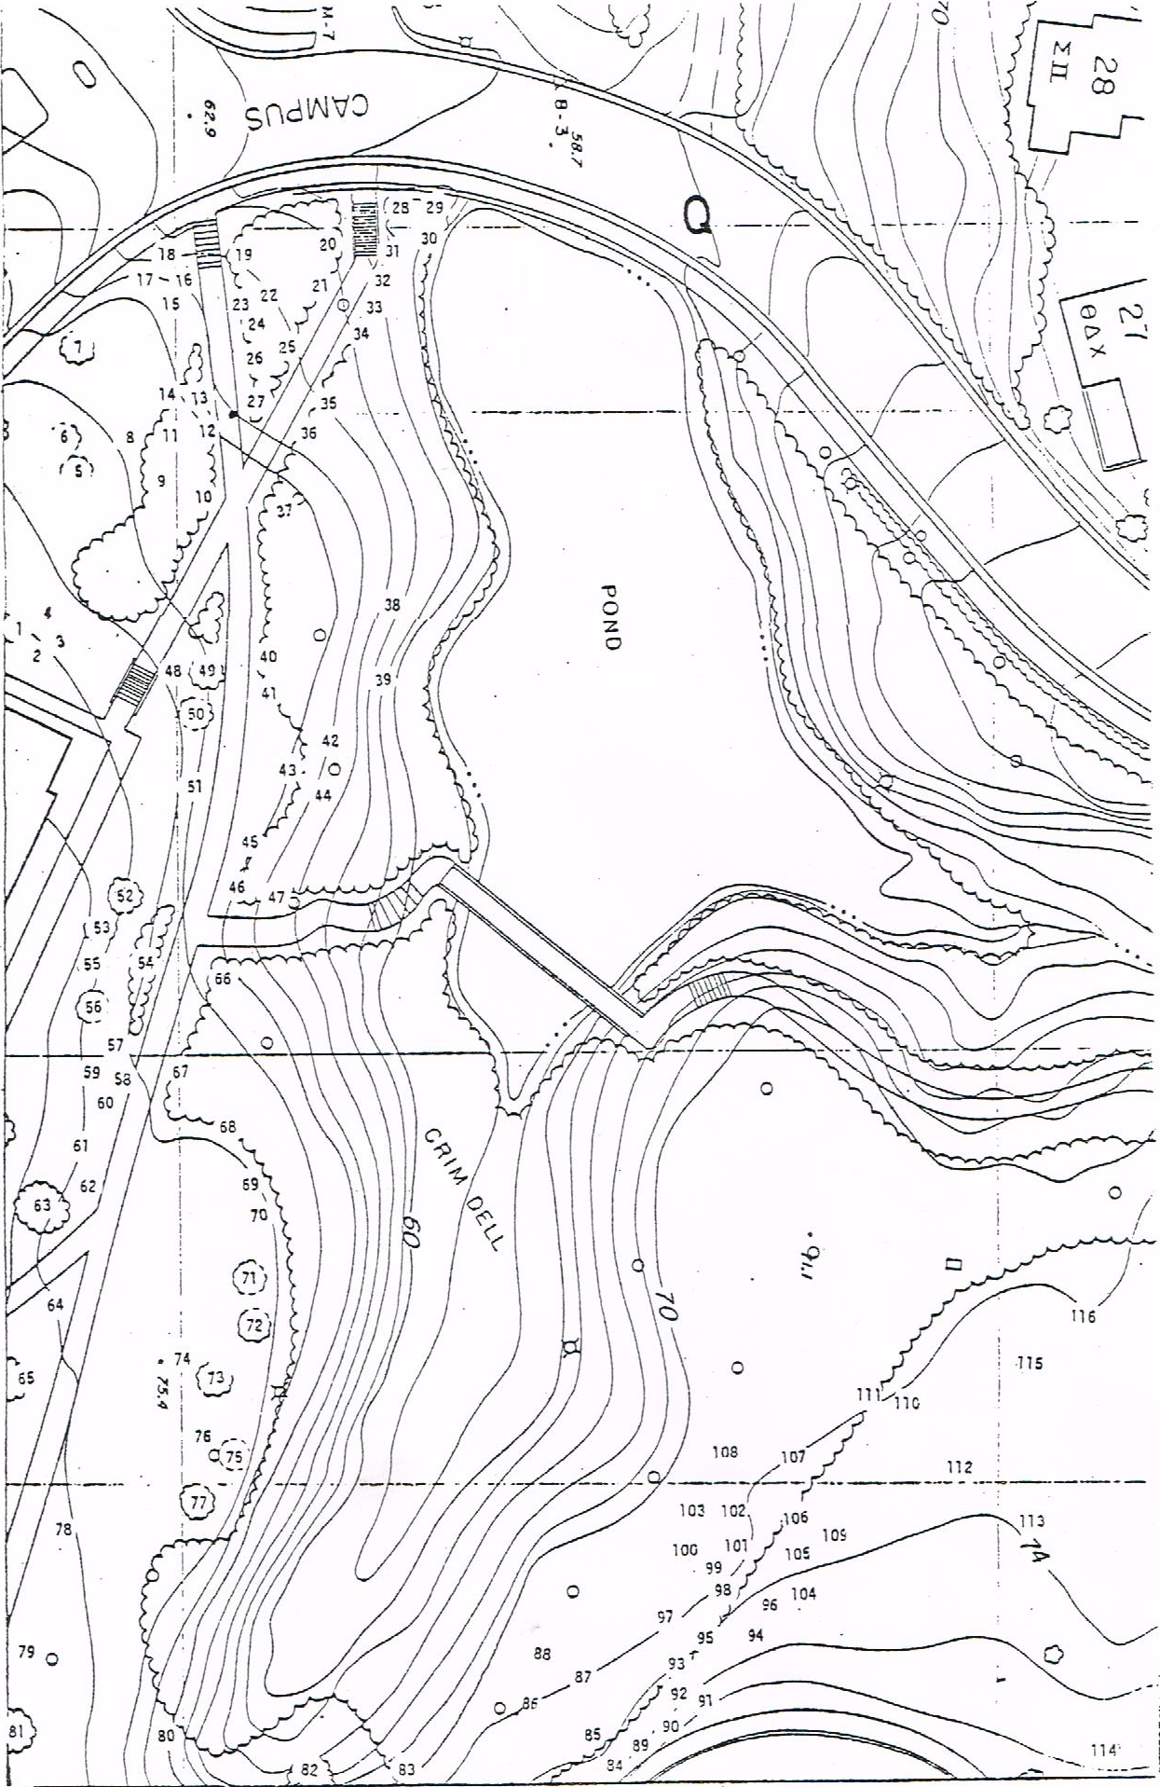
Fg. 5 Shows the Crim Dell with many woody species mapped. The numbers correspond to an itemized list of the native plants.
After determining that that the Collection of Woody Species map would not work very well, we investigated using the ESRI program ArcMap, a software used as a Geospatial Information System (GIS), and GPS to map the area. This came with its own unique challenges and advantages as we tried to navigate the use of GIS in our project. With help from the Center for Geospatial Analysis we were given layers from already existing data for our basemap - these layers included the Crim Dell pond, surrounding buildings, roads, paths, and two-foot contour intervals. Almost immediately, we discovered many issues with using GPS and ESRI ArcMap. GPS inaccuracy proved to be insurmountable as we were working in such a small area. In addition, we could not find the sources for the data given to us by the Center for Geospatial Analysis. Eventually, we discovered they probably originated from either Tim Russell, or from the James City County’s GIS database. When we obtained files directly from those sources we noted the shapefiles were exactly the same as those in the layer files from the Center for Geospatial Analysis. While both sets of data contributed to a very complete basemap, the contour lines and water features did not match up in a way that makes sense (Figure 6).
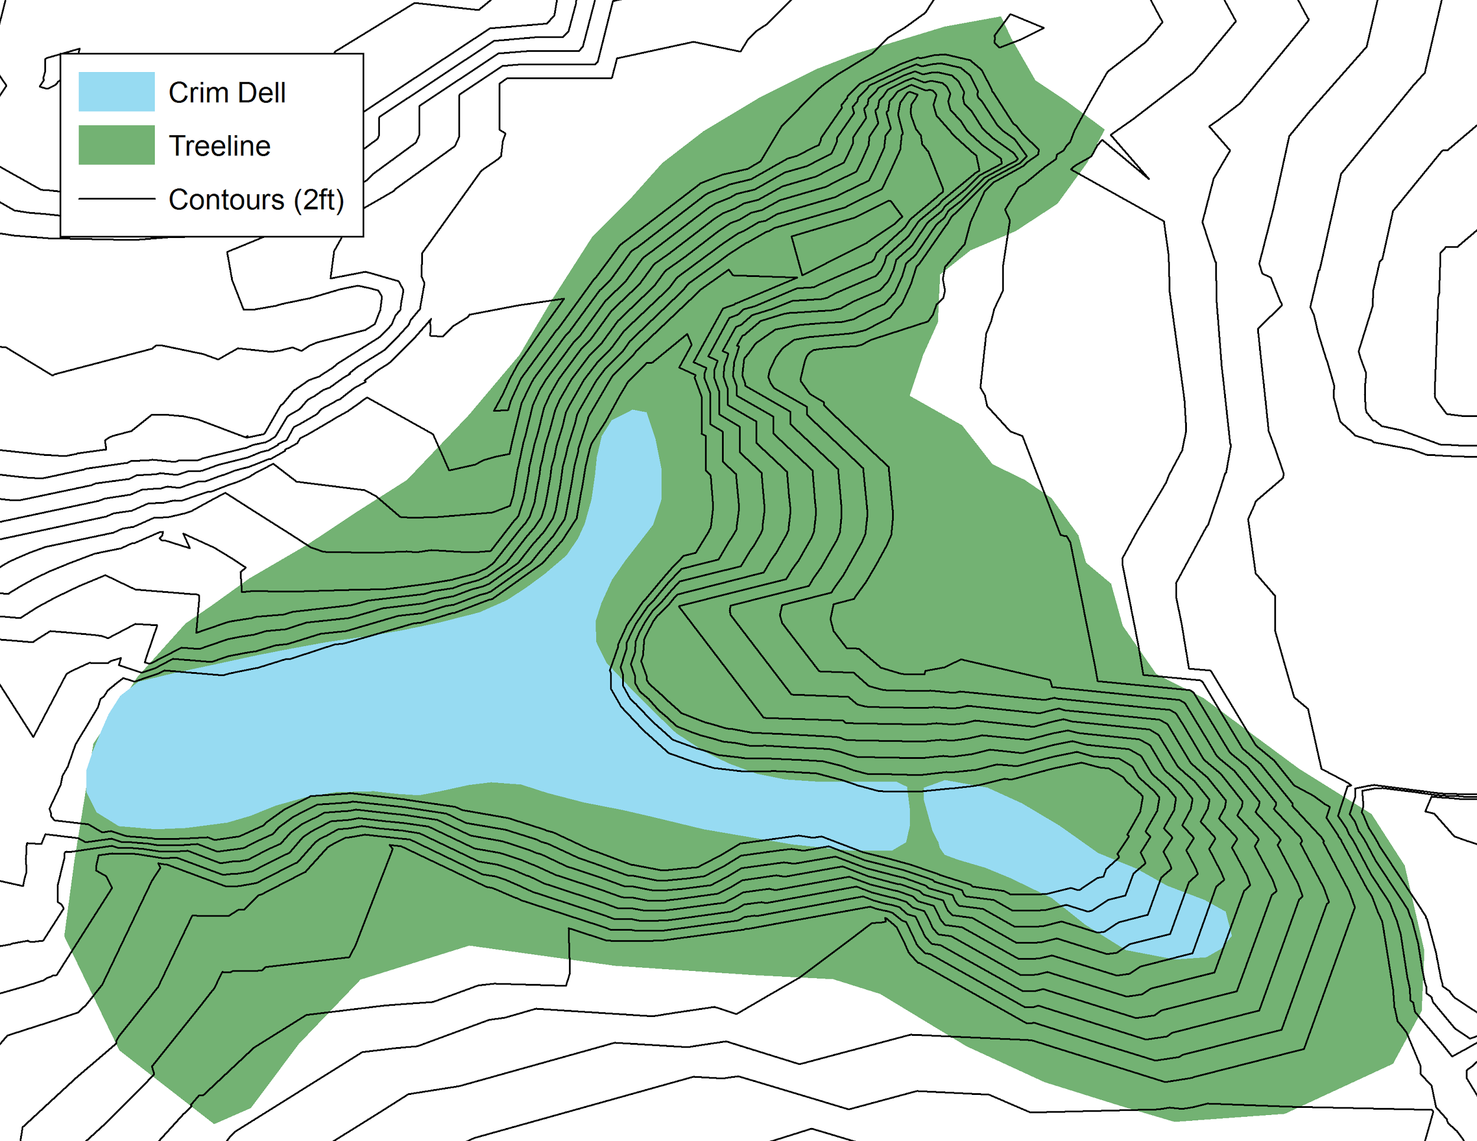
Fg. 6 Shows the GIS layers from the William and Mary CGA and James City County. The contour lines cross the water feature, indicating that these layers are aligned incorrectly.
The original goals of the project contained a very expansive look at the current ecological health of the Crim Dell. Initially, we wanted to focus on the entire Crim Dell area, map a majority of the woody species, map all areas that contain invasive species, calculate slope percentages, and create a plan for planting that would cover the entire area. In the end, we decided to scale back the area of our project to the southernmost extension of the Crim Dell (near Landrum and McGlothlin-Street Halls). As we encountered more and different problems with the mapping techniques we tried, attaining all of our goals seemed far-fetched. Because the southernmost tip of the Crim Dell gets the most prolonged sunlight exposure, and has had some of the worst invasive species infestations, we decided to focus our attention there so as to target the area where a replanting plan would be most effective. Because the restoration subcommittee of the Student Environmental Action Coalition, of which Jesse and I are members, is focusing efforts on that side of the Crim Dell, we also wanted our work to sync up with theirs. In addition, we also decided that documenting the history and current progress that has been made in the Crim Dell area would be very beneficial to us and future students and faculty who will pick up the project after we leave.
Conclusion
Naturally, despite our significant progress, there is still a substantial amount of work to be done in the Crim Dell. We need to monitor the effect of the erosion control mats, continue replacing the plants we have removed with more native plants, and continue working with Facilities Management on the accessibility of the area. Much of this future work has been planned by the SEAC committee, such as trail signs, trail improvements, and planting new plants. In addition, Dr. Randy Chambers (Biology Department, W&M) continues to monitor the water quality of the pond, collecting data which will help us assess whether our changes are helping the area beyond the immediate plant ecology on which we have been focusing. John McFarlane, of Facilities Management, also has a large stake and interest in the ongoing projects in the Crim Dell, including a plan to renovate the steps on the northeast end of the pond. Continued communication between students, faculty, and Facilities Management will help ensure the future success of projects in the Crim Dell.

Appendix A
William and Mary Resources

- Tim Russell, Spatial Data Manager for W&M Facilities
Tim Russell provided us with current maps of campus such as Figure 4. The maps were in a GIS program called ArcMap in layers, such as shapefiles of the Crim Dell, contour intervals, roads, buildings and pathways, as well as raster datasets of aerial satellite imagery.
- John McFarlane, Associate Director of Facilities Management
John McFarlane has helped SEAC Restoration with plans of improving the Crim Dell since the beginning. He is a link between students and facilities who helps guide and direct certain projects in the Crim Dell.
- Doug DeBerry, Professor of Biology and Environmental Science and Policy
Professor DeBerry teaches courses on restoration ecology and is a valuable resource for advice on invasive plant removal as well as native planting. His courses have helped students involved in the EcoAmbassador internship and SEAC Restoration apply principles taught in his class to the Crim Dell.
- Wayne Boy, Director of Facilities Planning, Design, & Construction
Wayne Boy aided the project by providing professionally made maps of the Crim Dell created by the consulting engineering firm Draper Aden Associates.
- Glenn Telfer, Laura Ayers, Ed Lyman, Draper Aden Associates
The map created by Draper Aden Associates became the basemap for the final product we produced.

Appendix B

Table of New Plants in Southern Arm of Crim Dell

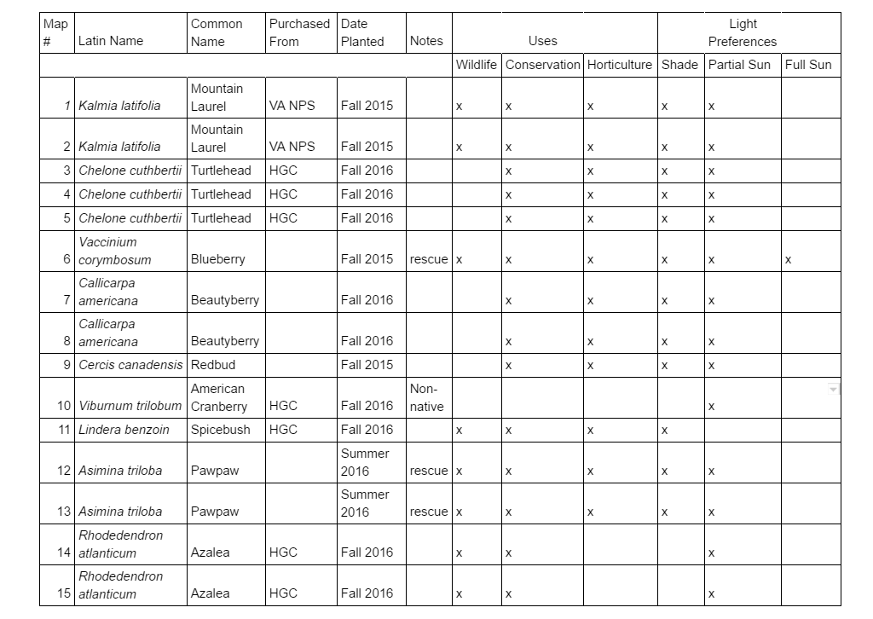
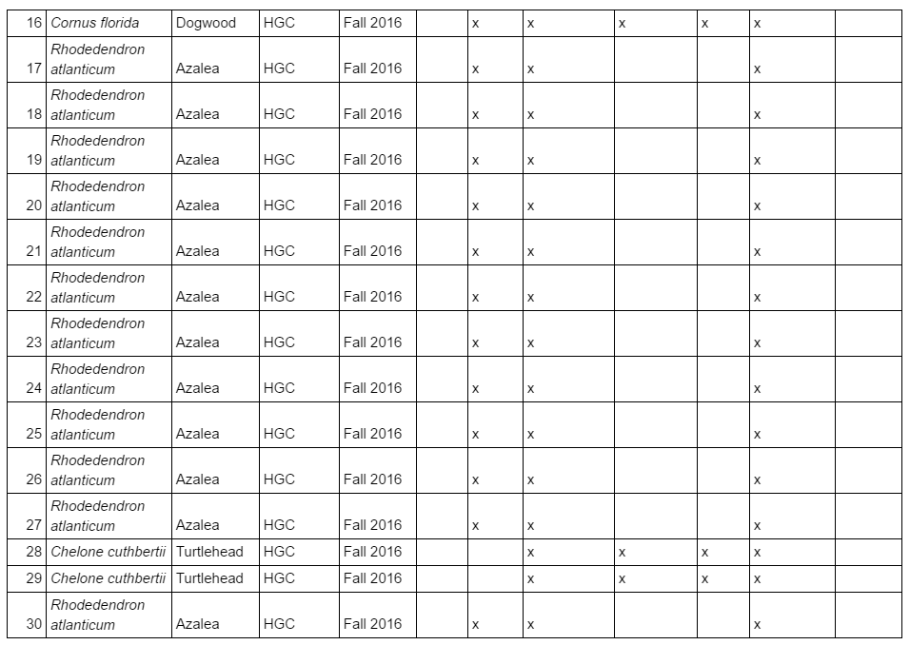

Appendix C

Table of Large Woody Species in Southern Arm of the Crim Dell

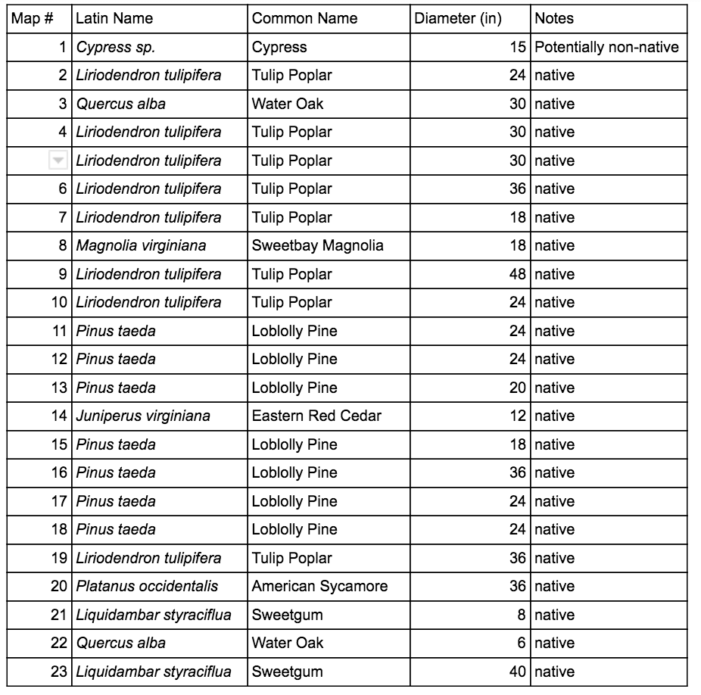

Appendix D

Metadata for Maps in Essay

- Figure 1. This map was created by Draper Aden Associates on May 11, 2016. Originally part of a plan for the entire campus, we used the Campus Stormwater/Infrastructure Improvement Site Plan for the Crim Dell.
- Figure 2. Figure 2 features the Draper Aden Associates map from Figure 1 with alterations made by Jesse Smyth. In November of 2016, Jesse used pen, pencil, and colored pencil to sketch details over the original map.
- Figure 3. This map is a digitized version of the Draper Aden Associates map with Smyth’s sketches; it includes invasive species, new plants, and erosion mats. Made in ESRI ArcMap in December of 2016 by Kendall King.
- Figure 4. This map is also a digitized version of the Draper Aden Associates map, this time clearly delineating areas where large woody species were noted on the original map. Made in ArcMap in December of 2016 by Kendall King.
- Figure 5. Figure 5 is a reproduction of Map Q from Martin Mathes “Collection of Woody Species”. Made in 1980, this map was hand drawn, and is part of a series of other drawn maps of the campus.
- Figure 6. This map combines two layers from two separate sources; the shapefile for the water feature was given to us by Tim Russell, while the contour lines were given to us by the Center for Geospatial Analysis at the College of William and Mary. An identical shapefile for contour lines exists in the James City County GIS Database.

References
Mathes, Martin. (1980). Map Q. Collection of Woody Species, 45-47.
Petrides, G. A. & Wehr, J. (1998). Eastern Trees. China: Houghton Mifflin Company.
Pimentel, D., Zuniga, R., & Morrison, D. (2005). Update on the environmental and economic costs
associated with alien-invasive species in the united states. Ecological Economics, 52(3),
273-288. doi:http://dx.doi.org/10.1016/j.ecolecon.2004.10.002
Restoration Ecology Class. (2016). Dr. Doug DeBerry, College of William & Mary. BIOL/ENSP.
Royal Horticultural Society. (2016). Bamboo Control. The Royal Horticultural Society.
doi:https://www.rhs.org.uk/advice/profile?PID=210
Van Den Berg, A. E., Maas, J., Verheij, R. A., & Groenewegen, P. P. (2010). Green space as a buffer between stressful life events and health. Social Science & Medicine, 70(8), 1203-1210. doi:10.1016/j.socscimed.2010.01.002
Virginia Department of Forestry (2001). Common Forest Trees of Virginia: How to Know Them A Pocket
Manual. Charlottesville, VA: Department of Forestry.
Virginia Department of Forestry. (2010). Common Native Trees of Virginia. Charlottesville, VA:
Department of Forestry.
Virginia Native Plant Society. (2011). Native plants for conservation, restoration, and landscaping.
Virginia Department of Conservation and Recreation.
Zavaleta, E. S., Hobbs, R. J., & Mooney, H. A. (2001). Viewing invasive species removal in a
whole-ecosystem context. Trends in Ecology & Evolution, 16(8), 454-459.
doi:http://dx.doi.org/10.1016/S0169-5347(01)02194-2

