Crisis and Emergency Management Plan

Approved by the Board of Visitors

November 2018

This Crisis & Emergency Management Plan (CEMP) plan is developed, implemented and presented pursuant to the provisions of the Code of Virginia §23.1-804 and the state mandated template for completion. The plan describes the authorities, structures and capabilities that support major incident response at William & Mary.

Crisis & Emergency Management Plan Graphic Layout

The support processes associated with emergency incident response and recovery are illustrated through four diagrams: one diagram representing the three general phases and one detailed diagram for each phase. Collectively, all diagrams illustrate the full scope and extensive range of response capabilities in the event of a major incident at William & Mary. Although the response process may appear sequential many of the tasks in the more detailed diagrams are performed simultaneously, as needed.

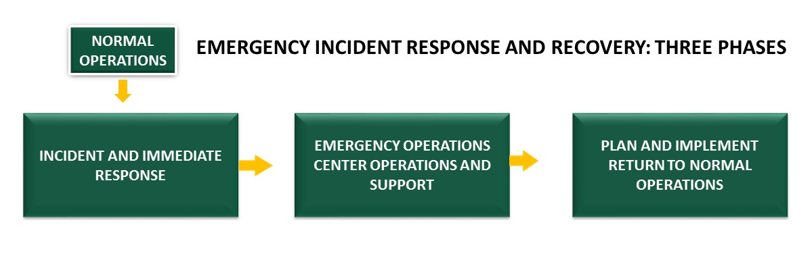

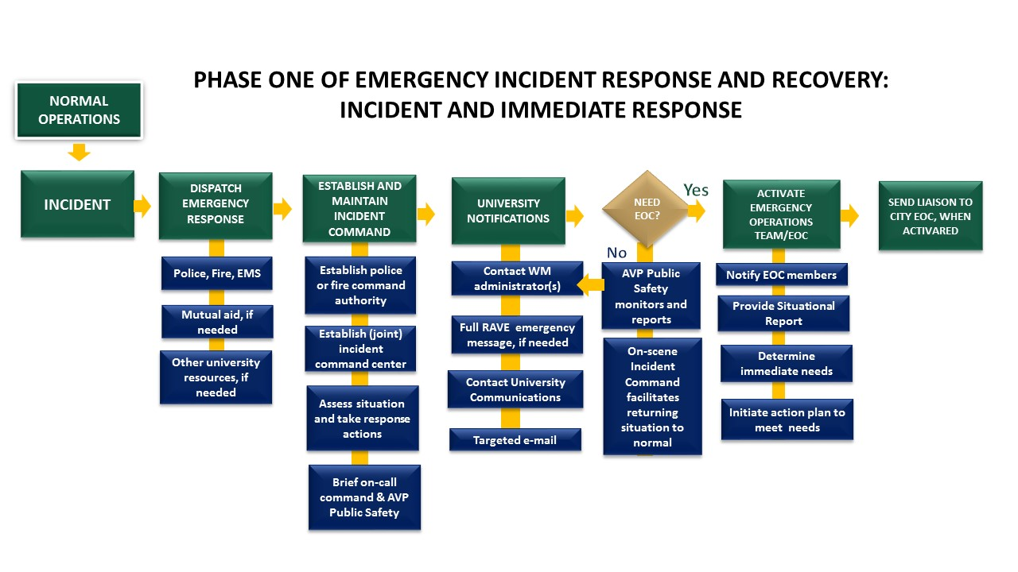
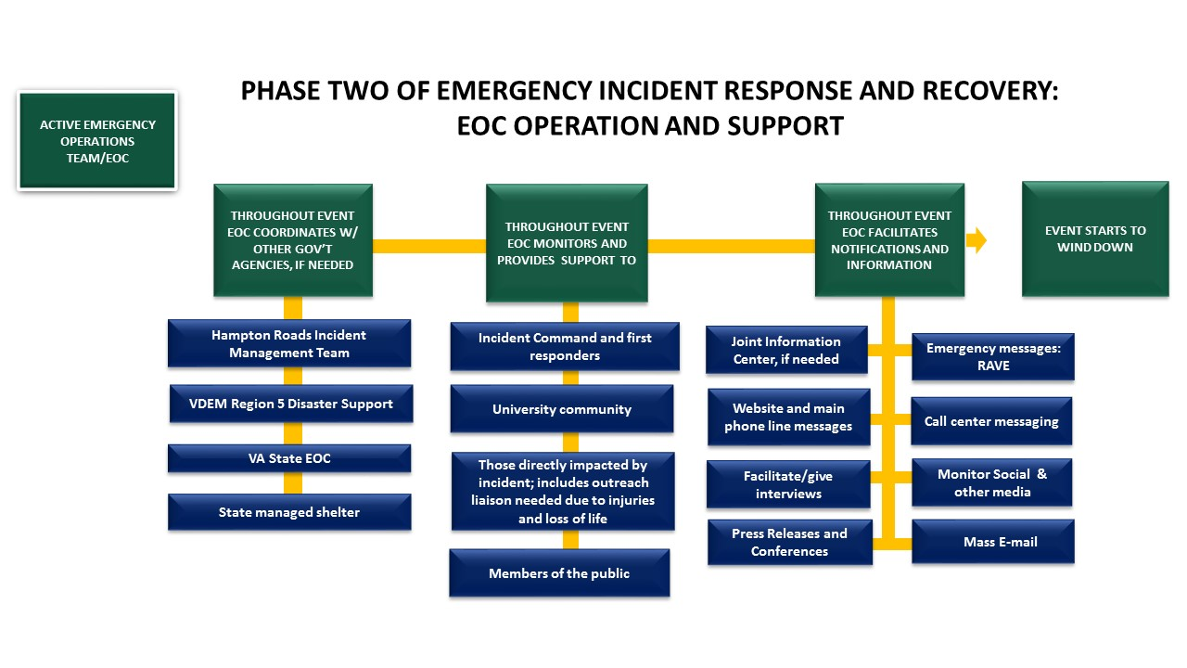
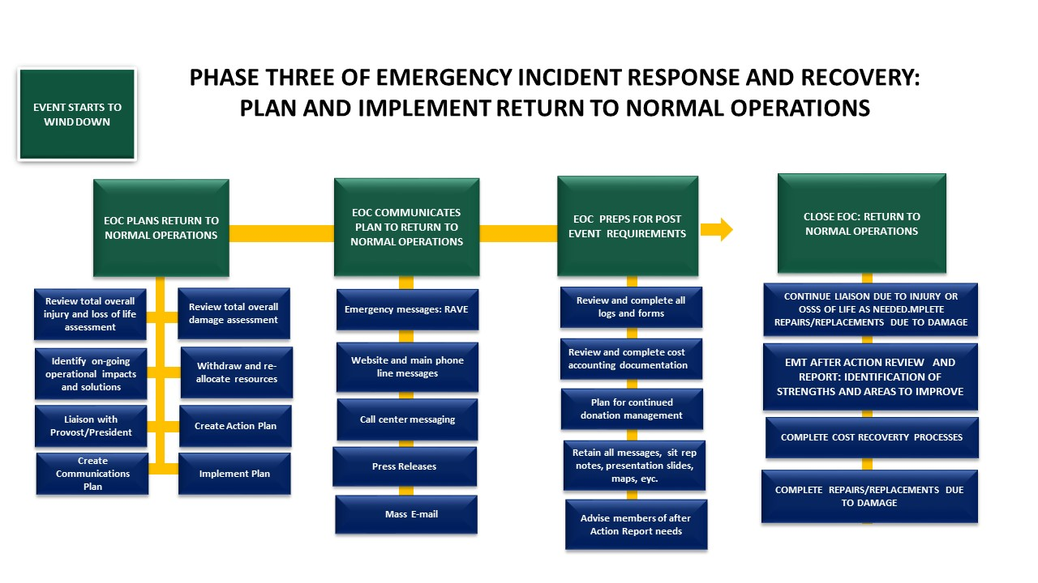
Table of Contents
Plan Documentation 8
Legal 8
Promulgation Statement 9
Approval & Implementation 10
Record of Distribution 11
Record of Changes 11
Authorities & Standards 12
Policies & Regulations 12
References 14
Introduction 15
Purpose of the CEMP 16
Scope 18
Situation Overview 18
Planning Assumptions 20
Concept of Operations 21
National Incident Management System 21
Direction, Control, & Coordination 21
Organization 23
Emergency Notification System 25
Campus Community: Roles & Responsibilities 26
Media Relations 29
Demobilization 29
Campus Recovery 29
Organization & Assignment of Responsibilities 29
Succession of Authority 29
Emergency Support Function Matrix 30
Plan Development & Maintenance 35
Program Roles, Responsibilities, & Administration 35
Training & Exercises 35
Exercise Program 36
After Action Review 36
Glossary & Acronyms 37
Glossary 37
Acronyms 43

Plan Documentation

Legal

Disclaimer

The information contained in the William & Mary Crisis and Emergency Management Plan (CEMP) has been prepared for internal use by William & Mary. The information provides guidance for managing an incident, recognizing that individual circumstance or events not anticipated by the CEMP may occur. The experience and judgment of those utilizing the CEMP is an important consideration in how and when the CEMP is used. The content represents the best opinions on the subject in conjunction with current legislative mandates. No warranty, guarantee, or representation is made by the William & Mary of the sufficiency of the information contained herein and William & Mary assumes no responsibility in connection therewith. The CEMP is intended to provide guidelines for safe practices; therefore, it cannot be assumed that all plausible and non‐plausible scenarios are contained in this document, or that other or additional information or measures may not be required.

Confidentiality

Public disclosure of this document would have a reasonable likelihood of threatening public safety by exposing vulnerabilities. It contains sensitive and confidential information that is not subject to the Freedom of Information Act (FOIA) under Virginia Code §2.2‐3705.2. Accordingly, William & Mary is withholding elements of the CEMP from public disclosure. Refer any request for a copy of this document to the William & Mary Freedom of Information Act Officer.

Promulgation Statement

The William & Mary Crisis and Emergency Management Plan (CEMP) is a multidiscipline, all-hazards plan that establishes a comprehensive framework for the management of incidents, emergencies, and events at any William & Mary campus in the Middle Peninsula region of Virginia. The plan is implemented when it becomes necessary to mobilize the resources of the identified departments and agencies to save lives, protect property and infrastructure, preserve mission continuity, and return to a state of normalcy. The plan assigns major roles and responsibilities to departments and agencies and requires planning, training, and exercising prior to a real world event to respond effectively. This plan represents a commitment by William & Mary leadership to work together to prevent, mitigate against, prepare for, respond to, and recover from emergencies in our community.

Pursuant to the provisions of the Code of Virginia §23.1-804 the following Crisis and Emergency Management Plan for William & Mary is hereby promulgated.

____________________________________ __________________________

Katherine A. Rowe Date
President of William & Mary

____________________________________ __________________________

Virginia Ambler Date
Co-Chair of the Emergency Management Team

____________________________________ __________________________

Deb Cheesebro Date
Co-Chair of the Emergency Management Team

Approval & Implementation

RESOLUTION TO APPROVE THE UNIVERSITY CRISIS AND EMERGENCY MANAGEMENT PLAN (CEMP)

WHEREAS, the Board of Visitors and the President of The College of William & Mary in Virginia are concerned with the health and well- being of its students, faculty and staff and desires that the best possible emergency service be available to them; and

WHEREAS, the §23.1-804 of the Code of Virginia requires that any public institution of higher education shall develop, adopt, and keep current a written crisis and emergency management plan; and every four years, each institution shall conduct a comprehensive review and revision of its crisis and emergency management plan to ensure the plan remains current, and the revised plan shall be adopted formally by the Board of Visitors or other governing body. Such review shall also be certified in writing to the Department of Emergency Management; and

WHEREAS, such a plan has been developed by the William & Mary Emergency Management Team in coordination with the Virginia Department of Emergency Management with input from various William & Mary departments and local municipal Emergency Management Agencies.

THEREFORE, BE IT RESOLVED that the Board of Visitors, does hereby officially adopt the College of William & Mary Crisis and Emergency Management Plan, to include plans and procedures for both natural and human-caused disasters.

I, Michael J. Fox, do hereby certify that the foregoing writing is a true, correct copy of a resolution unanimously adopted by the Board of Visitors of William & Mary at a meeting held on the 15th day of November, 2018.

________________________
Michael J. Fox
Assistant to the President and Secretary to the Board of Visitors

Record of Distribution

It is the intent, based on the sensitivity of information contained within this document that distribution is limited to those personnel, offices, departments, and agencies that have an operational “need to know.” The following list is not all inclusive; additional copies may be distributed at the direction of the Chair of the Emergency Management Team or Emergency Management Coordinator. All recipients listed below will receive an electronic copy of the CEMP. Distribution beyond the recipients listed below may not be made without authorization from the Chair of the Emergency Management Team or Emergency Management Coordinator. Requests for additional distribution of electronic or hard copies will be submitted to the Emergency Management Coordinator.

Agency/Department | Recipient Title | Distribution Method
Board of Visitors |  | Original hard copy
EMT |  | Digital Box file

Record of Changes

Submit recommended changes to this document to the Emergency Management Coordinator.

Change  Number | Section and/or  Page Number | Description of  Change | Date of  Change | Posted By
1 | Exercise schedule | Update | 10/30/19 | kt
2 | several | Staff reorg | 9/8/20 | kt
3 | Exercise schedule | various | 8/2/21 | kt

AUTHORITIES & STANDARDS

Policies & Regulations

The William & Mary CEMP is authorized and guided by provisions in the following documents:

Federal
Homeland Security Presidential Directive 5, Management of Domestic Incidents, February 28, 2003
Homeland Security Presidential Directive 8, National Preparedness, December 17, 2003
Homeland Security Act of 2002, Public Law 107-296, 116 Stat. 2135
Robert T. Stafford Relief and Emergency Assistance Act of 1988, as amended, 42 U.S.C., Public Law 93-288 as amended by Public Law 100-707
National Incident Management System, October 2017
National Response Framework (NRF), June 2016
National Disaster Recovery Framework (NDRF), June 2016
Americans with Disabilities Act
Jeanne Clery Disclosure of Campus Security Policy and Campus Crime Statistics Act (Clery Act)
Emergency Planning and Community Right-to-Know Act of 1986 (Public Law 99-499, October 17, 1986), Title III of the Superfund Amendments and Reauthorizations Act (SARA)

State
Commonwealth of Virginia Emergency Services and Disaster Law of 2000, as amended
The Code of Virginia, Title 23.1-800 et. seq.
The Code of Virginia, Title 44
The Code of Virginia §19.2-11.01
The Code of Virginia §23.1-804
Commonwealth of Virginia Governor’s Executive Order 102 (2005)
Commonwealth of Virginia Governor’s Executive Order 41 (2011)
Commonwealth of Virginia Governor’s Executive Order 50 (2012)
The Commonwealth of Virginia Emergency Operations Plan (COVEOP), March 2015, as amended

University
Emergency Closing Policy
Timely Warning Policy
Campus Violence and Threat Management Policy
Procurement Policies and Procedures
Telecommuting Policy (Continuity Operations)
Contracting and Signature Authority Policy
Hampton Roads Hazard Mitigation Plan
W&M Continuity of Operations Plan

References

FEMA Comprehensive Preparedness Guide 101, version 2.0, November 2010
FEMA Guide for Developing High-Quality Emergency Operations Plans for Institutions of Higher Education, June 2013
Emergency Management Accreditation Program (EMAP) 2016 Emergency Management Standard
National Fire Protection Association 1600 Standard
Commission on Accreditation for Law Enforcement (CALEA)

Introduction

University Mission

Established in 1693 by British royal charter, William & Mary is proud of its role as the Alma Mater of generations of American patriots, leaders and public servants. The mission of William & Mary is demonstrated through the institutions extraordinary teaching, research, and public service. Its moderate size, dedicated faculty, and distinctive history give William & Mary a unique character among public institutions, and create a learning environment that fosters close interaction among students and teachers.

The university's predominantly residential undergraduate program provides a broad liberal arts education in a stimulating academic environment enhanced by a talented and diverse student body. Masters and doctoral programs in the humanities, the sciences, the social sciences, business, education, and law provide a wide variety of intellectual opportunities for students at both graduate and undergraduate levels.

Quality research supports the educational program by introducing students to the challenge and excitement of original discovery, and is a source of the knowledge and understanding needed for a better society. The university recognizes its special responsibility to the citizens of Virginia through public and community service to the Commonwealth as well as to national and international communities.
Emergency Management Mission
William & Mary is committed to providing a safe and secure environment for its students, faculty, employees and visitors to learn, teach, work and enjoy our campus and all it offers. In pursuit of that goal the university takes a comprehensive approach to protecting the university community and preparing for any emergency.
The university employs an Emergency Management Coordinator, supervised by the Associate Vice President for Public Safety along with the Vice President for Student Affairs who serve as the Co-Chairs of the Emergency Management Team (EMT). Emergency Management priorities for the assigned staff and EMT, include but are not limited to:
  - Manage overall “All Hazards” planning and execution of emergency preparedness, response and recovery such as, but not limited to: Continuity of Operations Plan (COOP), Crisis and Emergency Management Plan, Technology Disaster Recovery Plan, Overall Emergency Operations.
  - Establish specific policies, procedures, programs in support of Emergency Management efforts. This includes any needed disaster specific response planning guides for situations such as, but not limited to: infectious disease and severe weather.

  - Develop and maintain an Emergency Operations Center physical and organizational structure for response to emergencies that cause or have the potential to cause significant disruptions to all or portions of the university.
  - Establish and maintain an emergency communications notifications system.
  - Inform the community of an emergency, disaster or potential disaster immediately upon determining the nature of the emergency.
  - Facilitate proper continued communications with the community about response and recovery efforts related to an emergency, disaster or potential disaster.
  - Develop and conduct training and exercises to prepare designated responders to fulfill necessary support functions in incident and emergency response and recovery situations.

PURPOSE OF THE CEMP

William & Mary is committed to creating, maintaining, and continuously improving a culture that reflects a responsibility to protect people, property and the environment. This commitment creates a duty for all members of our campus community to take proactive steps in preventing, responding to, and recovering from emergency situations. This is reflected in W&M’s core values, Code of Ethics, and contributes directly to W&M’s foundation for excellence in research, education and public service.

Guiding this effort in part, William & Mary’s Crisis and Emergency Management Plan (CEMP) establishes the organizational framework for the W&M community and external partners to work together to take care of our university in the worst of circumstances. The CEMP addresses the immediate requirements for an incident, emergency, or event in which normal operations are interrupted and special measures must be taken to:

- Advance the university by controlling risks thus preventing losses of human, physical and financial resources;
- Promote a safe and healthful environment that supports a thriving scholarly community, and brings continuity to our mission of teaching, learning, research and public service;
- Ensure the security of the William & Mary community so it may honor its traditions, shape the future and build positively toward a rich history;
- Reduce conditions that can create barriers to our success;
- Maintain public trust by exercising good stewardship in preventing losses and reducing the costs associated with accidents and asset losses to the greatest extent practicable;
- Promote a culture of continuous compliance with applicable standards, policies and regulations;
- Develop depth of staff oriented to support university emergency response;
- Ensure appropriate protections are in place to contribute toward the efficacious recovery of losses through the Commonwealth of Virginia’s Risk Management Plan, and Recovery Annexes of the Commonwealth of Virginia Emergency Operations Plan (COVEOP).
- Provide and analyze information to support decision-making and action planning;
- Protect and restore critical infrastructure and key resources;
- Ensure university leadership and administration continues to function before, during, and after the disruption;
- Manage communication regarding emergency response and recovery operations;
- Communicate critical information to the William & Mary community;
- Protect property and mitigate damages and impacts to individuals, William & Mary at-large, and the environment;
- Track response resources immediately and throughout response and recovery; and
- Facilitate the recovery process for members of the William & Mary community and the environment.

This plan does not supersede or replace the procedures for safety, hazardous materials response, or other procedures that are already in place within W&M. It supplements those procedures with a temporary crisis management structure. This structure provides an immediate, pre-planned means to manage needed responses and to re-establish normal operations in a timely manner.

The information contained in the W&M CEMP has been prepared for internal use by the university. The information provides general guidance for managing an incident, recognizing that individual circumstance or events not anticipated by the CEMP may occur. The experience and judgment of those utilizing the CEMP is an important consideration in how and when the CEMP is used. The content represents the best opinions on the subject in conjunction with current legislative mandates. No warranty, guarantee, or representation is made by W&M of the sufficiency of the information contained herein and the university assumes no responsibility in connection therewith. The CEMP is intended to provide guidelines for safe practices; therefore, it cannot be assumed that all plausible and non‐plausible scenarios are contained in this document, or that other or additional information or measures may not be required.

Scope

The CEMP outlines preparation for, and response to emergency situations on the William & Mary campus and may be applicable to extension campuses under certain circumstances. It is consistent with established practices relating to emergency response actions and incorporates the National Incident Management System (NIMS) to facilitate interagency coordination among responding agencies. The university will cooperate with federal, state and local emergency management agencies and other responders in the development, implementation and execution of emergency operations plans. Nothing in this plan shall be construed in a manner that limits the use of good judgment and common sense in matters not foreseen or covered by the elements of the plan.

Situation Overview

Location & Geography

The heart of William & Mary is located in Williamsburg, Virginia at latitude 37°16’15”N and 76°42’50”W longitude. Williamsburg is approximately 150 miles south of Washington, D.C. and located about midway between Richmond and Norfolk along Interstate 64. The main campus is composed of 1,200 acres; this land includes property along the scenic Lake Matoaka, the College Woods, and downtown Williamsburg. The university also owns or operates facilities located in James City County and in the City of Newport News, Virginia and Washington, D.C.

Population

The university has just under 9,000 students enrolled, many requiring accommodation for functional or access needs. William & Mary is a destination university, persons from every state and more than 68 countries, speaking more than 40 languages, are an integral part of the university community. In addition, the majority of W&M students will participate in international education programs encouraging student studies abroad. Combined with staff, the total daytime population exceeds 10,000 persons on the Williamsburg campus. This population is significantly reduced in the summer months and varies depending on summer program participation and other events. The majority of enrollees are undergraduates. Over 5,000 under graduate and graduate students live on campus in more than 80 residential facilities. W&M operates a 16,000-seat stadium and 10,000-seat arena.

Threat, Hazard, & Risk Assessment Summary

William & Mary is vulnerable to a wide spectrum of threats and hazards, whether natural, technological, or human-caused, all of which have the potential to disrupt the university’s operations, cause damage, and create casualties.

In support of the Hampton Roads Hazard Mitigation Plan (HRHMP) a quantitative and qualitative hazard identification and risk assessment (HIRA) was completed outlining the threats and hazards identified below. Assessment parameters included historical occurrence/probability, impacts to human capital/facilities/the institution as a whole, and the existing preparedness posture. Threats and hazards listed are not all-inclusive.

Natural | Technological | Human-Caused
Hurricane/wind | Hazmat (major) | Structure Fire
Flooding (pluvial) | Radiological Release | Major Criminal Incident
Winter storm
Tornado
Infectious Disease
Earthquake
Drought
Wild fire

Structure fires represent a persistent threat to the campus and may cause activation of the CEMP to coordinate relocation of persons or activities. The Wren Building burned in 1705 and 1859. Another fire deliberately set in 1862 was an act of warfare. Since 1865, documents have been noted to contain mention of structure fires involving residence halls and the president’s house. Better documented are fires in 1925 (dining hall), 1930 (Tyler Hall) and 1983 (Jefferson Hall). The campus last had a major structure fire in August 2005. Seventy Preston Hall residents were temporarily relocated to commercial lodging as a result. In November 2017 a transformer coolant leak resulted in a fire which destroyed the equipment and closed Gooch and Fauquier Halls displacing 396 residents for 2-days while power was restored. W&M is a densely populated residential campus providing opportunity for the transmission of infectious diseases such as MRSA and more commonly strains of influenza which are seldom fatal. W&M has the distinction of being the only public university campus in Virginia within a power plant 10-Mile Emergency Planning Zone (EPZ), and eastern sections of the campus are within the 800-meter evacuation corridor of the CSX railroad line (which has been used to transport Bakken crude oil). The university is responsible for a “high hazard” earthen dam which created Lake Matoaka and on which Jamestown Road was constructed. Finally, while the university provides comprehensive measures to prevent criminal acts on campus, no institution can discount the possibility of a major criminal incident. Universities and colleges across the country have experienced acts of violence resulting in significant loss of life and damage to property. In some instances while property could be repaired it was deemed inappropriate to continue the prior facility use and the space had to be taken off-line.

Capability Assessment

William & Mary has a strong foundation of planning with physical and technical capabilities to support implementation of this plan. W&M’s highly knowledgeable and experienced staff has responded to and recovered from several local and declared disasters in the course of their careers at this and other academic institutions or related facilities. Among the staff are credentialed engineers, architects, planners, and trades personnel. The university maintains relationships with pre-approved and vetted contractors with excellent histories of service. The university has a strong financial standing and continues to show a serious commitment to investing in emergency preparedness and business continuity.

Mitigation Overview

William & Mary is positioned to effectively prevent, mitigate against, prepare for, respond to, and recover from disruptive incidents. A key factor in meeting this objective is the university’s contribution in developing, updating, and maintaining the regional hazard mitigation plan. The Hampton Roads Hazard Mitigation Plan, last released in January 2017 addresses the institution’s HIRA. The university’s participation further establishes a broad regional community vision and guiding principles for addressing hazard risk, including the development of specific mitigation actions designed to eliminate or reduce identified vulnerabilities.

Planning Assumptions

The William & Mary CEMP is predicated on a realistic approach to the problems likely to be encountered during a major emergency or disaster. Hence, the following assumptions are made and should be used as general guidelines in such an event:

- William & Mary maintains a current CEMP, trains personnel to evaluate and respond to incidents, emergencies, and events, and maintains a roster of emergency response personnel to make such response in an immediate and effective manner.

- Personnel assigned responsibilities in the CEMP are familiar with requirements in the CEMP and are prepared to identify and assist in response to an incident/emergency/event by developing plans within their respective campus or department that supports the CEMP.

- The university will issue emergency notifications or warnings to the campus community any time a life safety situation exists, or such occurrence is probable, or when determined advisable in the exercise of caution.

- The City of Williamsburg and the university will continue to coordinate and develop plans compatible with National Incident Management System (NIMS) guidance.

- Public safety entities of the university will implement required NIMS activities and effectively use the Incident Command System when responding.

- The university will activate an Emergency Operations Center, when necessary and in coordination with community partners, to assist Incident Commander(s) and the Emergency Coordination Officer in mobilization of resources and personnel required in response to the situation.

- The university will maintain its CEMP and coordination with local officials and consistent with §23.1-804 of the Code of Virginia and Virginia Department of Emergency Management (VDEM) guidance.

Concept of Operations

National Incident Management System

William and Mary has adopted the National Incident Management System (NIMS) as the standard for incident, emergency, and event management. As both a national best practice and a state compliance requirement, NIMS sets common goals across all fundamental incident management components, including a flexible, scalable, and modular organization; management of incidents at the lowest operational level possible; unified command wherever possible; Multi-Agency Coordination Systems; common terminology; standardized incident action planning; comprehensive resource management; integrated communications systems; and pre-designated facilities.

W&M’s emergency response organization will implement a unified incident management strategy that aligns university department functions within the Incident Command System to manage, coordinate, and direct resources committed to an incident, emergency, or event. This structure supports effective coordination across personnel, facilities, equipment, and systems by maintaining a manageable span of control, staffing functional positions only when needed, and ensuring personnel safety and accountability.

Direction, Control, & Coordination

Incident Command System

William & Mary utilizes the Incident Command System (ICS, a NIMS component) for incident, emergency, and event management. ICS is an emergency management system designed to enable effective and efficient management of incidents by integrating a combination of facilities, equipment, personnel, procedures, and communications operating within a common organizational structure. ICS is widely applicable to organize both short-term and long-term field operations for the full spectrum of emergencies.

Unified Command

Unified Command (UC) will be used when there is more than one W&M department or organization with incident jurisdiction, or when incidents cross political jurisdictions. Departments will work together through the designated members of the UC to establish common objectives and strategies under a single Incident Action Plan (IAP) while retaining and preserving respective authorities.

In large-scale incidents/emergencies/events, key Emergency Operations Team (EOT) members, department heads, contractors, and other stakeholders may establish a Unified Command Post (UCP) at or near the incident site. They will notify other departments/agencies that need to be present at the UCP. They will jointly appoint command and general staff as necessary to carry out incident objectives.

Area Command

When a single incident covers a large geographical area or there are multiple incidents, multiple local ICS organizations may be required. When multiple organizations are operational, it may be necessary to establish an Area Command (AC) organization. An AC is an organization established to oversee the management of multiple incidents that are being handled by an ICS organization or to oversee the management of large or multiple incidents.

AC has the responsibility to set the overall strategy and priority, allocate critical resources according to the priorities, and to ensure that all incidents are properly managed and established objectives are achieved.

Multi-Agency Coordination System (MACS)

The primary function of multi-agency coordination is to coordinate activities above the field level and to prioritize the incident demands for critical or competing resources, thereby assisting the coordination of the operations in the field.

The Multi-Agency Coordination System (MACS) consist of a combination of elements: personnel, procedures, protocols, business practices, and communications integrated into a common system. For the purpose of coordinating resources and support among multiple jurisdictions, MACS can be implemented from a fixed facility or by other arrangements outlined within the system.

Emergency Operations Center (EOC)

One of the most commonly used elements of the MACS is the EOC. In emergency situations that require additional resource and coordination support, the W&M EOC will be used. In some cases the EOC may also manage direction and control of the incident.

Upon activation, communications and coordination will be established between Incident Command and the EOC. Additionally, the EOC will establish communication and coordination with neighboring jurisdiction EOCs and when necessary the Commonwealth of Virginia EOC to coordinate response and recovery activities. The university’s EOC organization will be discussed in detail later in this Plan.

Department Operations Center (DOC)

A department operations center (DOC) is a coordination point that focuses on a single department’s internal incident management and response. An example would be a DOC set up by Facilities Management to manage snow removal operations.

University departments may choose to establish a DOC to coordinate their emergency management activities. The DOC will be linked to the EOC and actions will be coordinated through the departmental representatives in the EOC.

Organization

On-Scene Incident Commander(s)

Most emergency situations are handled routinely by the front-line staff in departments such as Police, Athletics, Facilities Management, Environmental Health and Safety, Fire Prevention, Housing and Residence Life, Recreation and Wellness, Student Engagement and Enrollment Services, and others, with response activities conducted at the field level. ICS is routinely implemented to organize response to the emergency or disaster, incorporating the functions, principles and components of ICS (unified command, action planning, span of control, hierarchy of command). Once an emergency or disaster has occurred or is imminent, the responding department establishes on-scene incident command, including the designation of an Incident Commander (IC) and establishment of an Incident Command Post (ICP). The IC provides command and control, which includes planning, accountability, and carrying out a plan to mitigate the situation. The IC allocates resources assigned to the incident, including those activated through local mutual aid agreements. In the event that multiple departments/areas within university are affected, an on-scene IC may be present at each of several separate incidents. Depending on the scope of the incident/emergency/event, resources needed, and coordination necessary within and outside the university, the Emergency Operations Center (EOC) may be activated to provide support for IC field operations.

Emergency Management Team

William and Mary's Emergency Management Team (EMT) is responsible for overall coordination of the university’s emergency preparedness efforts. The Emergency Management Team operates under the authority of the President and is co-chaired by the Vice President for Student Affairs and Associate Vice President for Public Safety and Chief of Police. The team is responsible for the planning and execution of emergency preparedness, response and recovery. EMT members staff EOC positions during incidents providing high-level support for the Incident Commander, and the EOT’s functional units in execution of the plan. Accordingly, the responsibilities of this body include:

- Communicate critical emergency information to the campus community.
- Review plans for effectiveness, community inclusiveness, and recommend well developed plans to the President for approval.
- With authority from the President, approve all related policy and procedures.
- Identify critical functions and systems that must be restored and maintained.
- Monitor the recovery process to ensure the recovery is proceeding according to plan and to provide guidance/assistance as needed.

Emergency Management Team Members:

  - Vice President for Student Affairs - Co-Chair
  - Associate Vice President for Public Safety and Chief of Police – Co-Chair
  - Chief Operating Officer
  - Vice Provost for Research
  - General Counsel (Legal Advisor)
  - Chief Information Officer
  - Associate Vice President for Facilities Management
  - Associate Vice President for University Relations
  - Associate Vice President for Student Affairs
  - Associate Provost and Assistant to the President
  - Director of Auxiliary Services
  - Director of Operations & Support Services (VIMS)
  - Emergency Management Coordinator
  - Academic Department Chair
  - International Travel & Security Manager

Emergency Operations Center & Emergency Operations Team

W&M’s Emergency Operations Center (WMEOC) is activated to support the resource and information needs of Incident Commanders responding to an incident(s) and special operations coordination. Conditions that can cause the EOC and EOT to be activated include:

- A request from Incident Command when their resources are insufficient to effectively continue response activities without assistance.
- A determination by the Emergency Coordination Officer or Incident Commander that incident communications require a higher level of coordination or special operations support.
- Coordination of activities in advance of an event (such as emergency preventative measures taken before hurricane landfall).

Once activated, the EOC/EOT performs many functions to include:

- Provides overall incident management and coordination.
- Determines the scope and impact of the incident.
- Serves as the primary information collection and dissemination clearinghouse.
- Issues communications through University Relations and Joint Information Center.
- Requests additional resources from outside agencies. Coordinates with local, state, and federal government agencies.
- Maintains situational awareness and a common operating picture throughout the incident.
- Prepares Incident Action Plans for multi‐operational period incidents.
- Implements university business continuity of operations plans (COOPs).
- Staff incident management positions.
- Coordinate special operations (Call Center, Media Monitoring; etc.).

External Support

Incidents may also impact the surrounding community. If this occurs, the university will make every effort to coordinate and work with local, State, and federal officials in their delivery of emergency services. For coordination purposes with State agencies, the AVP for Public Safety and Chief of Police serves as the university’s Emergency Coordination Officer (ECO). The Emergency Management Coordinator serves as the secondary ECO assuming those responsibilities in the absence of the primary coordinator.

The City of Williamsburg Emergency Coordinator will serve as the point of contact to William & Mary when making resource requests to the Virginia Emergency Operations Center (VEOC). This operational policy to channel resource requests through the local government is consistent with the Code of Virginia §44‐146.18, and §23‐9.2:9, which mandates a state institution of higher education to maintain a Crisis and Emergency Management Plan, update it regularly, and integrate it with the local emergency operations plan.

William & Mary, as a state agency, has a role and responsibility to support the Virginia Emergency Support Team (VEST) agencies during a declared emergency or when otherwise needed. Upon receipt of a mission request from the VEOC, the university will make a determination if there are personnel and resources available to meet the mission requirements. W&M will promptly notify the VEOC regarding the status of their request. If university resources are available to fill the request, they will be deployed following receipt of a mission assignment from the VEOC.

Emergency Notification System

William & Mary has a number of ways to communicate to the campus community during an emergency situation. In a serious life safety situation, the university will activate three 120-decibel emergency sirens stationed across the campus. Another part of the notification system is an alerting service which sends out notifications through text messages, email, campus network and, some popular social media applications. The service is utilized to inform you about campus-wide emergencies, natural disasters and closings for inclement weather.

Campus Community: Roles & Responsibilities

Board of Visitors

Adopt the CEMP for the purposes of protecting the lives of the campus community as well as the property and assets of the university. Support the threat assessment committee, pursuant to § 23.1-804 of The Code of Virginia. Designate the administrator ultimately responsible for emergency management.

President

This plan is activated under the authority of the President who also approves policies having effect on this plan. Approves the CEMP.

Provost

The authority to close the university, to cancel classes or to maintain academic activity is delegated to the Provost who makes all such decisions in consultation with the President and the Emergency Management Team. The Provost assumes the authorities of the President in his/her absence.

Co-Chairs, Emergency Management Team

The Co-Chairs of the Emergency Management Team oversee development of policy, plans and protocols necessary for emergency operations. Upon consultation with President, the Co-Chairs shall be responsible for coordinating a declaration of emergency with the City Manager. In an emergency/disaster the Co-Chairs or a designee determines activation levels, activates the EOC and necessary functions, and assumes the role of EOC Manager.

Emergency Management Team

William and Mary's Emergency Management Team (EMT) is responsible for overall coordination of the university's emergency preparedness efforts. The Emergency Management Team operates under the authority of the President and is co-chaired by designated executives. The Team is responsible for the planning and execution of emergency preparedness, response and recovery. EMT members staff EOC positions during incidents providing high-level support for the Incident Commander, and the Emergency Operation Team’s functional units in execution of the plan. Accordingly, the responsibilities of this body include:

      - Communicate critical emergency information to the campus community.

      - Review plans for effectiveness, community inclusiveness, and recommend well developed plans to the President for approval.

      - With authority from the President, approve all related policy and procedures.

4. Identify critical functions and systems that must be restored and maintained.

5. Monitor the recovery process to ensure the recovery is proceeding according to plan and to provide guidance/assistance as needed.

Emergency Operations Team
The Emergency Operations Team (EOT) is responsible for the execution of the CEMP and its annexes during an incident. The EOT is comprised of members of the EMT, senior management and other personnel representing functional areas and special capabilities identified in position function plans. Members are responsible for ensuring that their plans identify the resources necessary for successful execution. The EOT includes both primary and alternate members. Alternate members direct and execute plan responsibilities in the absence/unavailability of the primary member or during their shift if around-the-clock operations are required. All primary and alternate members must be knowledgeable of overall CEMP. Members must also be available during a crisis situation. The composition of the EOT may vary depending on the type of emergency.

Accordingly, the responsibilities of this body include:

- Recommend the allocation of resources required to reduce identified vulnerabilities.

- Recommend the allocation of resources required to accomplish the purposes of the

- Emergency Operations and Continuity of Operations Plans

      - Ensure coordination with external agencies and resource providers.

      - Delegate necessary authorities for incident stabilization and protection of life and property.

Incident Commander

The Incident Commander is the individual responsible for the command and control of all operational aspects of the emergency response at the scene. The determination of Incident Commander is based upon the type of incident occurring. In an incident requiring a tactical response by police, fire, or EMS the appropriate supervisor will assume the role of Incident Commander.

Building Emergency Coordinators

William & Mary has identified Building Emergency Coordinators (BECs) who will be responsible for disseminating information and instructions to building occupants. These coordinators are critical resources in emergency preparedness and will be provided training and materials to accomplish their tasks. These individuals are responsible for familiarizing themselves with emergency plans and for ensuring that building occupants have an understanding of procedures related to emergencies both campus-wide and within their specific area. BECs are responsible for developing and maintaining an emergency plan for their respective building or area.

Faculty and Staff

Faculty and staff shall familiarize themselves with applicable emergency plans and procedures and evacuation routes. Faculty and staff should understand that students will look to them for leadership during an emergency. They should know who the building coordinator is for their building and take instruction from that coordinator in the event of an incident. Faculty and staff must be prepared to assess situations quickly but thoroughly, and use common sense in determining a course of action.

During a recovery period, faculty and staff will be provided with instructions about returning to their workplace.

Liaison to City of Williamsburg EOC

The City of Williamsburg maintains an Emergency Operations Center which is activated under its protocols for the declaration of an emergency. The university provides a liaison who operates in the EOC when activated. That representative also participates in planning meetings, tests and exercises performed under the auspices of the City’s EOC.

Emergency Management Coordinator

Maintain the EOC in a constant state of readiness. Develop and maintain the EOP and other relevant plans. Assume duties as directed by the Co-Chairs of the EMT or EOC Manager. Maintain the training and exercise program to better prepare designated staff for emergency response and recovery tasks. Coordinate directly with the Williamsburg Emergency Manager and other public safety officials in related planning, preparation, response and recovery efforts.

Emergency Coordination Officer (ECO)

Identification of an ECO, and alternate ECO, is required by the state to function as the primary point of contact for agency emergency management programs. Designation of individuals to these roles implies to the Office of the Secretary that these persons are directly responsible for the direction of emergency management programs on the campus.

Emergency Management Coordinator (City of Williamsburg)

Maintain the local emergency management program and the EOC from which emergency operations will be directed. The Coordinator will contact the VEOC with requests for resources on behalf of the university when local capabilities are exceeded.

Media Relations

University Communications staff, upon notification, should report to the WMEOC and/or designated Joint Information Center (JIC). The City of Williamsburg Public Information Officer (PIO) is typically responsible for the activation, operation, and demobilization of the JIC, unless the incident is isolated to the campus. The JIC may be a physical location or operated virtually depending on the scope of operations. The PIO function is to coordinate press releases with the Incident Commander/Unified Command.

Demobilization

The Incident Commander/Unified Command will determine when response operations can be demobilized. Demobilization requires the deactivation of the EOC (if applicable) and the compilation of incident documentation. The Planning Section, if activated and in conjunction with the IC/UC, will develop a written or verbal demobilization plan as early in the incident as possible.

Campus Recovery

Aligning with the university’s incident response priorities, the first recovery step for any incident is to establish a safe and secure campus. Restoration of critical infrastructure and facilities is then followed by resumption of the instructional and research environment. Working with the Provost, the EMT Chair will provide strategic guidance to the EOC and/or Office of Emergency Management and other university departments.

Organization & Assignment of Responsibilities

Succession of Authority

Pre-identifying orders of succession is critical to ensuring effective leadership during an emergency. In the event an incumbent is incapable or unavailable to fulfill his/her essential duties, successors have been identified to ensure there is no lapse in executive leadership. Authority shall return to the university President when he/she is capable of resuming essential duties or an interim or permanent replacement has been installed by the Board of Visitors. The university’s orders of succession and method of notification to personnel are:

Position | Successor #1 | Successor #2 | Successor #3
President | Provost | Chief Operating Officer | Vice President for Student Affairs
Provost | Vice Provost, Research and Graduate Studies | Vice Provost for Academic and Faculty Affairs | Vice Provost for International Affairs and Director of the Reves Center
Chair, Emergency Management Team | Vice President for Student Affairs | AVP for Public Safety and Chief of Police | AVP for Student Affairs and Director of Residence Life
AVP for Public Safety and Chief of Police | Major | Patrol Police Lieutenant | Administrative Police Lieutenant
AVP for Facilities Management | Director of Operations and Maintenance | Director of Planning, Design and Construction | Sr. Review Electrical Engineer

Emergency Support Function Matrix

The WMEOC is based on a functional support model and members are grouped into sections to enhance collaboration and effectiveness. A designated EOC Manager provides overall leadership and control of support operations. Positions include:

POSITION NO. | SECTION | RELATED FUNCTION
1 | Policy Section  Chief Operating Officer | Liaison with President and Provost  Financial Management
2 | Vice President for Student Affairs | Co-Chair of the EMT, Student community
3 | AVP for University Relations | Internal and external communications
4 | General Counsel | Legal issues
5 | Vice Provost for Research | Academic programs and research labs
6 | Operations Section  AVP for Public Safety and Chief of Police | Co-Chair of the EMT, First responders, public  safety and security , EOC operations
7 | AVP for Facilities Management | Facilities planning, management & recovery
8 | AVP for Student Affairs (Campus Living) and  Director for Residence Life | Student housing

POSITION NO. | SECTION | RELATED FUNCTION
9 | Planning and Logistics Section  Director of Auxiliary Services | Support operations: food service, transportation
10 | Assistant To The Vice Provost for  Research & Graduate/Professional Studies | Supplies, donations, procurement, financial processing
11 | Chief Information Officer | Information technology systems
12 | Academic Dept. Chair and Arts and Sciences Emergency and Planning Coordinator | Academic programs and research labs
13 | International Travel & Security Manager | International Students
14 | Communications Section  Director of News & Media | Communications: Press releases and all other messaging
 | Communications staff members as  determined by Director of News Media. | Communications: assist w/messaging & monitoring  social media
15 | EOC  Emergency Management Coordinator | EOC Facilitator for Process (notifications, tech support,  call center)
16 | Director of Risk Management | EOC Facilitator for Support Staff (logs, forms, phone lines)
17 | Associate Provost and Assistant to the  President | Williamsburg EOC Liaison (located in the City EOC)
WMEOC staff are members of the EOT assigned to emergency support positions when the center is activated. University employees familiar with the responsibilities and authorized to make resource decisions are designated to fill a particular position. Usually one of these employees is also a member of the EMT and functions as the primary contact for the position. The primary contact, or the next in succession if the primary is unavailable, is responsible for developing the operation cycle “plan of action” and coordinating the relief schedule. Other EOT members are designated to perform special operations required as consequence of an incident; i.e., call center, media monitoring, donation management, etc.

- EOC Manager

A co-chair will normally function as the EOC Manager. The EOC Manager is responsible for communications with senior administrators for the university (President and Provost). Manager exercises leadership over the operations of the WMEOC and is responsible for activating and staffing the EOC, authorizing resource request, approving internal and external communications, and compliance with applicable laws.

- Chief Operating Officer / Financial Management

The COO supports state and federal reimbursement of expenses when such programs are available. This position authorizes use of the disaster expenditure index and is responsible for the proper expenditure of university funds.

- Student Community Support

Student Community Support is responsible for call center operations, counseling services, family re-unification, and donation management. Student Community Support is also responsible for health concerns including medication distribution, infectious disease control, and liaison with hospitals and the Virginia Department of Health. Student Community Support will coordinate with the AVP for Human Resources to establish accountability of staff, students, faculty and guests on the campus.

- University Communications

University Communications is responsible for all internal and external communications. They are responsible for media and social media monitoring, rumor control and directly supports the call center. University Communications is responsible for scheduling news conferences and press releases. As necessary this communicator will represent the university in the public media,

- General Counsel

General Counsel is responsible for advising EOC leadership on legal concerns associated with emergency operations.

- Academic Programs and Research

Academic Programs and Research is responsible for the continuation/resumption of academic programs and special considerations and risks associated with university research. This may include alternative classrooms and may provide planning expertise in research and analysis.

- Public Safety and Security

Public Safety and Security is responsible for providing information from the Incident Command Post, if one exists, to the EOC and post incident safety/security planning. This liaison will communicate closely with first responders at the scene and will provide situational updates to the EOC. The AVP for Public Safety also assist with the EOC Operations.

- Facility Planning, Management & Recovery

Facility Planning, Management & Recovery is responsible for preventative/protective measures, damage assessment, building inspection, utility provider liaison, and historic preservation. Following a disaster FPM&R is responsible for coordinating restoration of the built environment.

- Student Housing

Student Housing is responsible for residence hall evacuations, temporary sheltering and emergency communications with residences.

- Auxiliary Services

Auxiliary Services is responsible for food, water, transportation and refuge of last resort operations.

- Logistics / Supply Unit

The Logistics / Supply Unit will locate, procure, and issue resources such as personnel, supplies, facilities, contracting services & equipment for the incident. This Supply Unit will determine if requests can be met internally or through other agencies, will obtain permission for expenditures, organize and forward all requests to either Procurement or the EOC Manager.

- Information Technology Operations

Information Technology Operations is responsible for the university phone, cable, and computer systems maintenance, testing, backup, and recovery.

- Academic Programs and Research

Academic Programs and Research monitors and coordinates directly with academic staff for the continuation/resumption of academic programs and research.

- International Student Affairs

This position is responsible for coordinating Reves staff in meeting the special needs of the campus’s substantial international student population. Also, this position assists the logistics unit.

- Internal and Public Information

This communicator is responsible for creation and distribution of university news and information including the scripts for the call center.

- EOC Facilitator

Facilitator is responsible for assuring the EOC is in a state of operational readiness and for situation awareness displays in the EOC. The EOC Facilitator has responsibility for coordinating technical support, system operators and other resources.

- EOC Facilitator

Facilitator is responsible for supporting staff assigned to maintain logs, completing ICS forms and other administrative tasks.

- Williamsburg EOC Liaison

The Williamsburg EOC Liaison reports to the City EOC when activated and represents the university’s interests and partnership during emergency operations. Liaison relays critical incident information concerning the university to the WMEOC or the presumptive EOC Manager if the WMEOC is not yet activated. That representative also participates in planning meetings, tests and exercises performed by the City’s EOC.

Plan Development & Maintenance

Program Roles, Responsibilities, & Administration

Board of Visitors

In accordance with Code of Virginia §23.1-804, the board of visitors shall develop, adopt, and keep current a written Crisis and Emergency Management Plan (CEMP). The plan shall include a provision that the Department of Criminal Justice Services and the Virginia Criminal Injuries Compensation Fund shall be contacted immediately to deploy assistance in the event of an emergency as defined in the emergency response plan when there are victims as defined in the Code of Virginia § 19.2-11.01. The Department of Criminal Justice Services and the Virginia Criminal Injuries Compensation Fund shall be the lead coordinating agencies for those individuals determined to be victims, and the plan shall also contain current contact information for both agencies.

President

In accordance with Code of Virginia §23.1-804, the Chief Executive Officer shall annually review the institution’s CEMP, certify in writing that they have reviewed the plan, and make recommendations to the institution for appropriate changes to the plan.

Associate Vice President for Public Safety and Chief of Police

The Associate Vice President for Public Safety and Chief of Policy is responsible for coordinating the preparation and updating of the CEMP as required. The AVP will collaborate as needed with internal and external partners.

The AVP will coordinate the annual review of the CEMP by the Chief Executive Officer and document the process per Code of Virginia §23.1-804. In addition, every four years the AVP will oversee a comprehensive review of the CEMP and secure its formal adoption by the governing board.

Emergency Support Functions

Emergency Support Functions bring together personnel that have authority, expertise, or a combination thereof, to determine a functional solution in response to an incident. ESFs can be used singularly, or in combination to resolve an incident and lay the foundation for recovery efforts.

Training & Exercises

Trained and knowledgeable personnel are essential for the prompt and proper execution of William & Mary’s Crisis and Emergency Management Plan (CEMP), Emergency Action Plans (EAP), and Continuity of Operation Plan’s (COOP). Personnel with emergency management responsibilities will be provided with training opportunities to better understand their roles and responsibilities during an incident. Awareness information and training will be provided to the campus community.

Exercise Program

Drills, tabletop and functional exercises are conducted as part of the Training & Evaluation (T&E) program established to build and maintain the university’s emergency capabilities. Major components of this program include training staff in their responsibilities, conducting periodic refresher training and validation of the university’s plans and procedures, systems, and equipment through exercise. A multi-year improvement planning process has been established for this purpose and is referenced in the following tables. In accordance with §23.1-804 of the Code of Virginia, the university conducts an annual functional exercise of the emergency operations plan. These exercises make general use of Homeland Security Exercise and Evaluation Program (HSEEP) standards. These standards have been useful in providing a clear, programmatic and repeatable method for everything from exercise concept development to improvement planning.
2021 T&E Plan
1st Q | 2nd Q | 3rd Q | 4th Q
 | VOPEX Rehearsal | Surry VOPEX
Alert/Notification Drill | Alert/Notification Drill | Alert/Notification Drill | Continuity Plan Seminar

2022 T&E Plan
1st Q | 2nd Q | 3rd Q | 4th Q
 | Exercise TBD | TBD Seminar | Continuity Plan exercise
Alert/Notification Drill | Alert/Notification Drill | Alert/Notification Drill

After Action Review

After Action Reports (AAR) and Improvement Plans (IP) developed from actual incidents or exercises are used to refine and adjust plans. The annual functional exercise, conducted with our jurisdictional partners, is typically based on a hazard or threat that will impact all of our agencies. These events encourage us to develop coordinated plans prior to the exercise and expose weaknesses in our plans through exercise. Similarly, actual events involving activation of our plans also expose the strengths and weaknesses of our plans. Each of these situations will receive in follow up a highly detailed AAR and IP which describe the actions taken and identify areas for improvement.

Glossary & Acronyms

Glossary

Campus Community: Refers to students, faculty, staff, visitors, vendors, and contractors on, or in, university property.

Command Post / Incident Command Post (ICP): That location at which primary command functions are executed; usually co-located with the Incident Base, also referred to as the Incident Command Post.

Communications Plan: This plan coordinates the use of available communications means and establishes assignments for certain functions to inform members of the campus community and monitor communications concerning the university.

Continuity of Operations Plan: A plan of action to continue business functions of a department/unit/organization after a disaster threatens to prevent them from resuming and/or continuing.

Crisis and Emergency Management Plan: An all hazards incident management document that provides guidance intended to preserve life, protect property, and contain an incident or emergency on the local campus in order to continue the university’s mission.

Decontamination: The process of making people, objects, or areas safe by absorbing, destroying, neutralizing, making harmless, or removing the Hazardous Materials/HAZMAT.

Emergency: Any occurrence, or threat, whether natural or human-caused, which results or may result in substantial injury or harm to the population or substantial damage to or loss of property or natural resources and may involve governmental action beyond that authorized or contemplated by existing law because governmental inaction for the period required to amend the law to meet the exigency would work immediate and irrevocable harm upon the citizens or the environment of the Commonwealth or clearly defined portion or portions thereof.

Emergency Alert System: A network of broadcast stations interconnecting facilities authorized by the Federal Communications Commission (FCC) to operate in a controlled manner to warn and inform the public of needed protective actions in the event of a disaster or emergency situation.

Emergency/Disaster/Incident: An event that demands a crisis response beyond the scope of any single line agency or service and that presents a threat to a community or larger area. An emergency is usually an event that can be controlled within the scope of local capabilities; a major emergency or disaster usually requires resources beyond what is available locally.

Emergency Coordination Officer: The person serving as the primary conduit between the state department of emergency management and the university with regard to emergency preparedness. The ECO coordinates planning, training, exercising, and all other activities related to the phases of emergency management.

Emergency Management: The process of coordinating available resources to effective manage emergencies or disaster that threaten the entity or institution, thereby saving lives, injury, and minimizing economic loss. This involves four phases: mitigation, preparedness, response, and recovery.

Emergency Action Plan: A department/area/unit specific set of guidelines and procedures for use during an imminent life safety event (e.g. building fire, severe weather, hostile intruder, etc.).

Emergency Operations Center: A facility or platform from which government directs and controls its emergency operations; where information about the status of the emergency situation is officially collected, assimilated, and reported on; where coordination among response agencies takes place; and from which outside assistance is officially requested.

Evacuation: Assisting people to move from the path or threat of a disaster to an area of relative safety.

Exercise: An activity designed to promote emergency preparedness; test or evaluate emergency operations plans, procedures, or facilities; train personnel in emergency response duties; and demonstrate operational capability. Exercises include seminars, workshops, tabletops, drills, games, and functional and full scale exercises.

Federal Disaster Assistance: Aid to disaster victims and/or state and local governments by federal agencies under provisions of the Robert T. Stafford Relief and Emergency Assistance Act of (PL 93-288).

Geographic Information System: A computer system capable of assembling, storing, manipulating, and displaying geographically referenced information, i.e., data identified according to their locations.

Hazard: Any source of danger or element of risk to people or property.

Hazardous Materials: Substances or materials that may pose unreasonable risks to health, safety, property, or the environment when used, transported, stored or disposed of, which may include materials that are solid, liquid, or gas. Hazardous materials may include toxic substances, flammable and ignitable materials, explosives, or corrosive materials, and radioactive materials.

Hazardous Materials Emergency Response Plan: The City of Williamsburg developed this in response to the requirements of Section 303 (a) of the Emergency Planning and Community Right-to-Know Act (Title III) of Superfund Amendments and Reauthorization Act of 1986. It is intended to be a tool for our community’s use in recognizing the risks of a hazardous materials release, in evaluating our preparedness for such an event, and in planning our response and recovery actions. This plan is separate from the city’s Emergency Operations Plan. It can be found in the WebEOC library board.

Hazard Mitigation Plan: A risk management tool used to identify natural and human caused hazards facing the university.

Incident: An occurrence or event, natural or human caused, which requires a response to protect life or property.

Incident Action Plan: The statement of objectives and priorities for supporting activities during a designated period.

Incident Command System: A model for disaster response that uses common terminology, modular organization, integrated communications, unified command structure, action planning, manageable span of control, pre-designed facilities, and comprehensive resource management. In ICS there are five functional elements: Command, Operations, Logistics, Planning and Finance/Administration.

Incident Commander: The person responsible for all aspects of an emergency response; including quickly developing incident objectives, managing all incident operations, applying resources, and holding responsibility for all persons involved in the response.

Incident Management Team: Select group of personnel closely aligning with representative departments that will manage the early stages of an incident with the Office of Emergency Management.

Incident Response Team: Key university departments/units that staff or otherwise support the Emergency Operations Center during an incident.

Initial Damage Assessment Report: A report that provides information regarding overall damage to public and private property, thereby providing a basis for emergency declaration and/or disaster assistance.

Joint Field Office: The central coordination point among federal, state and local agencies and voluntary organizations for delivering recovery assistance programs.

Joint Information Center: A location where personnel with public information responsibilities perform critical emergency information functions, crisis communications, and public affairs functions.
Liaison Officer: The Emergency Operations Center position responsible for internal/external coordination with departments/agencies playing a supporting response role during an event.

Local Emergency: The condition declared by the local governing body when, in its judgment, the threat or actual occurrence of a disaster is or threatens to be of sufficient severity and magnitude to warrant coordinated local government action to prevent, or alleviate loss of life, property damage, or hardship. Only the Governor, upon petition of a local governing body, may declare a local emergency arising wholly or substantially out of a resource shortage when he deems the situation to be of sufficient magnitude to warrant coordinated local government action to prevent or alleviate the hardship or suffering threatened or caused thereby.

Local Emergency Planning Committee: Appointed representatives of local government, private industry, business, environmental groups, and emergency response organizations responsible for ensuring compliance with the hazardous materials planning requirements of the Superfund Amendments and Reauthorization Act of 1986 (SARA Title III).

Mitigation: Activities that actually eliminate or reduce the chance occurrence or the effects of a disaster. Examples of mitigation measures include, but are not limited to, the development of zoning laws and land use ordinances, State building code provisions, regulations and licensing for handling and storage of hazardous materials, and the inspection and enforcement of such ordinances, codes and regulations.

Mutual Aid Agreement: A written agreement between agencies and/or jurisdictions in which they agree to assist one another, upon request, by furnishing personnel and/or equipment in an emergency situation.

National Incident Management System: The group of principles that are legislated for all entities to assist in coordination national emergency response functions.

National Response Framework: A guide to how the nation conducts all-hazard response. It is built upon scalable, flexible and adaptable coordinating structures to align key roles and responsibilities across the nation.

National Weather Service: The federal agency which provides localized weather information to the population and, during a weather-related emergency, to state and local emergency management officials.

Preparedness: The development of plans to ensure the most effective, efficient response to a disaster or emergency. Preparedness activities are designed to help save lives and minimize damage by preparing people to respond appropriately when an emergency is imminent. Preparedness also includes establishing training, exercises and resources necessary to achieve readiness for all hazards, including weapons of mass destruction incidents.
Presidential Declaration: A presidential declaration frees up various sources of assistance from the federal government based on the nature of the request from the governor.

Public Information Officer: The Emergency Operations Center position responsible for information management during an event.

Safety Officer: The Emergency Operations Center position responsible for safety oversight during an event.

Situation Report: A form which, when completed at the end of each day of local Emergency Operations Center operations, will provide the jurisdiction with an official daily summary of the status of an emergency and of the local emergency response. A copy should be submitted to the VEOC via fax or submitted through the Virginia Department of Emergency Management website.

Span of Control: As defined in the Incident Command System, span of control is the number of subordinates one supervisor can manage effectively. Guidelines for the desirable span of control recommend three to seven persons. The optimal number of subordinates is five for one supervisor.

Special Needs Populations: Populations whose members may have additional needs before, during, and after an incident in functional areas, including but not limited to: maintaining independence, communication, transportation, supervision, and medical care. Individuals in need of additional response assistance may include those who have disabilities; who are older adults, who are children; who are from diverse cultures; who have limited English proficiency or are non-English speaking; or who are transportation dependent

State of Emergency: The condition declared by the Governor when, in his judgment, a threatened or actual disaster in any part of the state is of sufficient severity and magnitude to warrant disaster assistance by the state to supplement local efforts to prevent or alleviate loss of life and property damage.

Unified Command: Shared responsibility for overall incident management as a result of a multi-jurisdictional or multi-agency incident. In the event of conflicting priorities or goals, or where resources are scarce, there must be a clear line of authority for decision-making. Agencies contribute to unified command by determining overall goals and objectives, jointly planning for tactical activities, conducting integrated tactical operations, and maximizing the use of all assigned resources.

Victim: A person who has suffered physical, psychological or economic harm as a direct result of the commission of a felony, assault and battery, stalking in violation, sexual battery, attempted sexual battery, maiming or driving while intoxicated (Source CoV §19.2-11.01B).

Weapons of Mass Destruction: Any explosive, incendiary, or poison gas, bomb, grenade, rocket having a propellant charge of more than 4 ounces, or a missile having an explosive incendiary charge of more than 0.25 ounce, or mine or device similar to the above; poison gas; weapon involving a disease organism; or weapon that is designed to release radiation or radioactivity at a level dangerous to human life. (Source: 18 USC 2332a as referenced in 18 USC 921).

Acronyms

AAR After Action Review
AVP Associate Vice President
BEC Building Emergency Coordinator
BOV Board of Visitors
CERT Community Emergency Response Team
CEMP Crisis and Emergency Management Plan
COOP Continuity of Operations Plan
COV Code of Virginia
DOE Department of Education
DRU Disaster Resistant University
DSA Division of Student Affairs
EAP Emergency Action Plan
ECO Emergency Coordination Officer
EH&S Environmental Health & Safety
EMS Emergency Medical Services
EMT Emergency Management Team
EOC Emergency Operations Center
ESF Emergency Support Function
FEMA Federal Emergency Management Agency
FEX Functional Exercise
FM Facilities Management
FOIA Freedom of Information Act
FSE Full Scale Exercise
HIRA Hazard Identification and Risk Analysis
HMP Hazard Mitigation Plan
HSEEP Homeland Security Exercise and Evaluation Program
IC Incident Commander
ICP Incident Command Post
ICS Incident Command System
IHE Institutions of Higher Education
IMT Incident Management Team
JIC Joint Information Center
MAC Multi-Agency Command
MNS Mass Notification System
MOA Memorandum of Agreement
MOU Memorandum of Understanding
NFPA National Fire Protection Association
NIMS National Incident Management System
NWS National Weather Service
OEM Office of Emergency Management
PDA Preliminary Damage Assessment
PIO Public Information Officer
SMS State Managed Shelter Plan
SOP Standard Operating Procedures
SSPC Safety and Security Policy Committee
SVP Senior Vice President
TTX Table Top Exercise
UC Unified Command
VDEM Virginia Department of Emergency Management
VIMS Virginia Institute of Marine Science
VEOC Virginia Emergency Operations Center
VP Vice President
VSP Virginia State Police
VOAD Voluntary Organizations Active in Disaster

W&M William & Mary
WEOC Williamsburg Emergency Operations Center
WFD Williamsburg Fire Department
WMEOC William & Mary Emergency Operations Center
WMPD William & Mary Police Department
WPD Williamsburg Police Department

The authors recognize this information is repetitive in the plan. The template requires such repetition.

