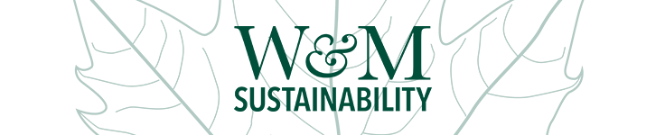
GREEN TO GOLD REVOLVING FUND
Proposal Cover Sheet
Project proposals are due to sustain@wm.edu by March 23, 2022 at 5pm.

Provide brief responses to the following:
Project Title:
Project Leader: | Phone: | Email:
Students (if applicable): |  | Email(s):
Project/Study Abstract (50 words or less):
Describe how the project reduces W&M resource use and/or greenhouse gas emissions.
Projected Savings:
- One-time: $
- Continuing: $/yr
- Payback Period: yrs
- Estimated Return on Investment over the lifetime of the project: %
- Estimated greenhouse gas emissions avoided: MTCO2e
Describe how savings will be tracked (measured and verified, estimates, combination)
Are students involved? If so, how?
Project Timeline and Completion Date:
Total Funds Requested: $
ATTACH A DETAILED PROJECT PROPOSAL. To find information on what to include, please visit https://go.wm.edu/KfRmGB

Project Leader Signature: Date:
FOR ALL PROJECT AWARDS, PROGRESS REPORTS ARE DUE EVERY SEPTEMBER. PROJECTS WILL BE EXPECTED TO BEGIN REPAYMENT IN THE FISCAL YEAR FOLLOWING THEIR COMPLETION. FINAL REPORTS ARE DUE UPON COMPLETION OF PROJECT.

