Contractor Agreement Request
Please follow the steps below to complete and submit a contract request for an Contractor Agreement. A Contractor Assessment must be approved prior to submitting this request. If an assessment has not been completed, please do not move forward with this request and complete the assessment found here: Contractor Assessment (https://wmsas.qualtrics.com/jfe/form/SV_1HYG68DD04DZPP7).

For questions related to your contract requests please submit an issue ticket found on wm.edu/buywm.
Contents
Contract Request Completion 1
Contract Request Tracking and Approvals 7
Contract Request Approval and Contract Creation – Procurement Action 9

Contract Request Completion
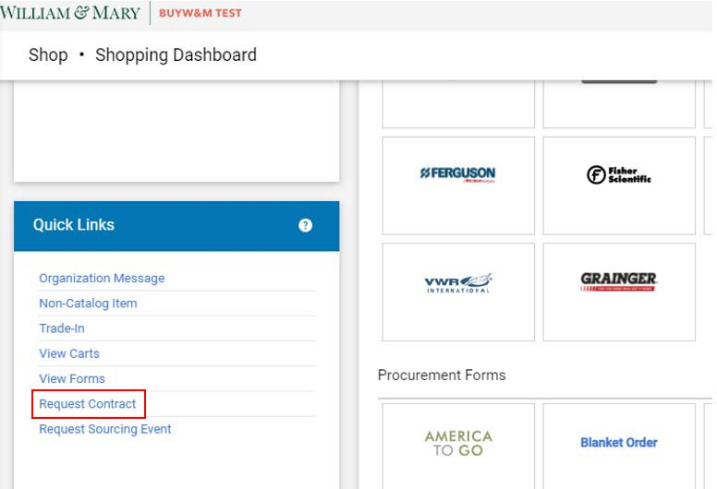
- From the Shopping Dashboard, locate the “Request Contract” link found under the “Quick Links” menu

  - This same option can be found under Contracts ‐> Requests ‐> Request Contract
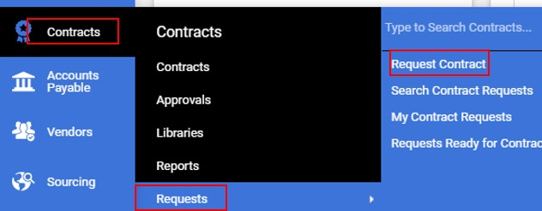
- From the pop up window, enter in the Contract Request Name (this will populate on the agreement form) and select “Contractor Agreement” from the template drop down then select Submit
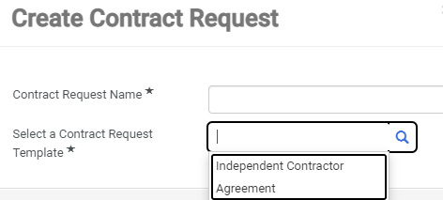
- The new request form will open on the “Instructions” screen. Once read, please select “Next” to continue.
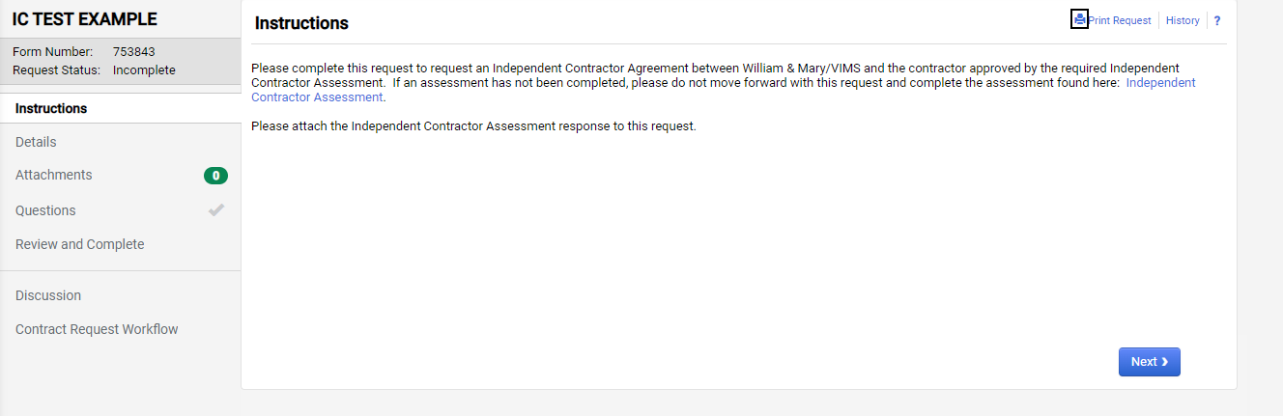
- From the “Details” page, the end user will be given the option to revise the “Contract Request Name” if needed. Select “Next” to continue.
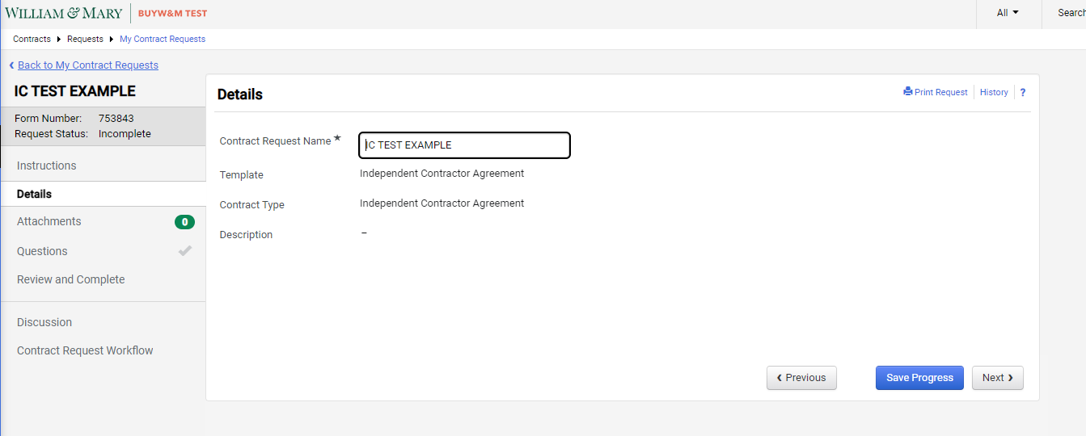
- Attachments are not required, but if there is an estimate, quote, or a document that is associated with this request please upload on this page. Select “Next” to continue.
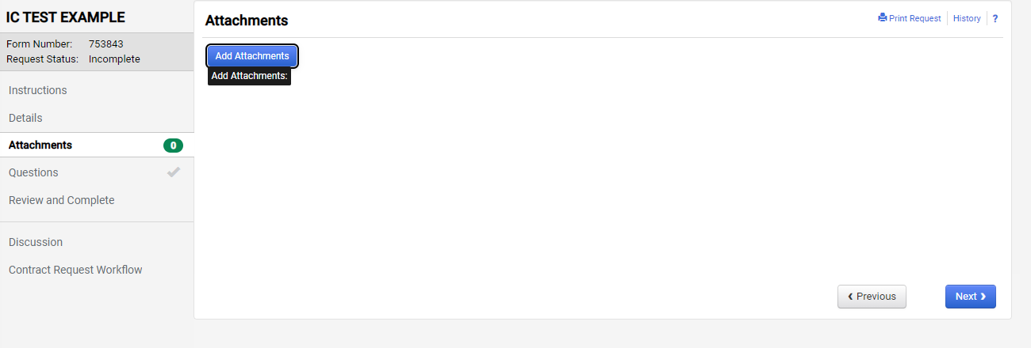
- The “Questions” page is broken out into multiple sections, which all correlate to the Agreement contract form.
  - Contractor Agreement
  - Scope of Work
  - Reporting
Each section will contain required fields which are indicated by an * and some which can be left blank due to being optional or not applicable to the request.
- Contractor Agreement:
  - Requester’s Name (required) – the name of the person submitting the request
  - Requester’s Email (required) – email of requester
  - Requester’s Phone (required) – phone number of requester
  - Department (required) – If department is not listed please put in a buyW&M ticket to request the department to be added (https://go.wm.edu/V5GyX2)
  - Assessment Number (required) – ID number generated from the Contractor Assessment (https://wmsas.qualtrics.com/jfe/form/SV_1HYG68DD04DZPP7)
  - Contractor Name (required) – speaker/presenter/performer associated with the request. Please note that the contractor must be approved and active in buyW&M prior to the request submittal. If not in buyW&M, please submit a vendor request to have this contractor added (reference user guide: Vendor Request Guide)
  - Additional Second Parties (**IGNORE**) – this cannot be removed from the request as it is a system generated field that is tied to the “Contractor Name” field. **PLEASE IGNORE**
  - Background Check (required) – Select “Yes” if a background check is required for this engagement
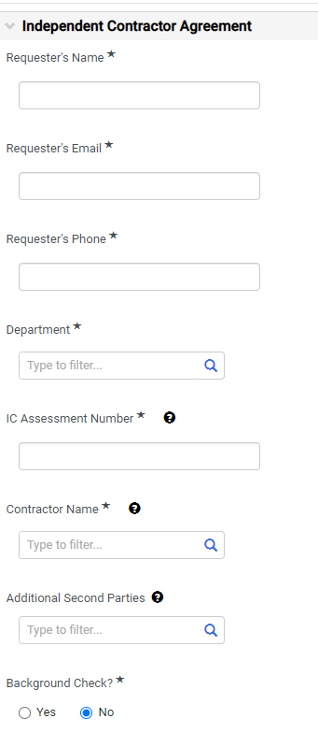
- Scope of Work:
  - Deliverables (required) – enter the desired end result(s)
  - Specific Objectives (required) – If multiple steps, please enter in chronological order
  - Start Date (required) – the date the contractor will begin
  - End Date (required) – the date the engagement will conclude
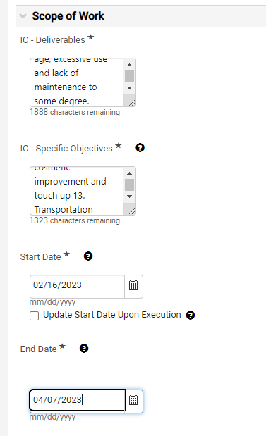
  - Auto‐Renew (**IGNORE**) – this cannot be removed from the request as it is a system generated field that is tied to the two date fields. These could be potentially be used in the contracts module by the responsible Senior Sourcing Specialist for tracking purposes **PLEASE IGNORE**
  - Renewal Term (**IGNORE**) – this cannot be removed from the request as it is a system generated field that is tied to the two date fields. These could be potentially be used in the contracts module by the responsible Senior Sourcing Specialist for tracking purposes **PLEASE IGNORE**
  - Renewals Remaining (**IGNORE**) – this cannot be removed from the request as it is a system generated field that is tied to the two date fields. These could be potentially be used in the contracts module by the responsible Senior Sourcing Specialist for tracking purposes **PLEASE IGNORE**
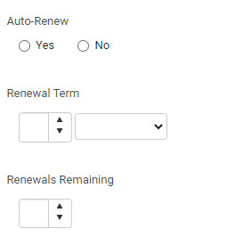

  - Total Compensation Breakdown or Not to Exceed? – select between whether the compensation will require a break down between travel, service and other
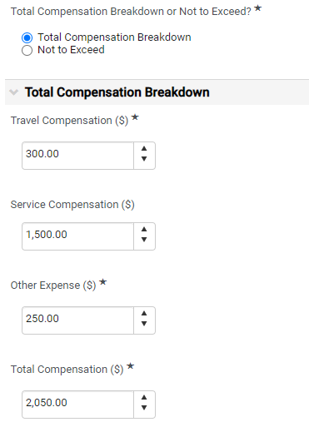
or a flat not to exceed value
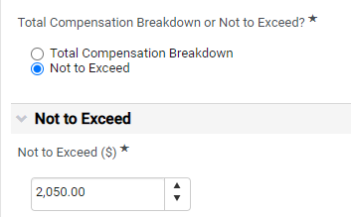

- Reporting:
If the contractor is required to submit reports please enter in the details in the fields under this section. If the contractor is not required to submit any reports, then enter N/A.
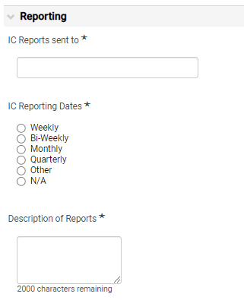
- Once all questions have been answered, select Next to continue to the “Review and Complete” section. If all items have a green check box then select “Complete Request”
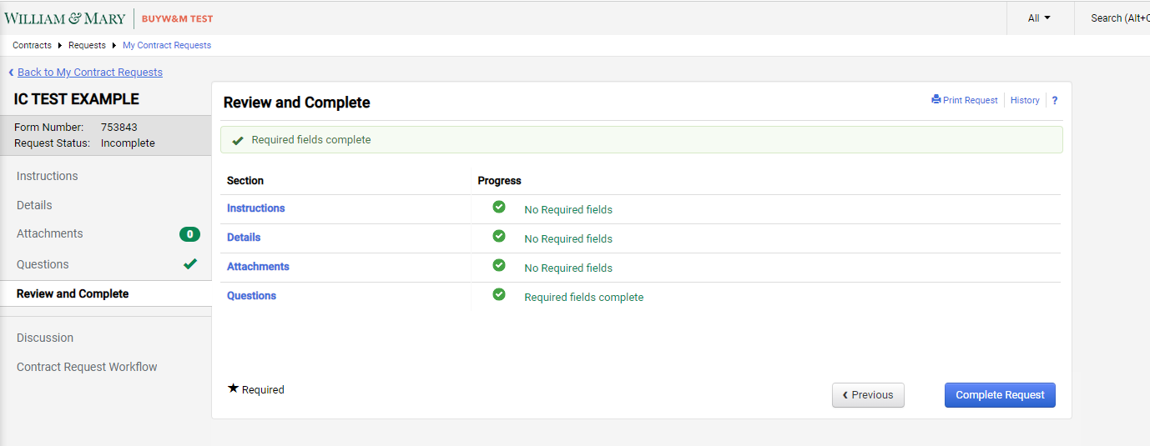
If there is a warning at the top of the “Review and Complete” page, please go to the section not marked with a green check and address the missing required information
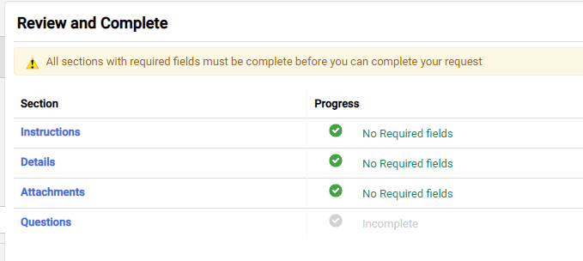

- Select Yes to confirm and submit the request
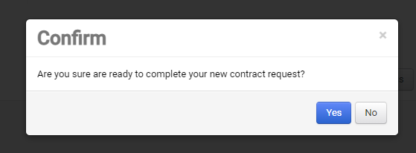

Contract Request Tracking and Approvals
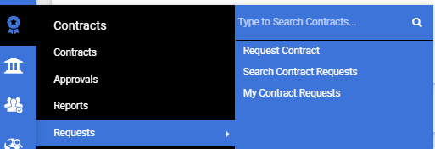
All contract requests are trackable by the end user to determine where in the approval process the request resides by navigating Contracts ‐> Requests ‐> My Contract Requests

A listing of all contract requests will show with their current status, workflow step and dates. To access a request to review, select the request name to open.
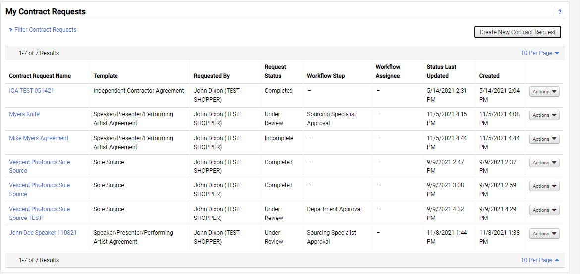
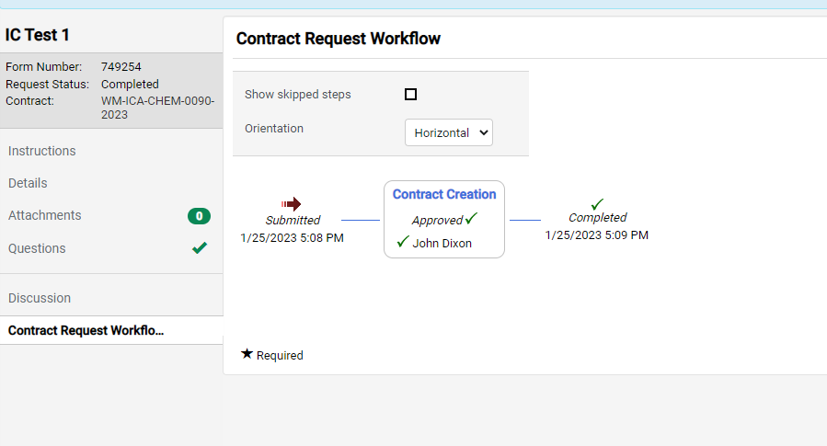
- Once the request is open, select “Contract Request Workflow” from the left menu to view the request’s current workflow step
- The requester will receive a notification email once the contract has been generated and both parties have signed (Contractor and Procurement) with a copy of the signed agreement.
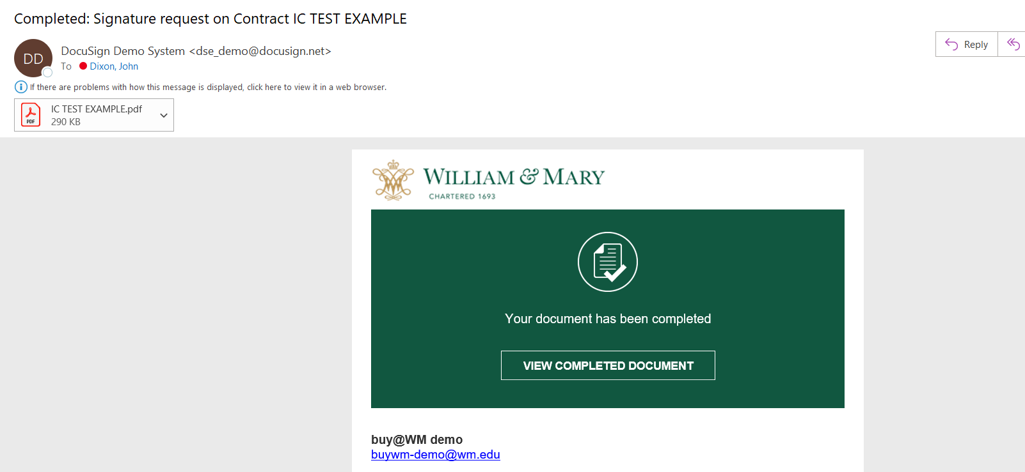

Contract Request Approval and Contract Creation – Procurement Action
These steps will be accomplished by the Senior Sourcing Specialist who is assigned to the requester’s department. Complete the steps below to approve the contract request, create the Contractor Agreement and submit for signature.
- Once the Request has been submitted, the department’s associated Sourcing Specialist will receive an action notification to approve.
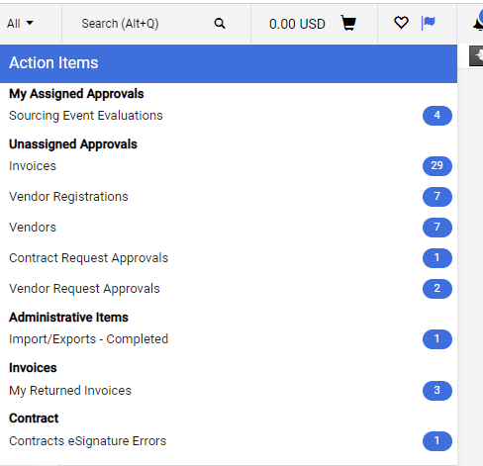
Select on the contract request form number to open the request
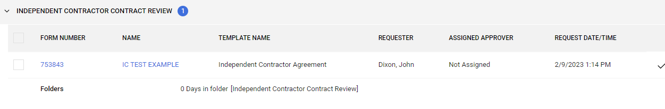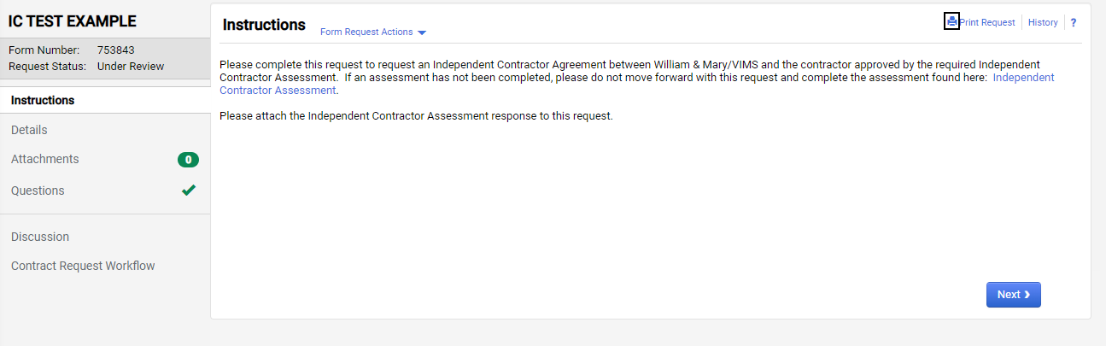
- Select “Questions” to review the information associated with the contract request
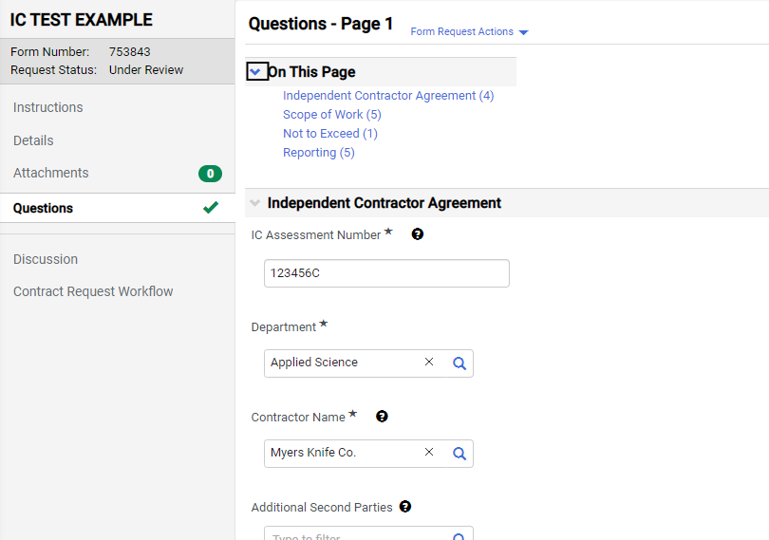
- If the request is ready for contract generation, select “Approve/Complete” from the “Form Request Actions” drop down.
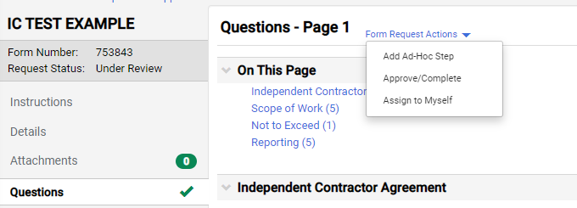
If the request needs to be rejected or returned, select “Assign to Myself” and then either “Reject” or “Return to Requester” if they need to provide more information.
- Once approved, select the “Request Actions” drop down and then “Create Contract”
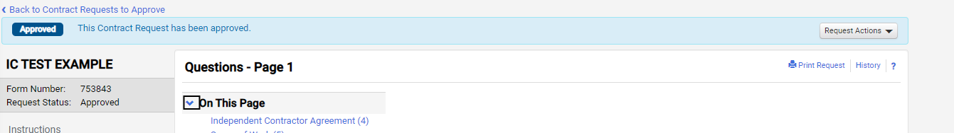
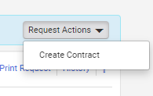
- The “Create Contract” pop up will show and enter in the Contract Name from the request and ensure all remaining fields are populated (these should prepopulate) including selecting the “Main Document Template” then select “Next”
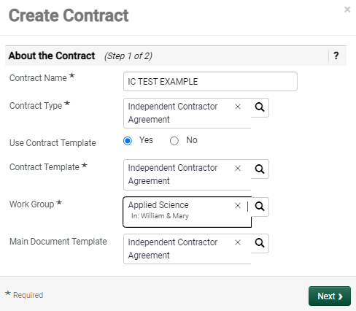
- The contract template will then show.
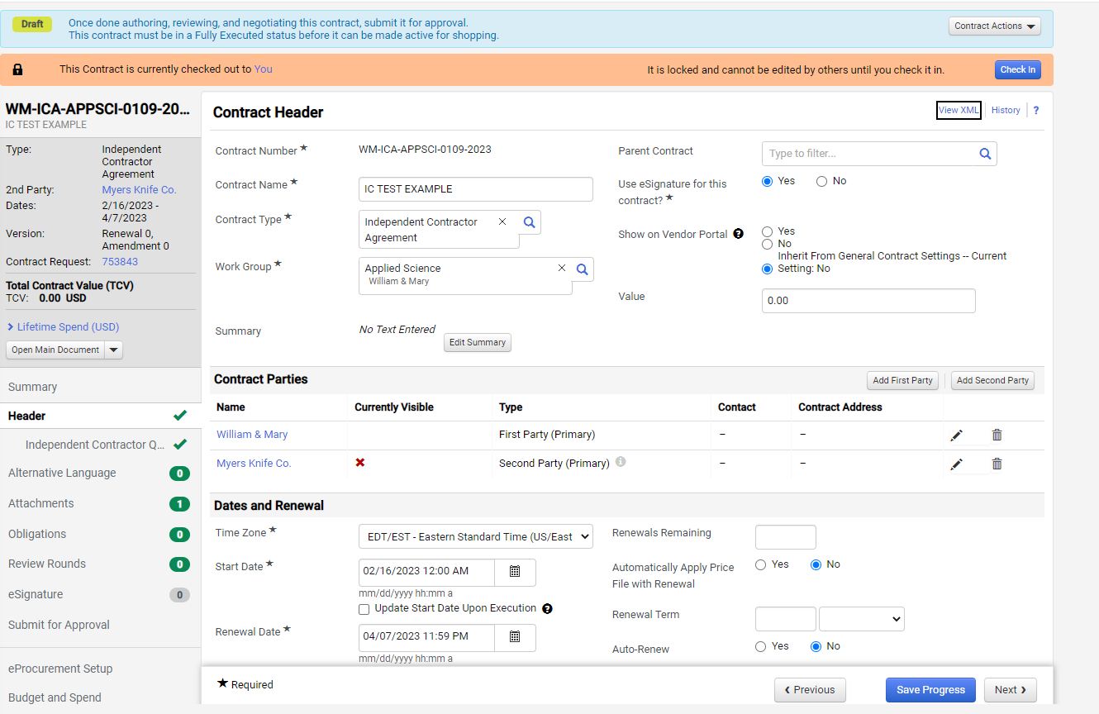
- Enter in the Value of the contract that was listed on the request
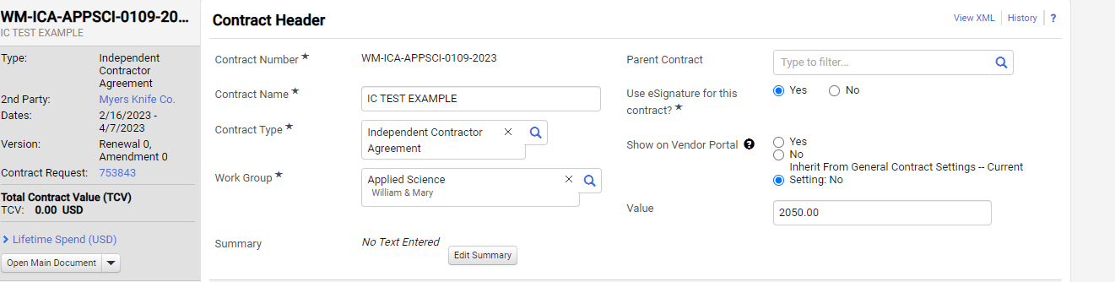
- Scroll down to the “Contract Parties” and select the pencil icon on the Vendor row then select “Edit Contact”
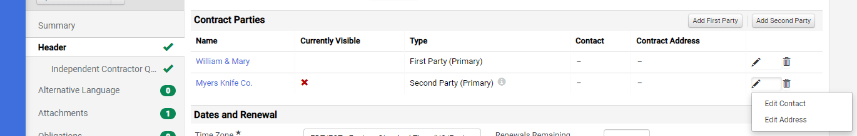
- Select from the drop down list the vendor name. If more than one select the Remittance Contact.
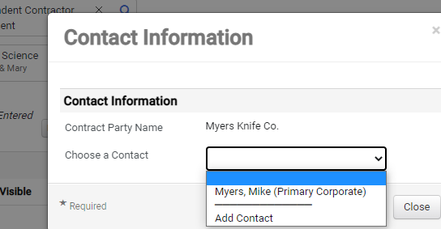
- The contact information will pull from the registration and the select “Save Changes”
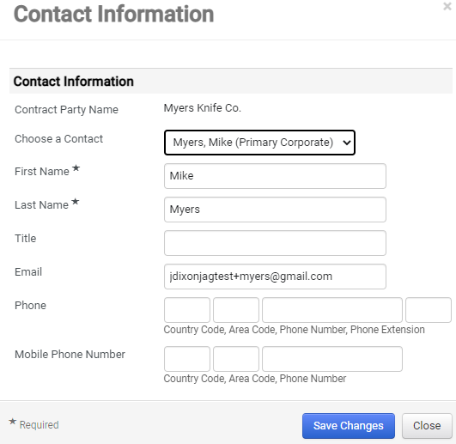
- Repeat for the Address, select remittance if more than one listed
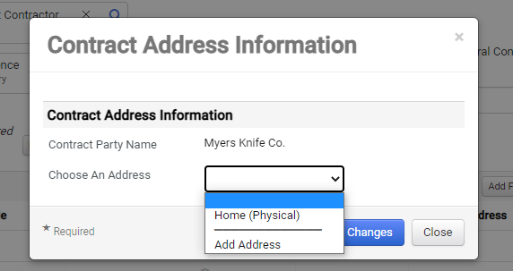
- All address information will be pulled from the vendor’s registration then select save.
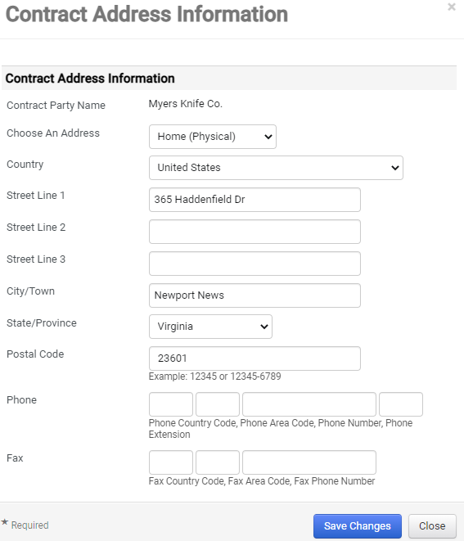
- Select “Save Progress” once complete
- Click on “Attachments” on the left menu where the contract will be shown. All contract details should be populated based on the information listed in the contract request. Click on the link to download the document for review if needed.
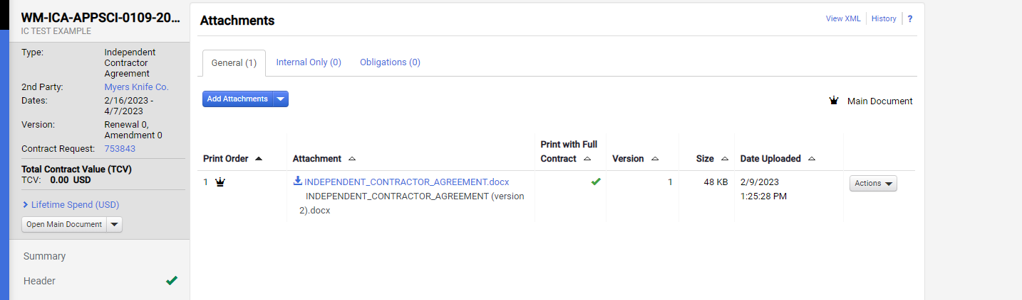
- Next, click on “eSignature” from the left side menu. Select “Add Signer” to create the signer routing
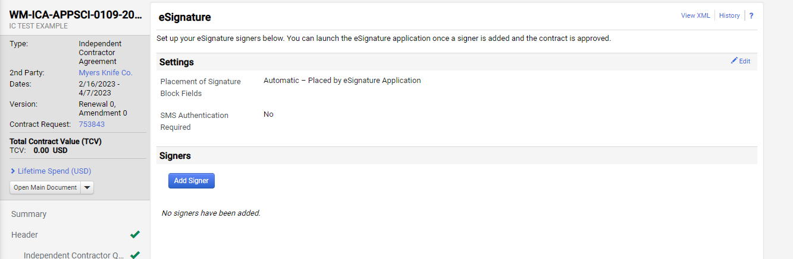
- From the “Contract Party” dropdown, select the Vendor first
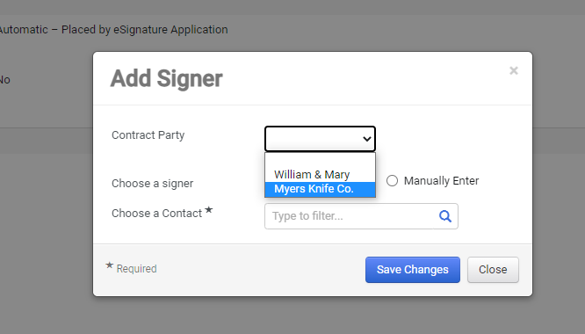

- Select the “Remittance” contact to pull in the email and name of the signer and select “Save Changes”
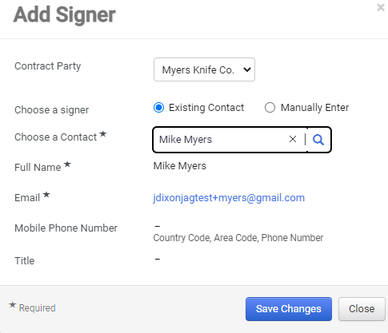

If the contract needs to be sent to a contact not listed, select “Manually Enter” then enter in the desire contact name and email and select “Save Changes”
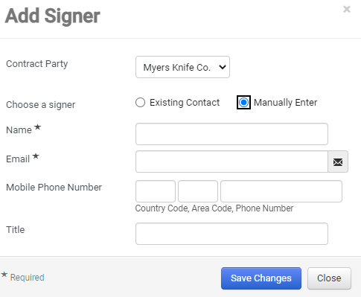

- Select “Add Signer” again and select “William & Mary” from the “Contract Party” drop down. Then select the applicable signer from the “Choose a Contact” listing then “Save Changes”
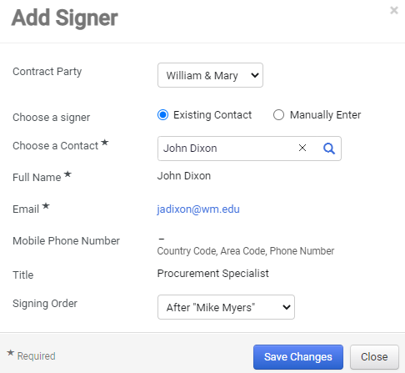
- Once the signers have been applied, select “Submit for Approval” from the left menu then the “Submit for Approval” button
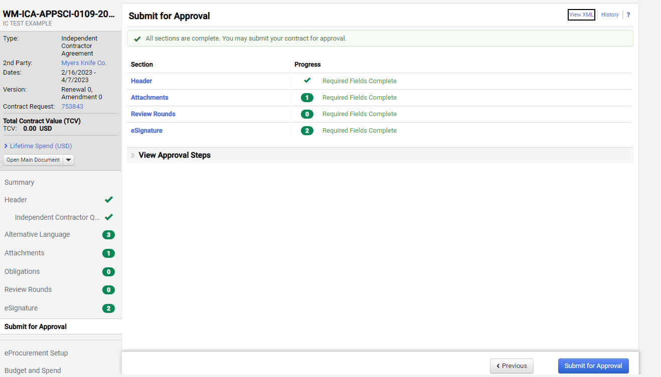
- Optional, but enter in a message to the signers if desired and then select “Submit for Approval”
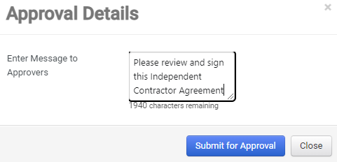
- The contract will then be sent to the Second Party (Contractor) for signature.
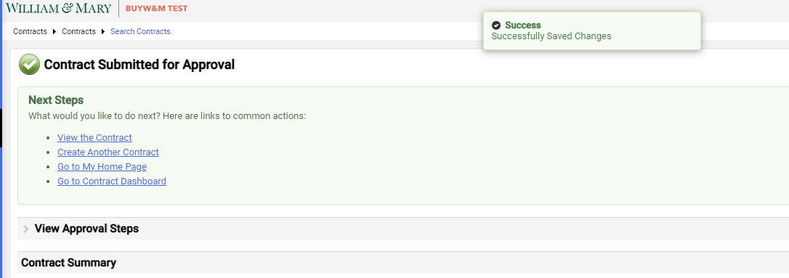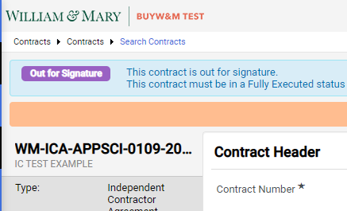
- A notification email will be sent to the W&M party for signature once the Contractor has signed
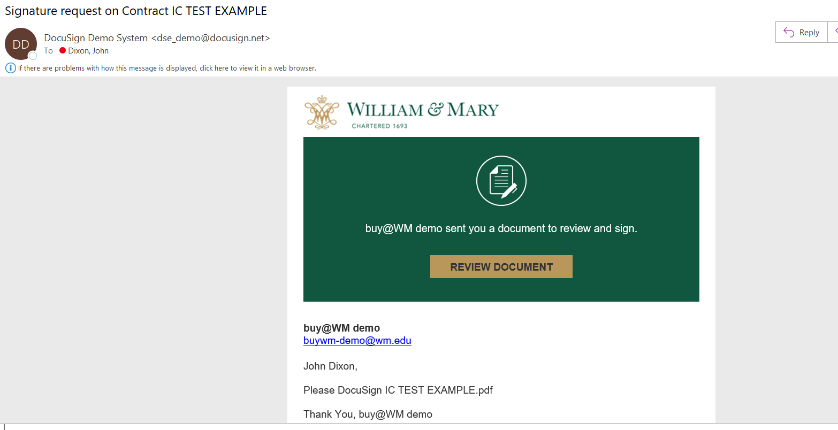
- Once in DocuSign, select “CONTINUE” to open the agreement
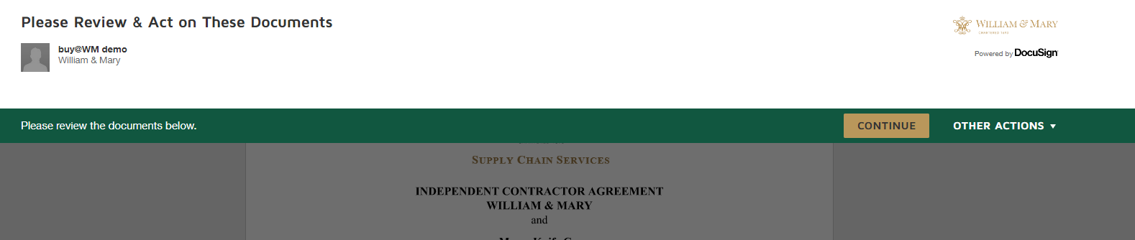
- Select the “START” to navigate to the signature block
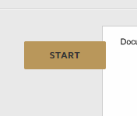
- Select the “Sign” button to apply the digital signature
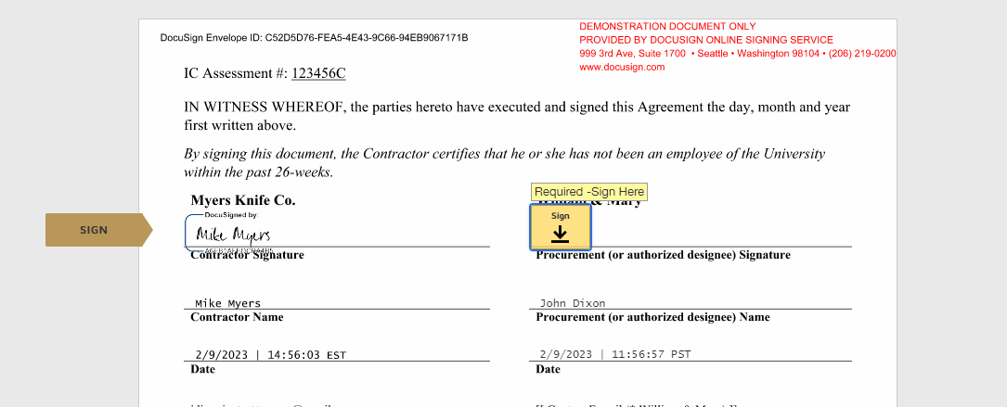
- Once signed, select “FINISH” to finalize the contact
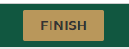
- Once all parties have signed, the signed agreement will be sent via email to both signers

