- Enter myWM, selecting Banner Self Service and log in using your WM user id and password.

- Select Employee>Tax Forms.

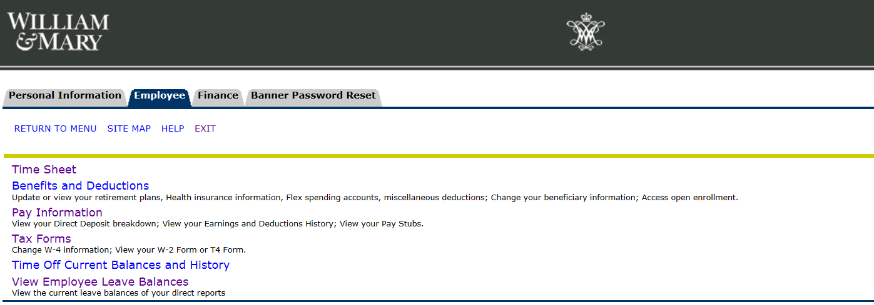

- To make changes to your Federal tax withholdings (Form W-4):

  - Select W-4 Tax Exemptions/Allowances.

b. Your current W-4 information will be shown on this screen, to make changes select Update
(located at the bottom of the screen).

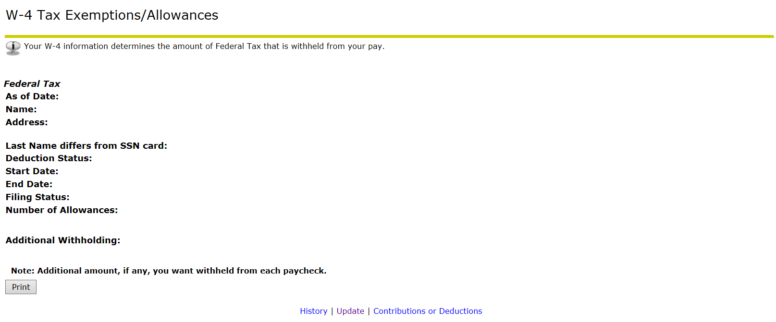

- Complete the required (*) fields, using the drop down boxes as provided. The “Deduction Effective” date will default to the first available change date, based upon your last pay date. Select “Certify Changes” at the bottom of the page to continue the update process.

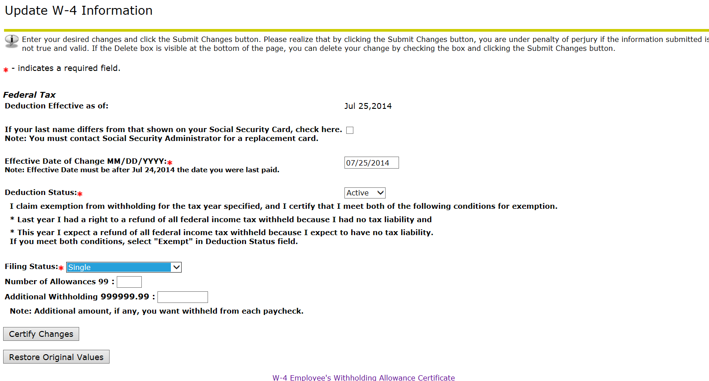

- To certify that the information which you have provided is accurate and complete, enter your
myWM password and then click on the “Submit” button.
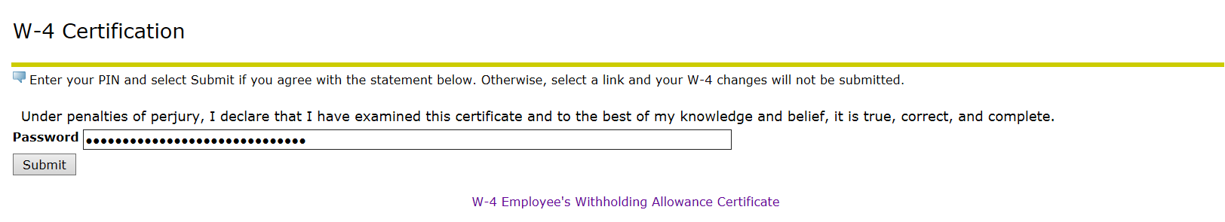

- You will then see the Tax Update Confirmation screen, confirming that your changes were
successfully completed.

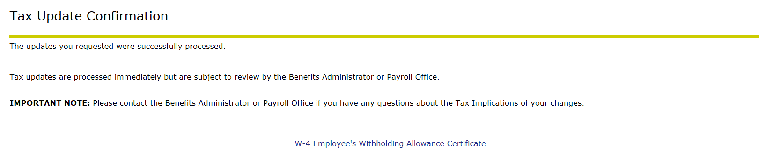

- To elect to receive Form W-2 electronically:

  - Select Electronic W2 Consent.

b. Read the statement and check the box next to Consent to receive W-2 electronically.
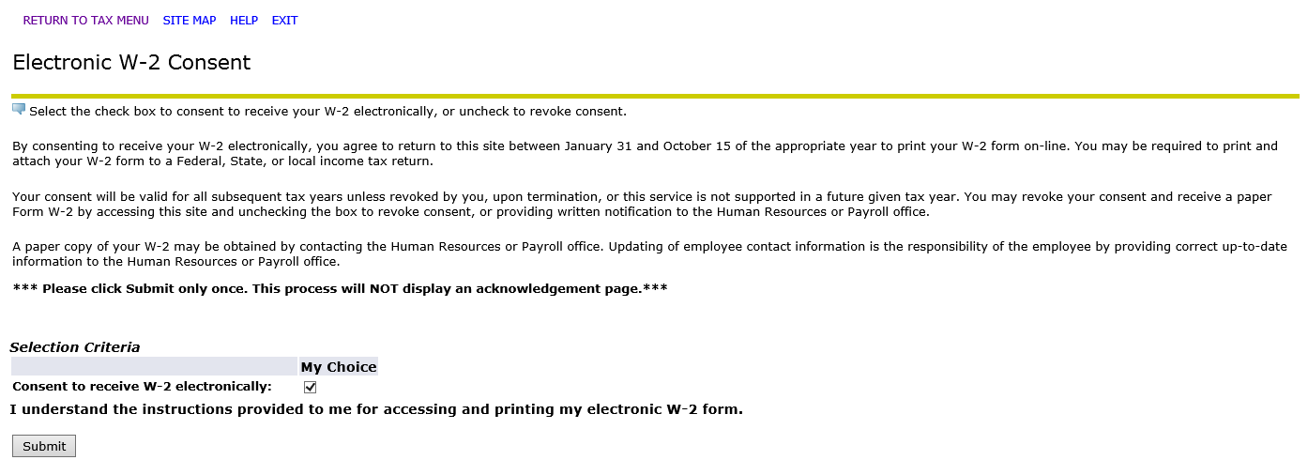

- Select the Submit button and you are done! You can now access your W-2 from any computer, tablet or mobile device whenever you need.

- To view and print Form W-2 in Banner Self Service:

  - Select W-2 Year End Earnings Statement

  - Select the tax year from the drop down menu and then click on Display.
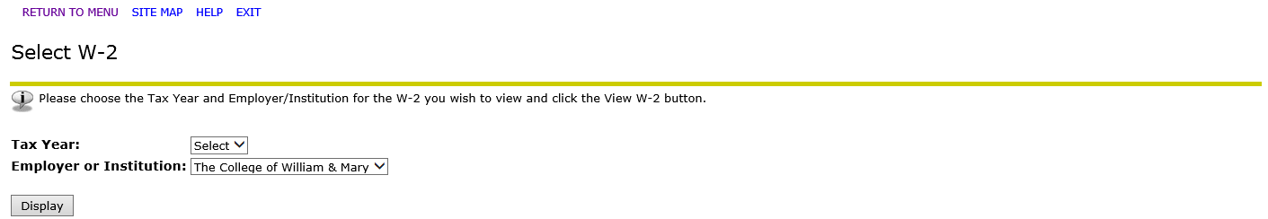

c. View your W-2 on this screen, or to print your W-2 on plain paper, click on Printable W-2.

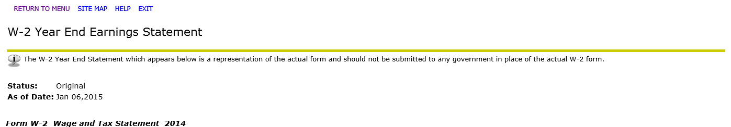
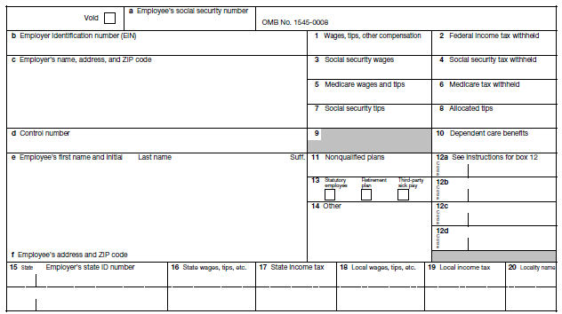

- You will be prompted to enter your password, then click on “Submit” to access the printable version of your W-2.

The Payroll Office will publish announcements in The Digest, as well as communicate directly to the departments, as soon as electronic W-2’s are available. Watch for them upon our return from Winter Break!

If you have any questions, please contact the Payroll Office at 757-221-2848.

