COLLEGE PARK LANDING LOOP – 5.66 miles

http://www.mapmyride.com/routes/view/962254925

0 mi |  | Head east on James Blair Dr
0.23 mi |  | Turn right onto Richmond Rd
0.35 mi |  | Turn left onto N Boundary St
0.37 mi |  | Turn left onto W Duke of Gloucester St
1.11 mi |  | Slight right onto Blair St
1.17 mi |  | Turn right onto Francis St E
1.52 mi |  | Turn right onto S England St
1.94 mi |  | Head west on Newport Ave
1.96 mi |  | Sharp left
2.06 mi |  | Head south on Colonial Pkwy
3.21 mi |  | Head south toward S Henry St
3.34 mi |  | Turn right onto S Henry St
5.14 mi |  | Turn left onto Francis St W
5.23 mi |  | Turn right onto S Boundary St
5.32 mi |  | Turn left at W Duke of Gloucester St
5.33 mi |  | Slight right
5.65 mi |  | Turn left onto James Blair Dr Destination will be on the right
5.66 mi |  | Destination

College Landing Loop Map
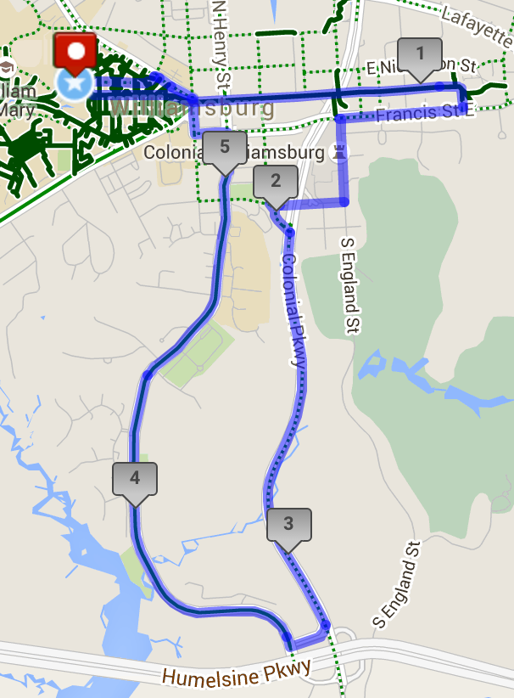
NEWTOWN AND MONTICELLO MARKETPLACE – 8 miles

http://www.mapmyride.com/routes/view/733258655

0 mi |  | Head southeast on James Blair Dr
0.01 mi |  | Turn right to stay on James Blair Dr
0.04 mi |  | Slight left at Gooch Dr
0.13 mi |  | Head northwest on Landrum Dr
0.35 mi |  | Continue onto Campus Dr/Ukrop Way Continue to follow Ukrop Way
0.57 mi |  | Head south on Ukrop Way toward Jamestown Rd
0.57 mi |  | Turn right onto Jamestown Rd
0.94 mi |  | Turn right onto Mill Neck Rd
1.62 mi |  | Turn left onto Berkeley Ln Destination will be on the left
1.71 mi |  | Head west on Berkeley Ln toward John Tyler Ln
1.79 mi |  | Turn right onto John Tyler Ln
2.02 mi |  | Continue onto Strawberry Plains Rd
3.05 mi |  | Turn right onto Ironbound Rd
3.18 mi |  | Turn left onto VA-321 W
3.19 mi |  | Turn right onto Ironbound Rd
3.2 mi |  | Head west toward Courthouse St
3.66 mi |  | Head west toward Settlers Market Blvd
3.84 mi |  | Turn left onto Casey Blvd
3.85 mi |  | Turn right onto VA-321 W/Monticello Ave Continue to follow Monticello Ave
4.14 mi |  | Head southwest on Monticello Ave toward Windsormeade Way
4.54 mi |  | Turn right onto State Rte 613
4.64 mi |  | Turn right
4.65 mi |  | Head northeast
4.78 mi |  | Head north
4.79 mi |  | Turn right
4.83 mi |  | Head east
4.97 mi |  | Head northeast toward Old News Rd
4.99 mi |  | Turn right onto Old News Rd =
5.02 mi |  | Head southeast on Old News Rd toward Monticello Ave
5.11 mi |  | Head south toward Monticello Ave
5.12 mi |  | Sharp left onto Monticello Ave
5.58 mi |  | Turn right onto State Rte 615
6.31 mi |  | Turn right onto Monticello Ave
7.03 mi |  | Turn right onto Compton Dr
7.04 mi |  | Head south on Compton Dr toward Matoaka Trails
7.35 mi |  | Head southeast on Compton Dr toward Brooks St
7.61 mi |  | Turn right onto Ukrop Way
7.69 mi |  | Slight left onto Yates Dr
7.8 mi |  | Turn right onto Gooch Dr
8.06 mi |  | Turn left onto James Blair Dr
8.06 mi |  | Destination
New Town and Monticello Marketplace Map
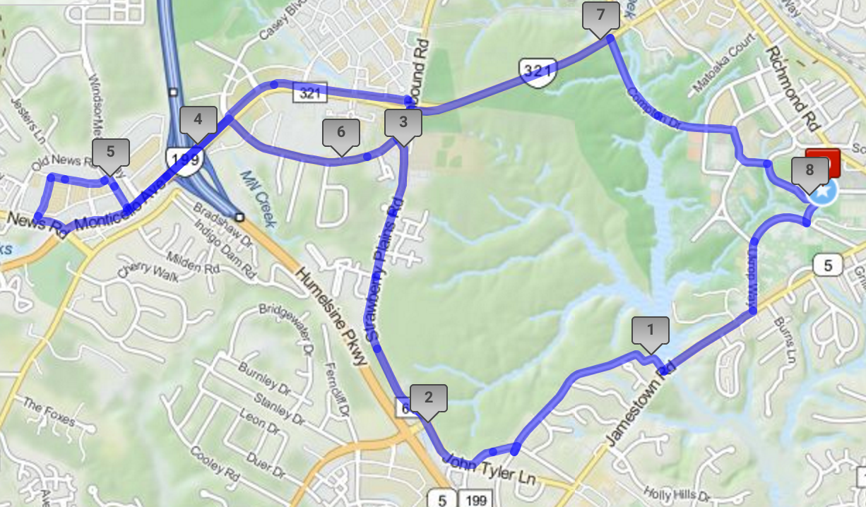
QUEEN’S LAKE LOOP – 12.5 miles

http://www.mapmyride.com/routes/view/883947343

0 mi |  | Head northeast on James Blair Dr
0.08 mi |  | Turn left
0.1 mi |  | Turn left onto James Blair Dr
0.26 mi |  | Turn right onto Richmond Rd
0.38 mi |  | Slight right onto N Boundary St
0.48 mi |  | Turn left onto Francis St W
0.49 mi |  | Head east on Francis St W toward S Henry St
1.36 mi |  | Continue onto York St
1.5 mi |  | Continue onto Page St
1.53 mi |  | Head north on Page St toward Capitol Ct
1.67 mi |  | Turn right onto Penniman Rd
1.69 mi |  | Head east on Penniman Rd toward Broadway Ave
2.65 mi |  | Head east on State Rte 641 toward Monument Dr
2.95 mi |  | Head north on Hubbard Ln toward Edale Ave
3.83 mi |  | Head north on Hubbard Ln/W Queens Dr toward Lakeshead Dr - Continue to follow W Queens Dr
3.95 mi |  | Head north on W Queens Dr toward National Ln
7.12 mi |  | Turn right onto Lakeshead Dr
8.14 mi |  | Turn left onto Hubbard Ln/W Queens Dr Continue to follow Hubbard Ln
8.73 mi |  | Head south on Hubbard Ln toward Edale Ave
9.06 mi |  | Head south on Hubbard Ln toward State Rte 641
9.08 mi |  | Turn right onto State Rte 641
10.36 mi |  | Turn left onto Page St
10.54 mi |  | Continue onto York St
10.67 mi |  | Continue onto Francis St E
10.71 mi |  | Head west on Francis St E toward Blair St
10.8 mi |  | Turn right onto Blair St
10.86 mi |  | Head north on Blair St toward E Duke of Gloucester St
10.86 mi |  | Continue onto E Duke of Gloucester St
11.02 mi |  | Head north on N Botetourt St toward E Nicholson St
11.08 mi |  | Turn left onto E Nicholson St
11.11 mi |  | Head west on E Nicholson St toward Colonial St
11.36 mi |  | Head north on Palace Green St toward Scotland St
11.46 mi |  | Turn right onto Scotland St
11.48 mi |  | Turn right onto Palace Green St/Scotland St
11.58 mi |  | Turn right onto Prince George St
11.87 mi |  | Turn right onto N Boundary St
11.88 mi |  | Turn left onto Prince George St
11.96 mi |  | Turn left onto Armistead Ave
12.03 mi |  | Turn right onto Richmond Rd
12.3 mi |  | Continue straight onto Stadium Dr
12.31 mi |  | Head south on Stadium Dr toward James Blair Dr
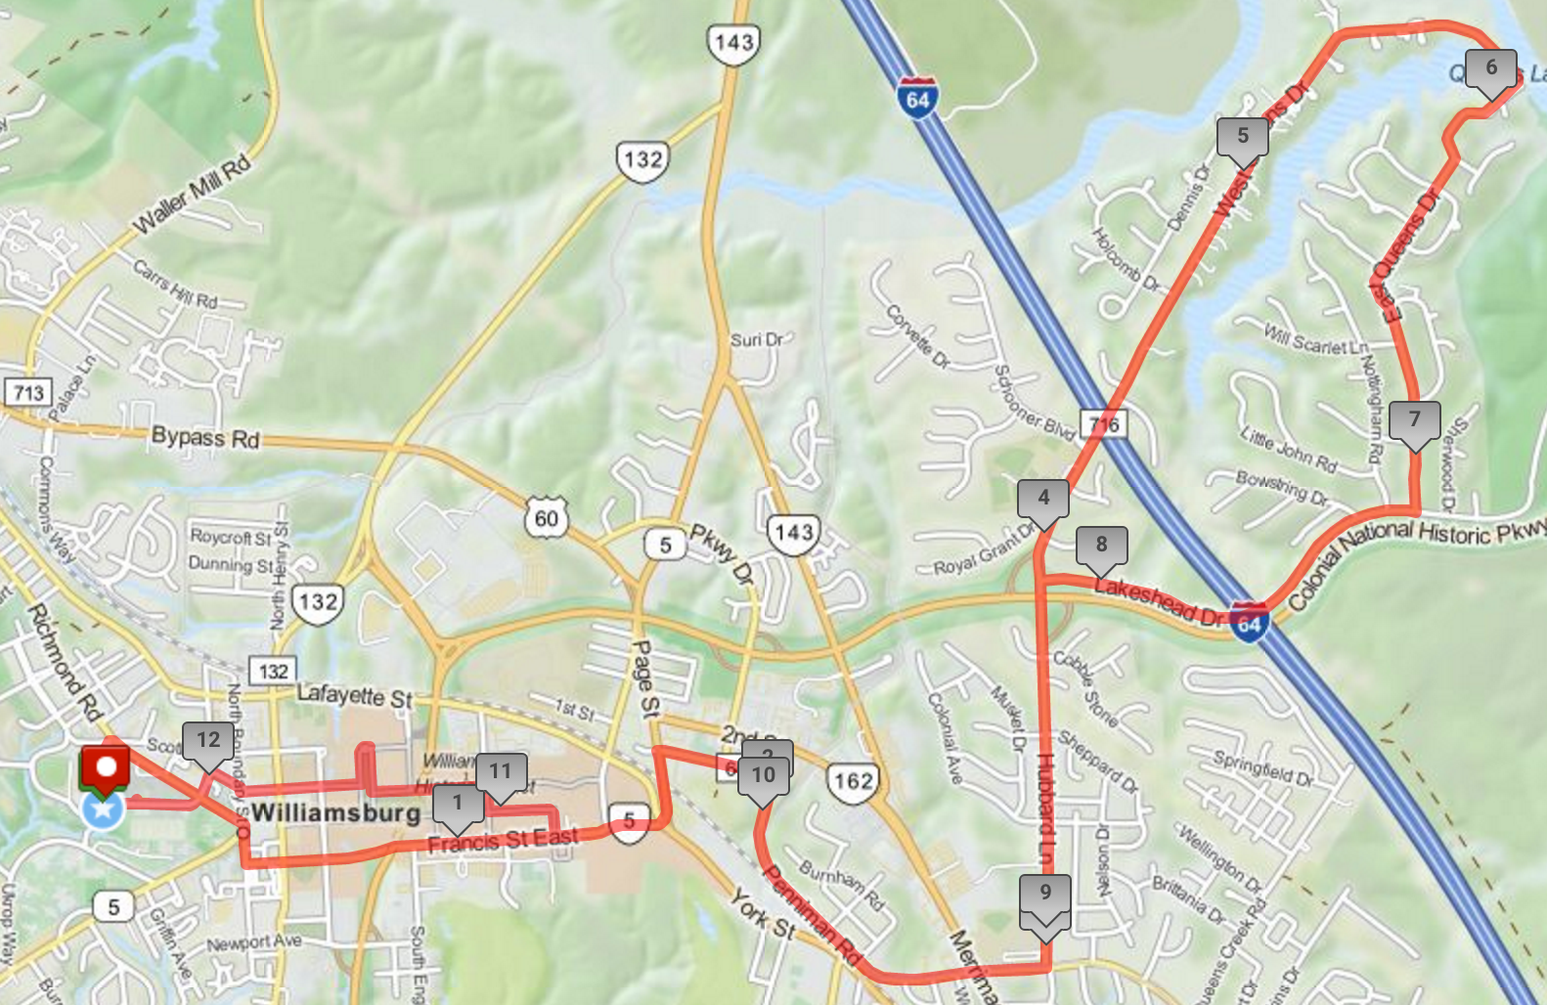
Queen’s Lake Loop Map
COLONIAL PARKWAY/JAMESTOWN LOOP – 16 miles

http://www.mapmyride.com/routes/view/851695667

0 mi |  | Head southwest on James Blair Dr toward Gooch Dr
0.01 mi |  | Slight left at Gooch Dr
0.1 mi |  | Turn right onto Landrum Dr
0.32 mi |  | Continue onto Campus Dr/Ukrop Way
0.55 mi |  | Turn right onto Jamestown Rd
0.91 mi |  | Turn right onto Mill Neck Rd
1.56 mi |  | Turn right onto Berkeley Ln
1.72 mi |  | Turn right onto John Tyler Ln
1.95 mi |  | Turn left onto John Tyler Hwy
2.1 mi |  | Head west on VA-5 W toward Ferncliff Dr
3.21 mi |  | Turn right at New Castle Dr
3.21 mi |  | Turn left onto VA-5 W
3.54 mi |  | Turn left at Venture Ln
3.54 mi |  | Turn right onto VA-5 W
3.63 mi |  | Head southwest on VA-5 W
3.64 mi |  | Turn left
3.79 mi |  | Turn left toward Ironbound Rd
3.88 mi |  | Turn left onto Ironbound Rd
3.97 mi |  | Turn left onto Village Park Dr Restricted usage road
4 mi |  | Turn left onto Village Park Dr W
4.07 mi |  | Head southwest on Village Park Dr W Restricted usage road
4.14 mi |  | Turn right onto Village Park Dr Restricted usage road
4.18 mi |  | Turn right onto Ironbound Rd
4.26 mi |  | Turn left
4.29 mi |  | Head southwest toward Powhatan Creek Trail
4.52 mi |  | Head south on Powhatan Creek Trail
6.58 mi |  | Slight left onto Virginia Capital Trail
6.58 mi |  | Head south on Virginia Capital Trail
6.91 mi |  | Turn right toward VA-614 E
6.92 mi |  | Turn right onto VA-614 E
7.13 mi |  | Head southeast on VA-614 W
7.34 mi |  | Turn left toward Virginia Capital Trail
7.35 mi |  | Turn right onto Virginia Capital Trail
7.79 mi |  | Head south on Virginia Capital Trail toward VA-31 S
7.8 mi |  | Turn right onto VA-31 S/Jamestown Rd
7.94 mi |  | Head southwest on Jamestown Rd toward Colonial National Historic Pkwy
7.96 mi |  | Turn left onto Colonial National Historic Pkwy
11.36 mi |  | Turn left onto a trail that leads to a road.
11.52 mi |  | Continue onto Treasure Island Rd
12.78 mi |  | Continue straight onto Lake Powell Rd
14.23 mi |  | Turn right onto Jamestown Rd
15.88 mi |  | Turn left onto Landrum Dr
15.9 mi |  | Head northwest on Landrum Dr
16.07 mi |  | Head north toward Gooch Dr/James Blair Dr
16.16 mi |  | Slight right onto James Blair Dr
16.18 mi |  | Destination

Colonial Parkway/Jamestown Loop Map
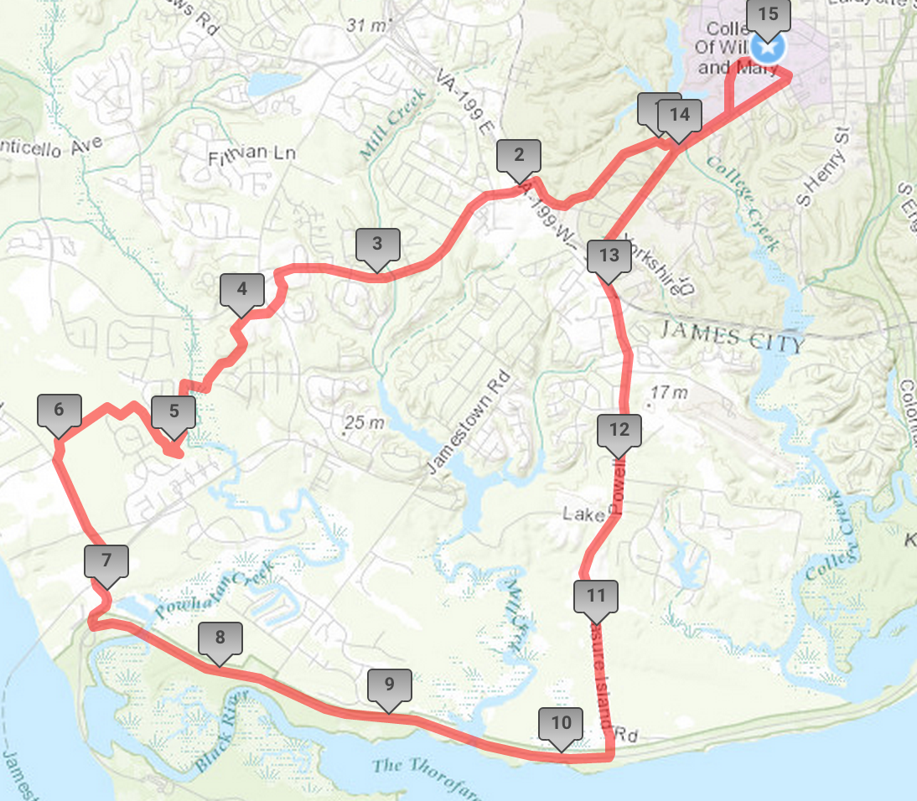

CHICKAHOMINY RIVERFRONT PARK OUT AND BACK – 24 Miles

http://www.mapmyride.com/routes/view/733245165

0.01 mi |  | Turn right to stay on James Blair Dr
0.04 mi |  | Slight left at Gooch Dr
0.13 mi |  | Head south toward Landrum Dr
0.13 mi |  | Turn right onto Landrum Dr
0.35 mi |  | Continue onto Campus Dr/Ukrop Way
0.57 mi |  | Turn right on Jamestown Rd toward Rolfe Rd
0.94 mi |  | Turn right onto Mill Neck Rd
1.68 mi |  | Turn right onto John Tyler Ln
2.01 mi |  | Turn left onto John Tyler Hwy
2.32 mi |  | Head southwest on VA-5 W toward Carolina Blvd
3.6 mi |  | Turn left at Venture Ln right before the McDonald’s into a parkinglot
3.68 mi |  | Direct/offroad route segment behind the stores in the parking lot
3.87 mi |  | Cross the street into the middle school
4.18 mi |  | Head south on Powhatan Creek Trail toward Powhatan Creek Trail
5.28 mi |  | Turn right to stay on Powhatan Creek Trail
6.15 mi |  | Turn right on a connector trail to the Capital Trail
7.32 mi |  | Turn left onto the capital trail
11.78 mi |  | You’ve reached Chickahominy Riverfront Park
11.95 mi |  | Turn around
12.71 mi |  | Go back down the Capital Trail
16.59 mi |  | Turn right toward Greenspring Trail
17.76 mi |  | Turn left onto Powhatan Creek Trail
18.63 mi |  | Turn left to stay on Powhatan Creek Trail
19.72 mi |  | Cross the road to get to the parkinglot
20.04 mi |  | Direct/offroad route segment
20.12 mi |  | Direct/offroad route segment
20.22 mi |  | Turn Right on VA-5
22.03 mi |  | Turn right onto John Tyler Ln
22.26 mi |  | Head east on John Tyler Ln toward Mill Neck Rd
22.35 mi |  | Turn left onto Mill Neck Rd
22.84 mi |  | Head east on Mill Neck Rd toward Canterbury Ln
23.1 mi |  | Turn left onto Jamestown Rd
23.46 mi |  | Head north on Ukrop Way
23.64 mi |  | Head north on Campus Dr/Ukrop Way
23.69 mi |  | Continue onto Landrum Dr
23.91 mi |  | Turn left
23.91 mi |  | Head north toward Gooch Dr/James Blair Dr
24 mi |  | Slight right onto James Blair Dr
24.03 mi |  | Turn left to stay on James Blair Dr
24.04 mi |  | Destination

Chickahominy Map

