Conference Sponsors:

Dean of Arts and Sciences

Wendy and Emery Reves Center for International Studies

European Studies Program

Mellon Foundation

Special thanks to:

Maria Rogacheva

Monika Van Tassel

All events are free and open to the public.
World War II

12th Annual Student-Faculty Conference in European Studies
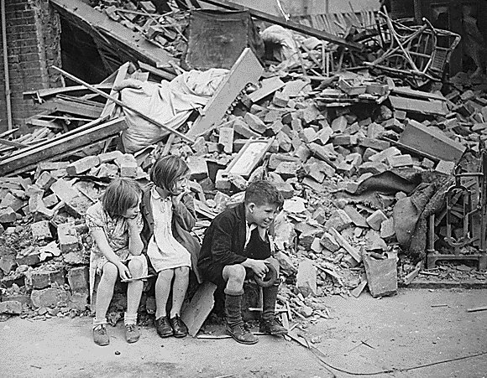
March 18, 2017
College of
William and Mary

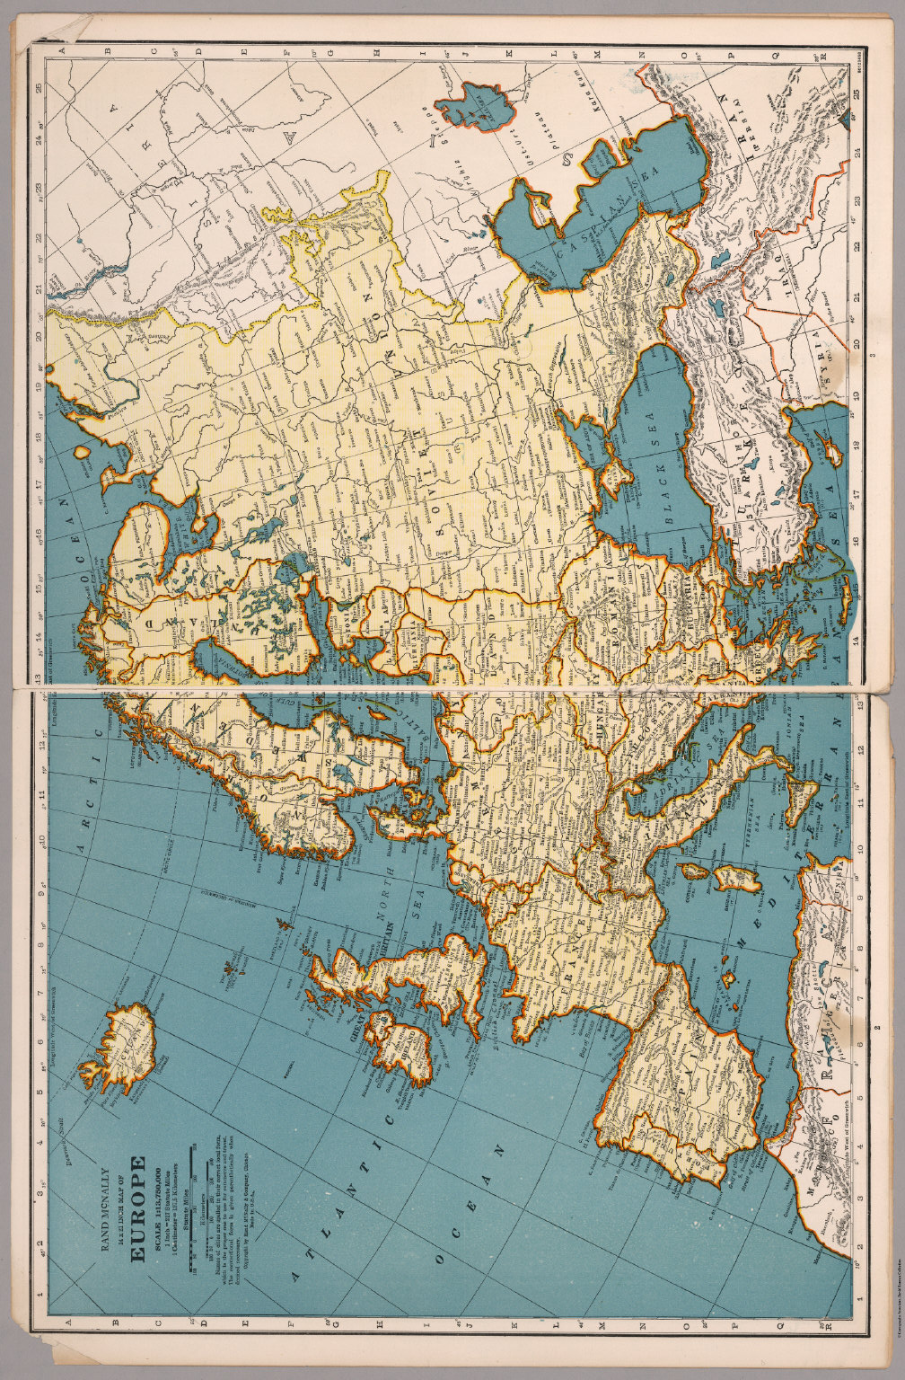
Saturday March 18

Tucker Hall 127A

8:30-9:00 Breakfast

9:00-10:20 Experiences of War: Soldiers, Civilians, and
Nurses

Moderator: Kendall Carter

Monica Cronin, “Combat and Ideology in Stalingrad”

Ingrid Unander-Scharin, “Finnish Children in Sweden during World War II”
Abigail Kane, “American Nurses on the Frontlines of the European Theater”

10:20-10:30 Coffee

10:30-11:50: Representations of War: Media, Propaganda, and Memory

Moderator: Lauren Hammett

Rose Richardson, “Media Coverage of Refugees in World War II”

Hailey Sabol, “Soviet Propaganda and the Red Army”

Sloane Nilsen, “Gertrude Stein, the Vichy Syndrome, and Memories of Occupation and Collaboration in Postwar France”

12:00-1:00 Lunch

